UniPhi 15

Practice Management
Training Manual

Contents
Creating Organisations & Sites 5
Creating a Resource 8
Adding a Resource to a Site 9
Viewing External Resources 10
Viewing Internal Resources (Staff) 13
Viewing Organisations & Sites 15
Creating Projects 17
Adding and Deleting Roles to existing Resources 25
Creating the Revenue Estimate 26
Revenue Budgets 26
Revenue Phasing 28
Auto-Phasing Revenues 29
Manual Contract Phasing 30
Estimating 31
Creating contract deliverables 35
Heading Types 37
Contract Views 43
All View 43
Claim View 43
Schedule View 44
Accounting View 44
Importing contract deliverables 47
Contract Maintenance 50
Creating an Invoice 51
Lump Sum 53
Time and Materials 54
Contract details and registers 55
Contract registers 56
Cost Contract registers 58
Timesheets 63
Adding projects to your timesheet 63
Adding Timesheet Hours 66
Removing Projects form Timesheet 67

Course Aim
The aim of this manual is to provide instructions that will effectively introduce you to the practice management aspects of UniPhi. Within this manual you will learn how to create a new project, assign resources and organisations, and work with financial information such as creating budgets and invoicing.
How to use this User Training Manual
As you read this manual you will notice the following icons recurring which will help to highlight and enable you to quickly locate activities and summary areas, they will also assist you to understand UniPhi, and avoid any problems.
Puzzle Piece:
The puzzle piece appears at the beginning of each session and any major section to mark the overview of that item’s content or concept.
Cogs:
The cogs denotes a step by step activity to be completed using UniPhi by the participant relative to the section it is located in.
Light bulb:
The light bulb denotes a helpful hint or tip you should be aware of.

Screen shots have been used throughout the manual to demonstrate what you should be viewing as you move through the activities. They are for illustrative purposes only. Details such as dates, budget figures and other entered text/data may vary.

Creating Organisations & Sites
Organisations and sites are effectively the company or companies that your organisation engages with. Organisations refer to the company or business, while Sites refer to physical locations of each organisation. Therefore Sites are always linked to Organisations.
To create an Organisation, go to the Resource tab, and press the Add Organisations button
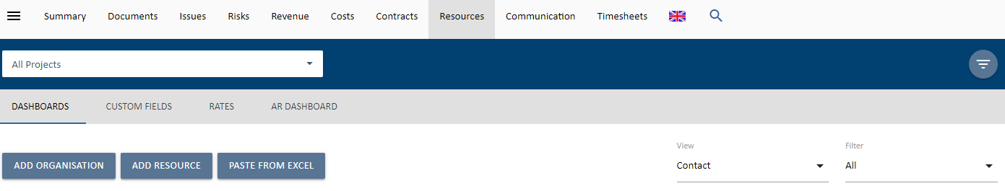
When creating a new Organisation, you will be presented with several detail fields that can be populated with Organisation specific information. The only mandatory field that requires information at this stage is the Organisation name, and the primary Site details. Obviously the more details you have entered here, the more useful your resource information will be, particularly when performing tasks such as generating documents, or invoices, etc.
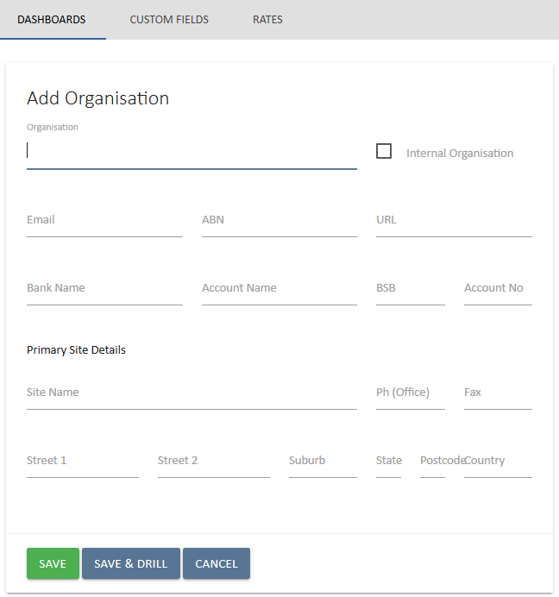
Once you have created an Organisation and Primary Site details, you can press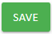. Using the navigation bar, you can add more sites under the Organisation tab.

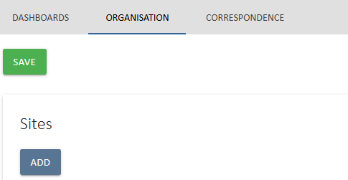

The Organisation should be marked as Internal if this is your organisation. Leaving the Internal box un-ticked will treat the organisation (and associated sites) as an external organisation (e.g. a client/supplier).
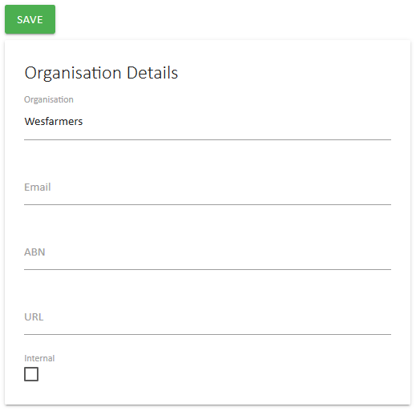

Creating a Resource
UniPhi categorises all people resources as internal or external contacts. Importantly these resource contacts can also be assigned to organisations, sites, and Projects.
Resource contacts are added via the Portfolio / Resources tab, and pressing the Add Resource button.
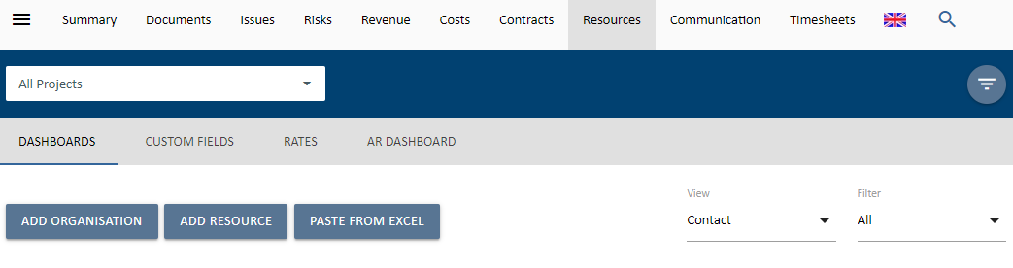
There are several contact fields that you may choose to populate at any time. The only mandatory field that requires input at this stage is the resource Name. All other fields, such as phone numbers, email address, licence type, and position detail can be updated or amended at a later date. Remember to save your new resource details before leaving this page.
Resources can only be added to UniPhi when “all projects” are selected in the Project: filter. If you have selected a specific project, you may only add pre-existing resources to that project. This means, you cannot create resources at the project level.
The access level that your resource will have to the UniPhi system will depend on the licence type that you select. The four licence types available to you are:
- None. No access to your UniPhi deployment, the purpose of this licence type is purely to store your external client information. This information can be used when generating documents, and emailing from UniPhi.
- Team Member. A lower level of access which will allow your team members to see their issues and actions, a view project related documents, and allocate time via their own timesheet.
- Project Manager. High level access to documents, issues, and financials
- Program Manager. Full access to all project information, but no access to structural Methodology and Admin sections
- Administrator. Full access to issues, documents, financials, and admin and methodology sections.

Resources are specified as being Internal or External based on the Organisation & Sites that they are assigned to. (See below for Organisations & Sites)

Linking a Resource to a Site
To link an existing contact resources to a site, simply drill into the specific site, and press the Add Contacts button. Find the site by either using the View dropdown on the far right or filtering for Organisation and then selecting the Site or by directly filtering for Site.
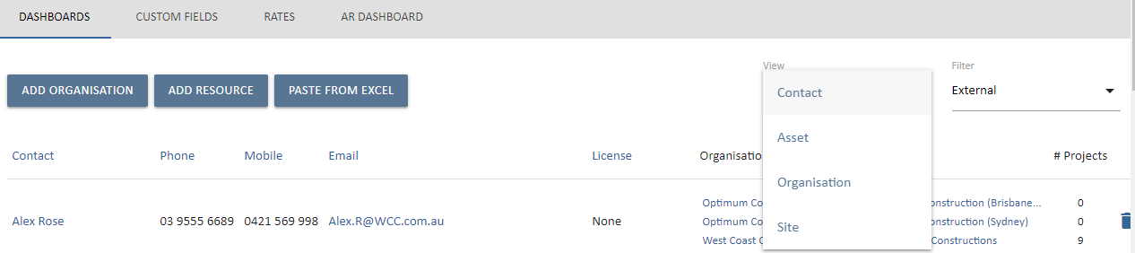
Once the site is selected, use the Link Resource button to search and add an existing resource to the site. You also have the option to create a resource in that page should you wish to do so.
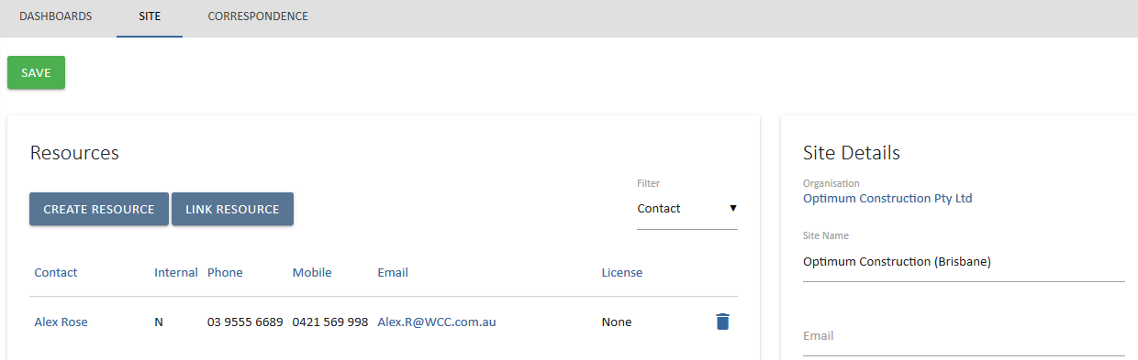

Viewing External Resources
Navigating resource contact information via the Resources tab is quite straight forward. Filters exist to help narrow your search so that if you are looking for a person (contact), you can select the View: People option, and you may also filter for internal or external people.
Clicking onto a resource will take you into the detail screen for that person. Here you will find more of the specific information about the person, and the company (or companies) that they belong to. It is possible to have one contact linked to numerous organisations and sites. Where a contact is linked to more than one organisation, you will need to specify their “Primary Site”.
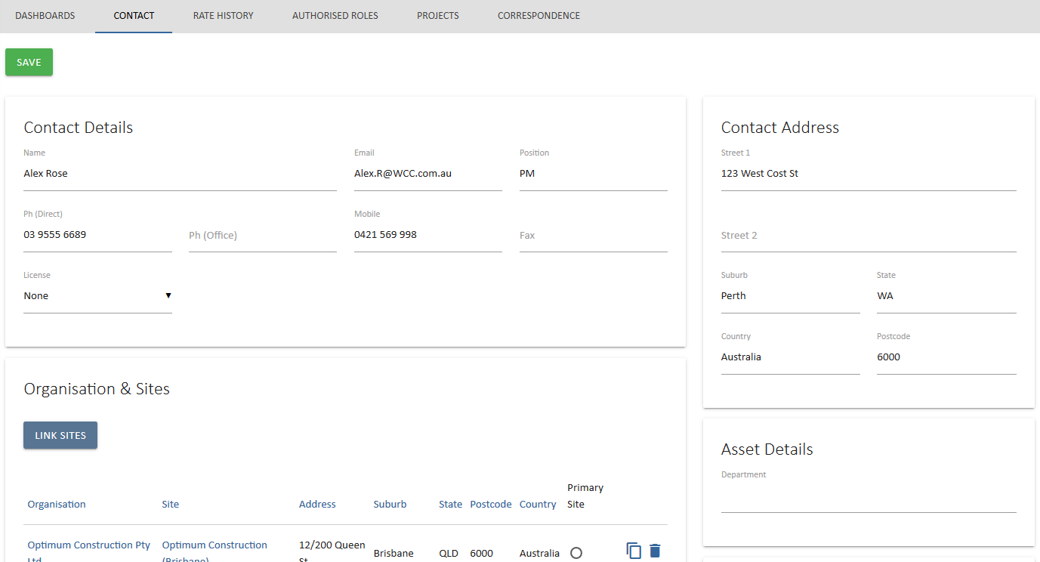
Note: You can also link sites from this screen as well by using the Link Sites button.
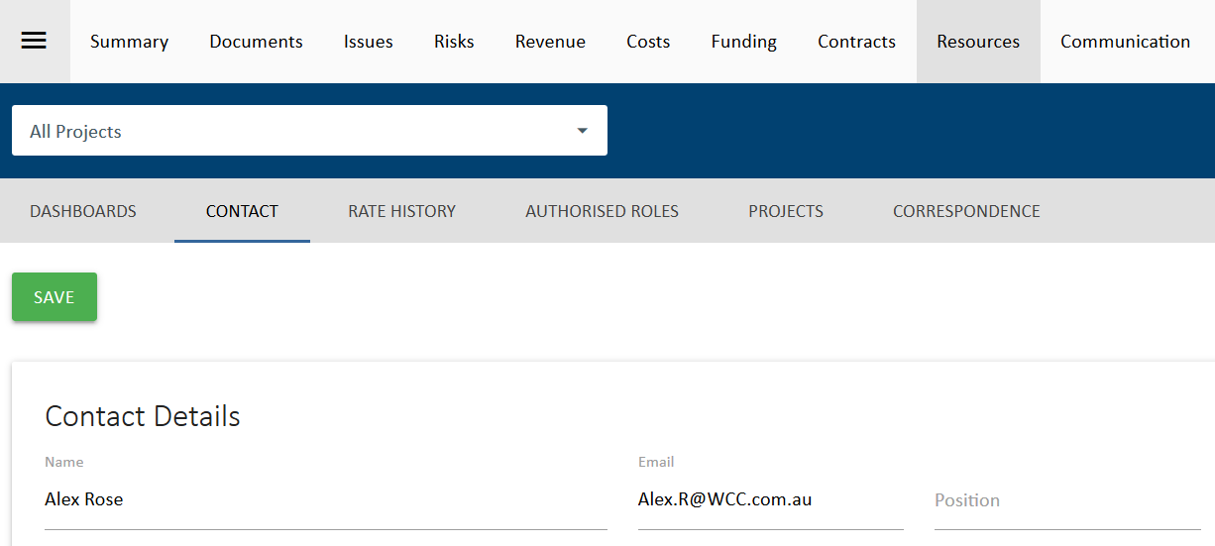The Sub navigation menu for a contact provides access to the following views:
- Dashboards – the resource pool
- Contact – edit and update contact details
- Rate History – for internal resources, review their charge and cost rate history
- Authorised Roles – for internal resources, review the roles they are authorised to be assigned to
- Projects – review the list projects and roles the contact is assigned to
- Correspondence – review any correspondence with this contact

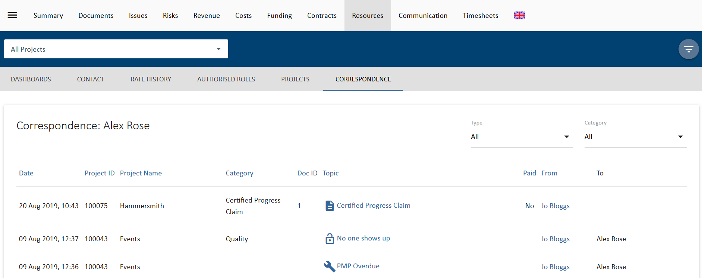
Correspondence
The correspondence panel displays all UniPhi generated interactions that have taken place involving the resource contact that you are reviewing. This correspondence includes documents, issues, comments, and emails. It’s important to note that all communications are displayed here, regardless of their status (e.g. issues are displayed even if they are closed or awaiting review). Items from closed projects are also displayed.
The benefit to using the Correspondence module to locate this information is that it brings all of the information into one place, and eliminates the need to open multiple browser tabs to locate a specific item.

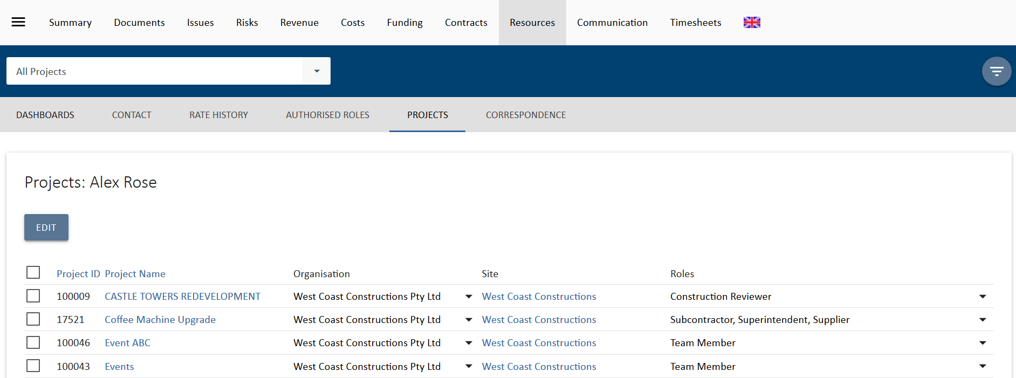
Projects
The information displayed in this view is a useful way to observe which projects a contact resource has been assigned to, and the role that they are performing within those projects.

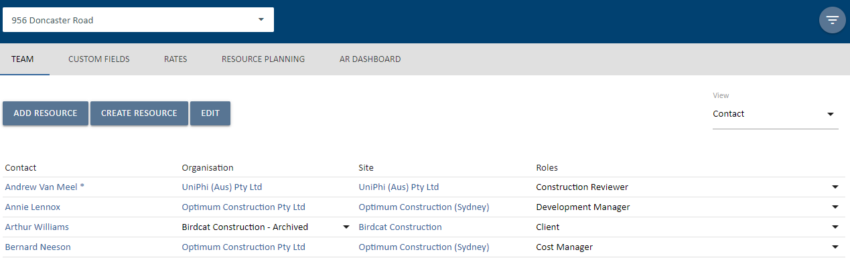Clicking on the project link within this screen will take you to the Project Team resource details tab for that particular project. This view provides a useful stakeholder list, as it displays each resource by name, as well as the organisation and site that they belong to, and the role, or roles that they have been assigned.

Viewing Internal Resources (Staff)
The contact details for internal contacts features the capability to attach a signature image, and an email signature. This information can then be used when generating and transmitting documents and emails from UniPhi.

The signature image is a scanned image of a written signature that is uploaded into UniPhi, which can then be selected when “signing off” a document. The output document has the embedded signature attached, which saves the time and effort of printing a document, signing it, and then scanning it back as a soft copy format.
Attaching an email signature works the same way that most email programs (e.g. Outlook) allow you to attach a predefined email signature. Again, this is a time saving feature as all of your outbound emails from UniPhi will appear with your customised signature information, which may include contact details, and your company logo.

The following sub navigation views may be useful in managing internal staff access to UniPhi:
Authorised Roles
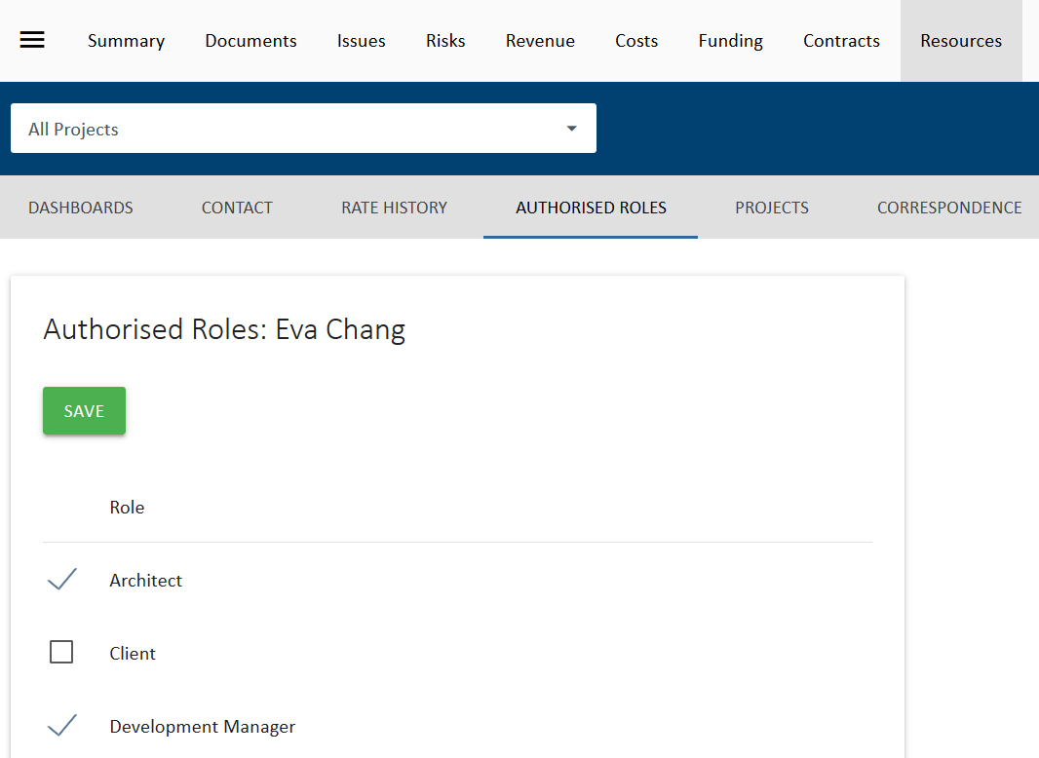
The Authorised Roles sub navigation view provides a list of available roles that can be assigned to a user. If any of these is checked, the user will be limited to those roles on a project. If none are checked, then the role allocation is only limited according to the user’s license.

Projects View for Internal Staff
The Projects sub navigation view provides a number of options for managing an internal user’s access to UniPhi projects.
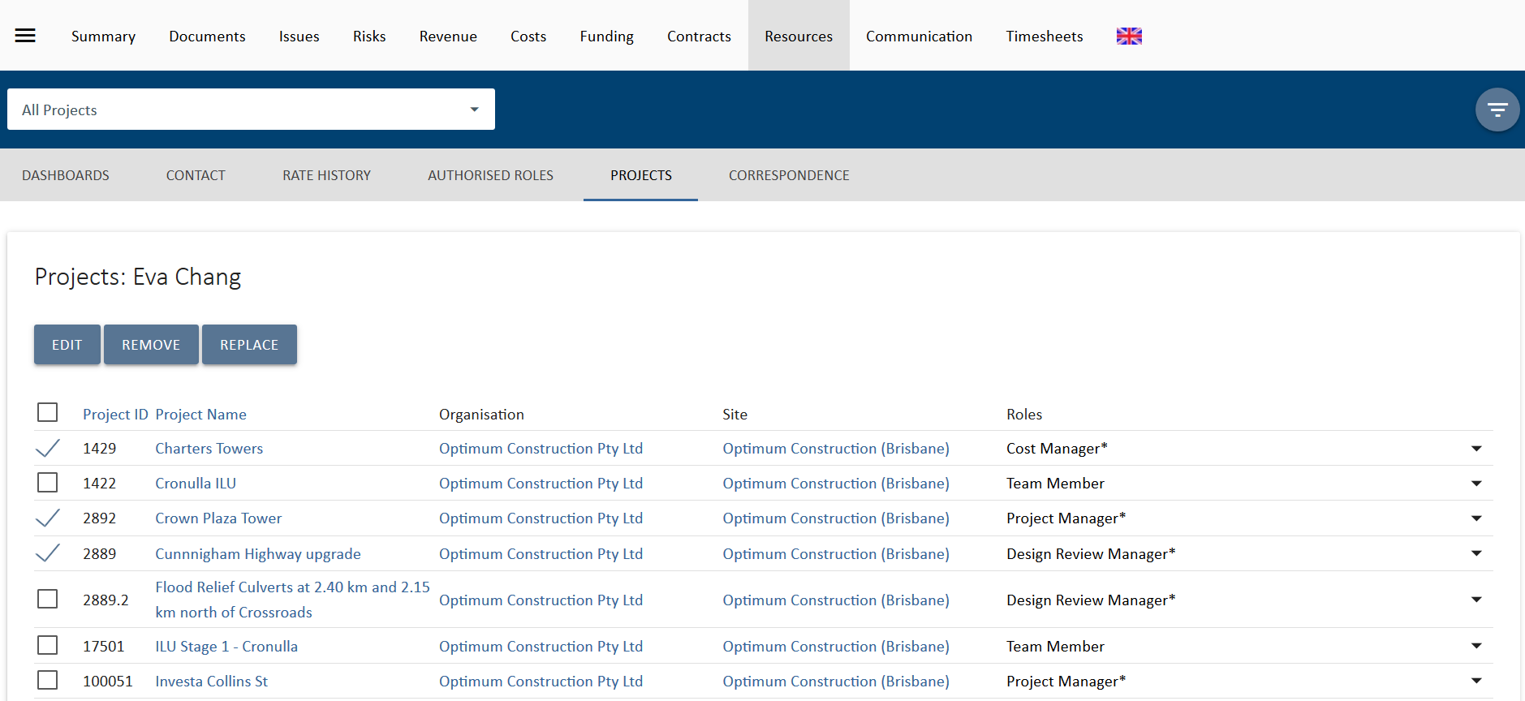

Select projects from the list displayed and two additional buttons will appear, Remove 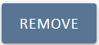 and Replace 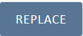.
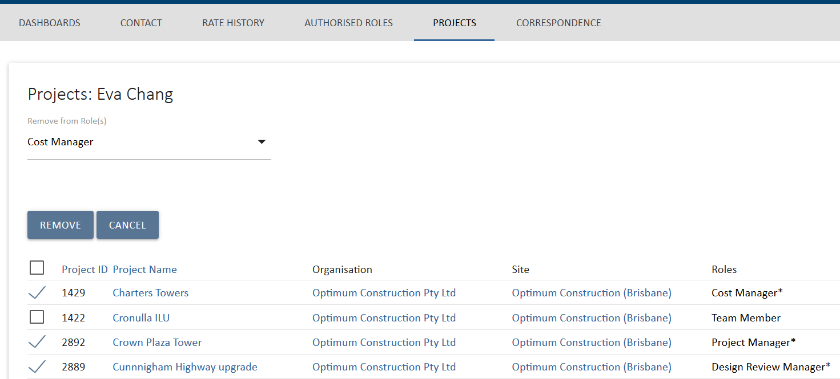
The Remove options provides a drop down to select what roles you want to remove the user from. Select Remove again to complete the task. This option is useful to remove someone form projects after they have left an organisation or changed roles.

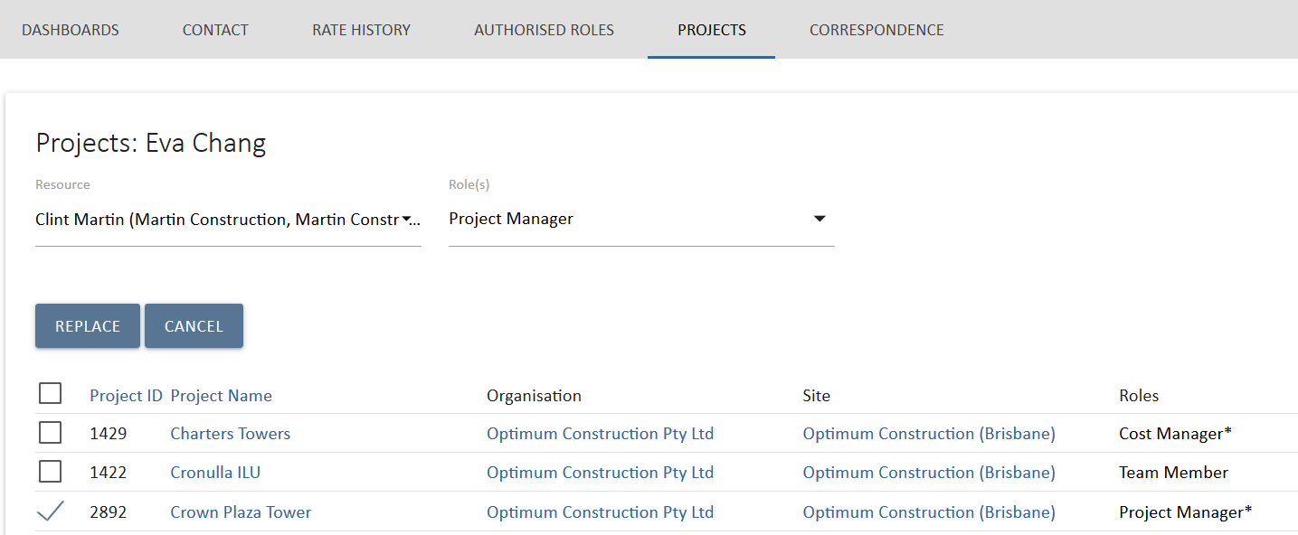
Figure 16 Projects view Replace option
The Replace option provides two drop down lists to select the resource replacing the user and the role that you will place the new user into on the select projects. Select Replace again to complete the task. In the example above, Eva Chang will be replaced by Chris Martin as Project Manager on the Crown Plaza Tower Project. This is useful to replace staff going on leave or when project roles change.
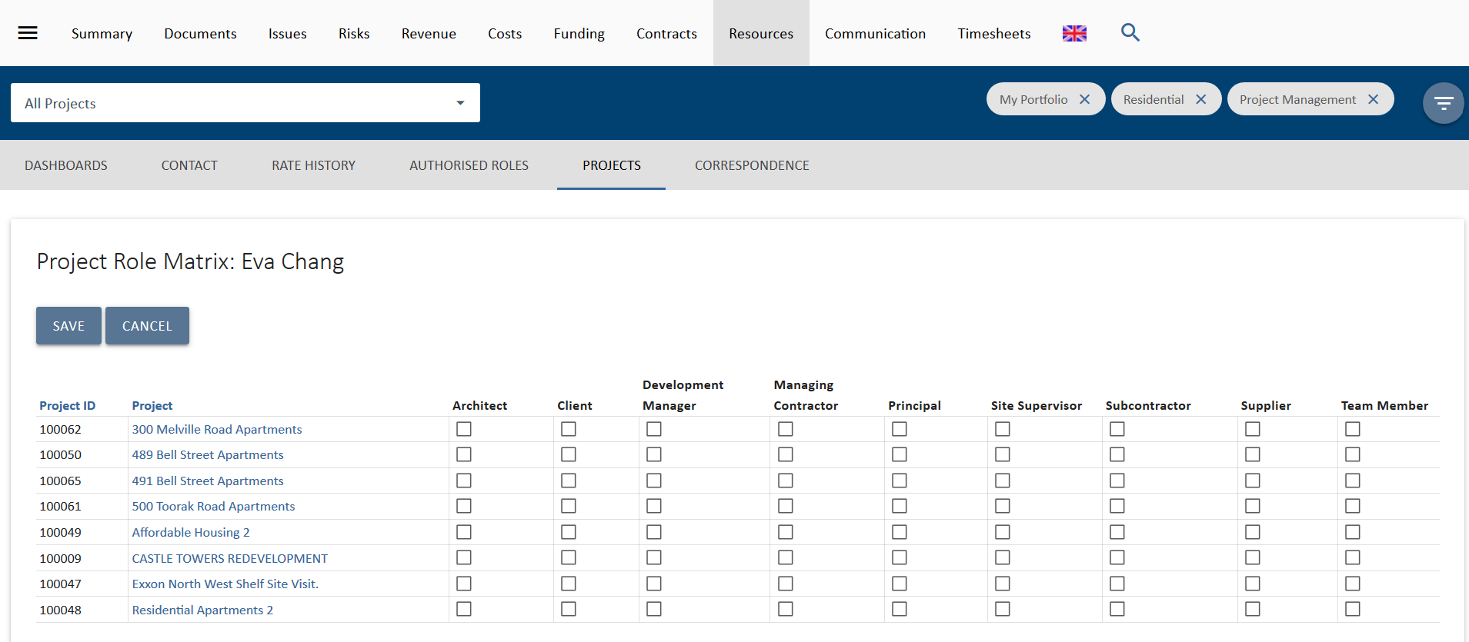
Figure 17 Projects view Edit option
The third option is to bulk edit 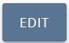 the project and role allocations of the user. Select this and a list of all available projects and roles will display. If this list is too long, you can apply portfolio filters to it. Select the roles and the projects the user needs to be assigned to and select save. You can also deselect them form any existing roles.
This option is designed to quickly add and remove a user to a project or list of projects

Viewing Organisations & Sites
Viewing Organisations at the highest level will display information about all of the Organisations that you have entered into UniPhi. At this high level, you can see detail such as the name of the organisations, the number of sites related to the organisation, and the number of people assigned. Each of the headings are sortable, so you can sort organisations alphabetically, or by the number of assigned sites, or number of people assigned.
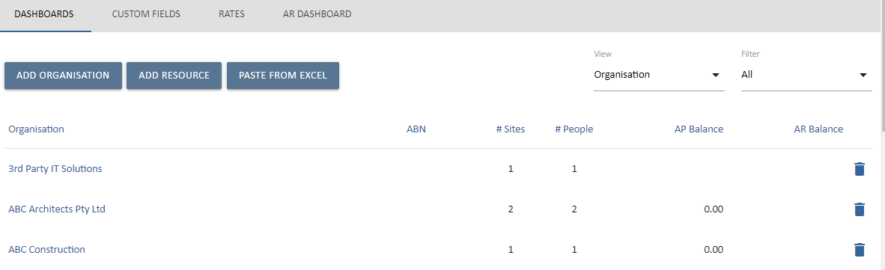
Clicking into an organisation will display the organisation specific information, such as the company website, ABN, email address and the bank details.
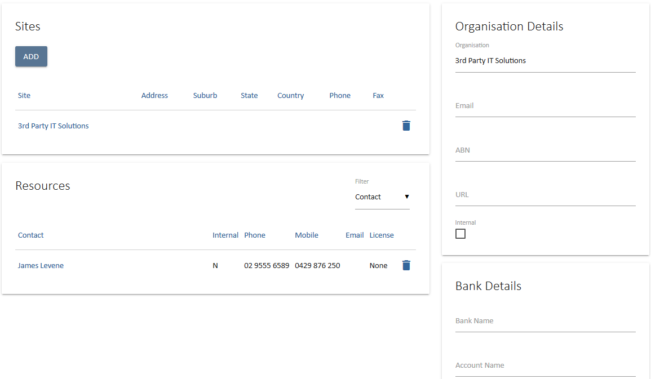

Also within the Organisation view, you can see each of the contacts within the Organisation, their contact details, and licence access type.
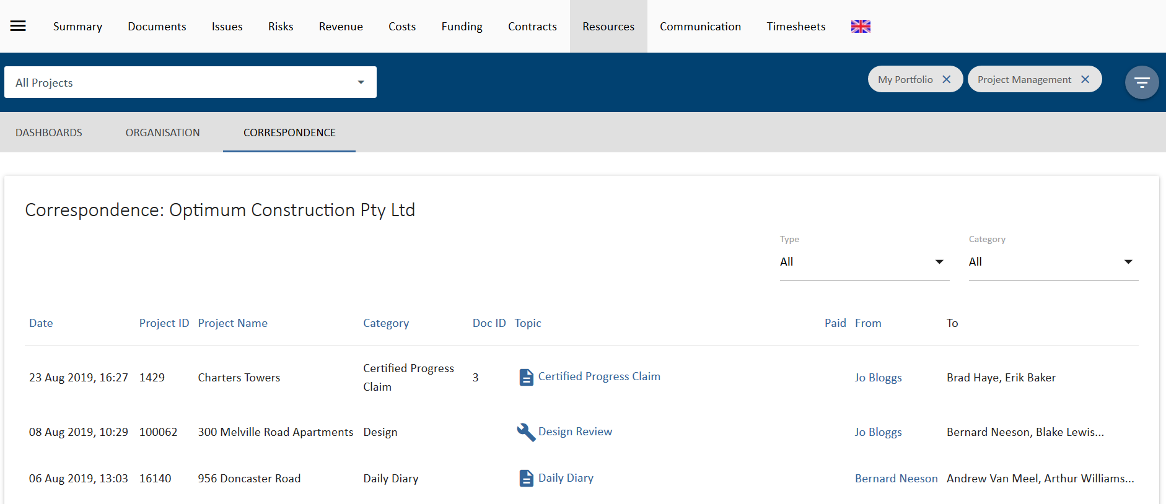 The Correspondence sub navigation displays all correspondence from UniPhi linked to this organisation.
Creating Projects
Projects need to be created and data attributed to provide information that’s utilised at the reports and dashboard level. Each business identifies information to be captured against the project that is utilised in their reports and dashboards.
- Projects are generally created when they require a quote to be generated.
- Creating the project involves entering the name of the project, classifying it (e.g. Sector it belongs, lifecycle phase etc.), assigning resources and estimating the timeline for the lifecycle phases.
- Most projects are created in a pre-sale phase (e.g. submissions)
- Creating the project in this phase allows for UniPhi to calculate win/loss rates by tracking which quotes move to a post-sale phase and which move to a completed phase without entering a post-sale phase (e.g. withdrawn)
Each lifecycle phase contains two start and end dates per phase, a baseline and an actual/forecast. The baseline dates enable you to measure actual and forecasted progress versus original schedule.
Creating New Projects
- Select Summary tab and make sure “All Projects” is selected from the Project filter.
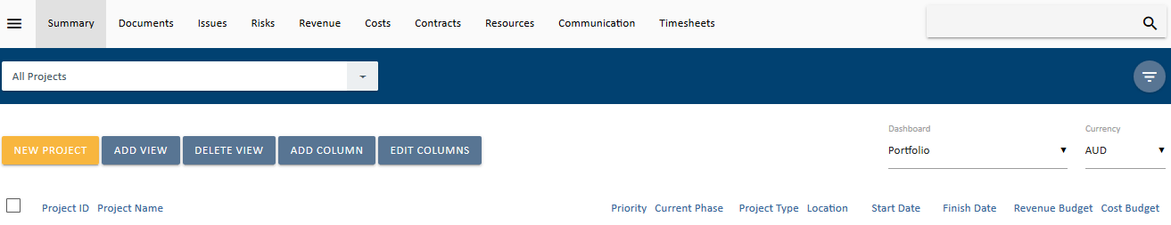
- Click 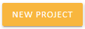 and following form will appear:
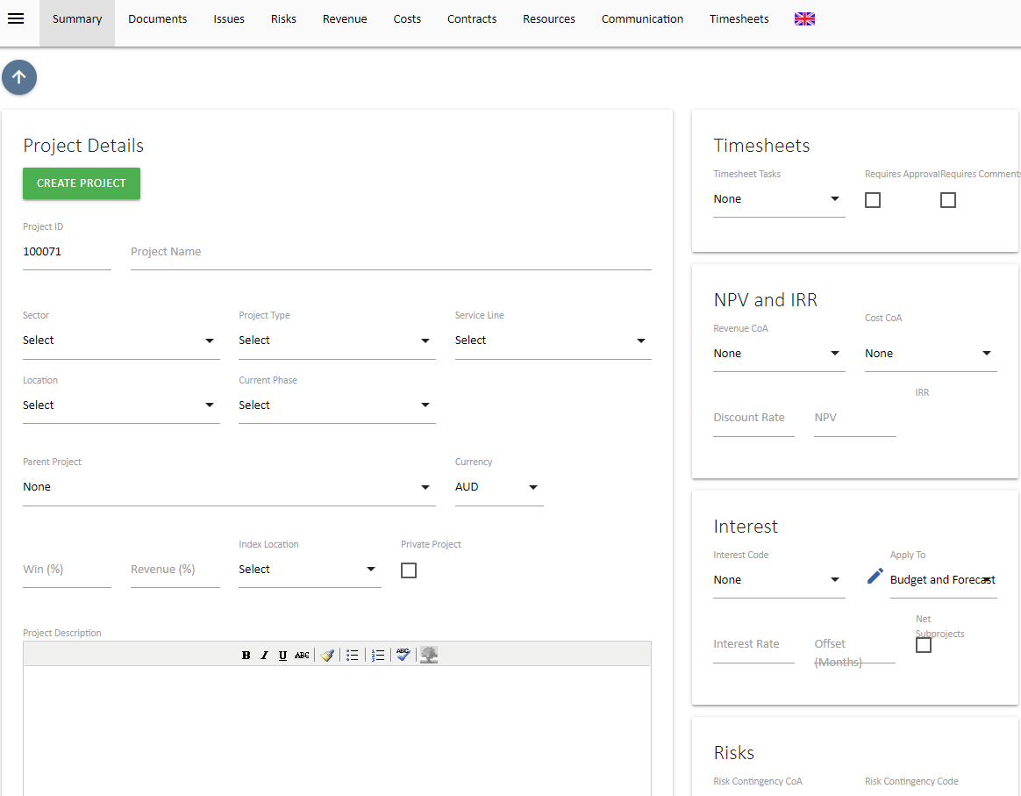
- Fill in the following fields, Project Name, Sector, Project Type and Current Phase. A Project ID is generated automatically. The remaining fields are optional.

Optional Fields: Not all fields are relevant to all projects / portfolios and some can be ignored. If a mandatory field is left blank, you will be notified with a red warning message. The only mandatory fields are the fields listed above at point 3. Note however that if no resources are added to a project then an administrator will need to add resources once they are known.
Priority: Companies can devise their own Project Prioritisation Framework which the user creating the project can complete to establish a projects’ priority. The prioritisation framework is displayed at the bottom of the create project screen. If you complete the Project Prioritisation Framework the result will automatically populate in this field once the project is created. Alternatively you can enter in a priority manually. Project prioritisation allows team members to make discretionary decisions over work that needs to be completed at the same time. Knowing which project has a greater priority to the organisation can assist in the decision making, reducing the management time required to review and prioritise tasks.
Private Project: If this box is ticked then only resources assigned to the project can view it. Extreme caution should be used when choosing to make a project private as it makes the project “invisible” to anyone not assigned to the project.
Win %: As explained in the introduction to the session, projects are generally created when a quote or proposal is required. When Revenues, costs and hours are estimated, UniPhi will automatically adjust these Revenues in reports by the win % allocated to the project. The win % represents the probability that the organisation will win the job. The end result is a risk adjusted resource plan and cash flow forecast for the business. Win/loss ratios displayed in the Submissions dashboard can assist the user in determining a value for this particular field.
Revenue %: The Revenue % functions the same as the win % thereby compounding the risk adjustment factor. The Revenue % adjustment reflects the likely reduction in Revenues that will occur through contract negotiation phase.
Project Description: This can be used to pre-populate documents and will explain the scope of the project to other staff members who may need to work on it. The project description is designed to provide more detailed meta-data on the project.
Currency: UniPhi supports an unlimited number of foreign currency translations. The currency selected by default in these tabs is based off the default selected here. It can be changed by the end user if they wish to see the end results converted into other currencies.
Risk Contingency COA: UniPhi’s risk management module allows for the build up of a dollar value for risks in the project cost budget. Risks identified have contingency values allocated to them. The total of which is then transferred to the project budget via the relevant contingency code selected. Risk contingency dollar values are applied to costs, not revenue, so this is only relevant when managing a project cost budget. The code list available is all code structures that have “Contingency” codes flagged in their chart of accounts
Risk Contingency Code: The account codes that have been flagged as contingency codes in the chart of accounts selected are displayed here. Selecting one code will provide for a default code selection when creating risks. This default can be changed for each risk identified but the default selected here should be the most common contingency code (e.g. construction contingency).
Parent/Child Project Relationships: UniPhi allows for a program of works within a portfolio to have an unlimited number of “child” projects underneath it. This is managed through selecting the Parent Project that the newly created project belongs to. Parent projects will consolidate budgets and contract costs and revenue for all children allocated to it. The Parent project will also display issues and risks that exist across the program (i.e. within each child)
The resulting project filter will look like this:
Parent Project: This is a list of all the projects in the system that have been flagged as being a parent as per the above method. Selecting a parent project will make the current project you are creating to become a child project.
Timesheet Tasks: defaults to a predetermined list that is visible to add work hours against the project when time sheeting. Standard tasks are used when work is completed on a project without specific contract deliverables. Examples of this type of work would be support work for a product that has been already commissioned or project management during a defects liability period in the construction industry.
Requires Approval: If timesheets on the project need to be approved before submission then this is selected.
Timesheet approval in UniPhi is based off the access level of roles on the project. If a project role has a project manager access level (as opposed to a team member access level) then people in this role are able to approve other people’s timesheets.
Rejecting a timesheet reverts the timesheet back to a “saved” state rather than a “submitted” state. The team member can then amend and re-submit for approval.
If timesheet approval is not selected then timesheets can still be reviewed in both the contracts tab and via reports.
Timesheets can be “rolled back” to allow the team member to correct any errors, and re-submit. Only submitted hours are displayed in the contracts tab, while saved but not submitted hours can optionally be displayed in the timesheet reports.
Requires Comments: Select if daily comments next to each task are required for successful submission of timesheets. If this is selected, staff will not be able to submit their timesheets unless they have entered text in the comments field.
Assigning Resource: The next panel is for adding resources. It is highly advisable to add at least one resource to your newly created project.
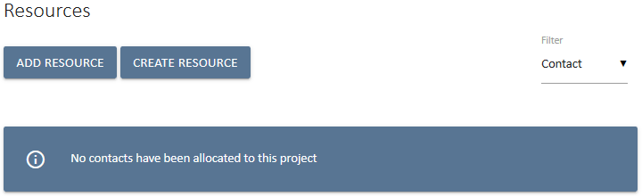
Resources are allocated to roles on the project. Below is an example list of roles in UniPhi – these are configurable by each business.
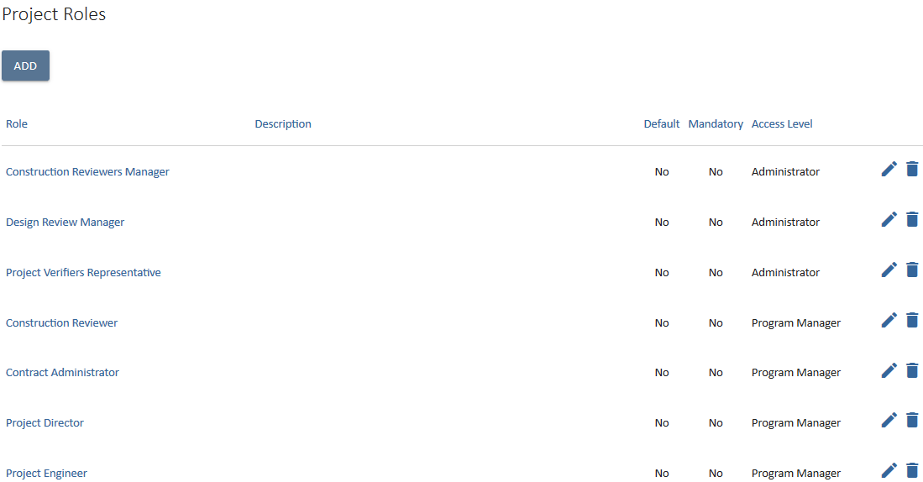
People in different roles have different access levels which controls what people can enter and manipulate in UniPhi.
Companies can determine what functions can be performed by resources at certain roles / access levels. For example it may be that only project managers can assign additional resources to a project, create contracts and estimate effort – if this was your company and your project, you would need to be in the program manager role.
Internal resources are staff members and external resources which are people outside the organisations such as clients, suppliers and company contacts.
UniPhi can manage your contracts for both clients and with suppliers. UniPhi determines the type of contract by the person allocated to the supplier role in the contracts system.
Resources can be edited (i.e. you can add or remove resources) throughout the life of the project.

Copy a Project
UniPhi allows you to copy an existing project instead of creating a project from scratch. To copy a project:
- Select the project that will be copied.
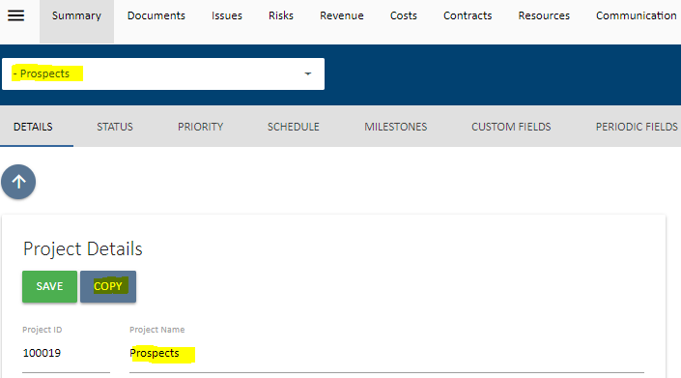
- Click on the copy button as highlighted above. You will be presented with a form as shown below:
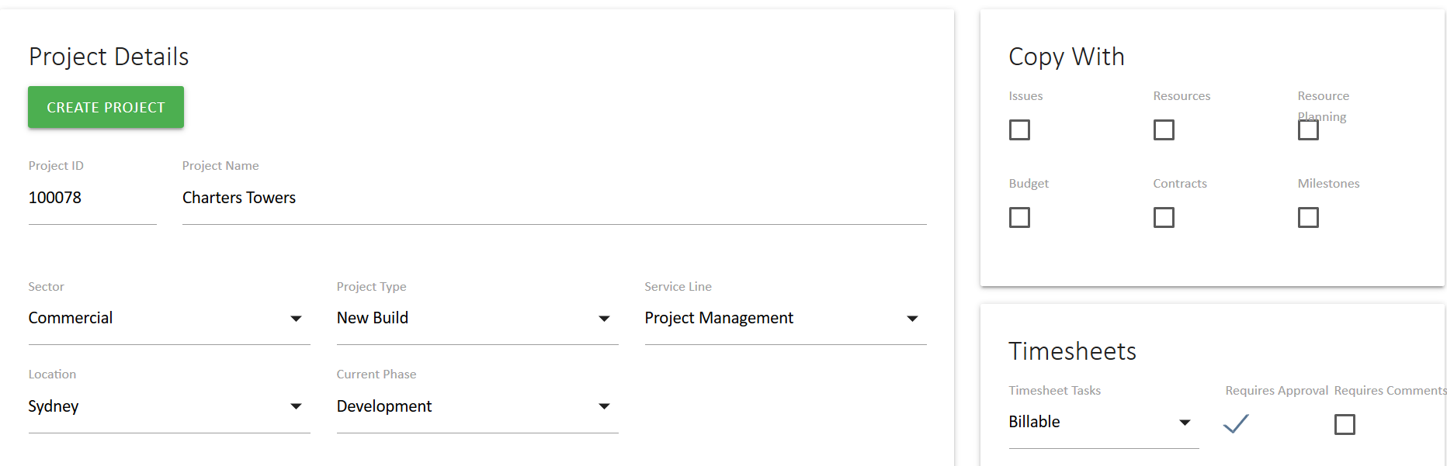
- When copying a project, UniPhi allows the new project to also have a copy of the following items from the source project; Issues, Resources, Resource Planning, Budget, Contracts and Milestones.
- Should you wish to copy any of the data above, simply check the box under each label.
- UniPhi inherits the filters (sector, project type, service line, location and phase) of the source project. Should these need to change on your new project, you may make the change now.
- Once all the project data has been confirmed, and the project has been resourced, click on 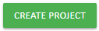

Adding a Resources to a project
- Select the 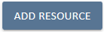 button in the Resources box, select Internal or External from the filter. You may now scroll up or down to locate the resource you are looking for, or you can search for the resource by name. Once you have found the resource, simply highlight their name, and assign them into the role, or roles that they will perform on the project.
. 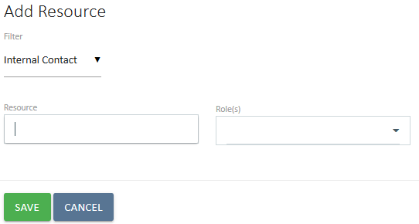
- Select 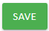 to add the resource.

Adding and Deleting Roles to existing Resources
Adding Roles: You can assign additional roles to a resource at any time. Select the Roles dropdown to the right of the resource and select the role you want to add:
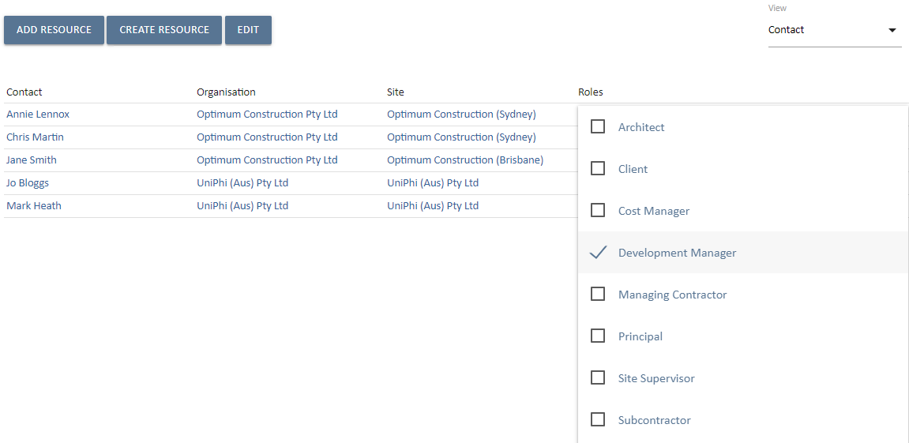
Deleting Roles: To delete a role you have added to a resource, select the dropdown button next to the role you wish to remove and untick the box.

What if my resource is not in the list?
If a resource is not shown in the resource list you will need to enter them in to your resources database. Use the 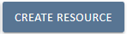 button as described in the next section, Resources.
Creating the Revenue Estimate

Revenue Budgets
When a project is in its early pre-sale phase, an estimate of the potential Revenue can be made in the Revenues tab. The Revenue budget screen has an “N” level code structure which allows Revenue estimates to be structured to the appropriate level of granularity. By default, the Revenue structure as defined in your Revenue Chart of Accounts will be displayed. :
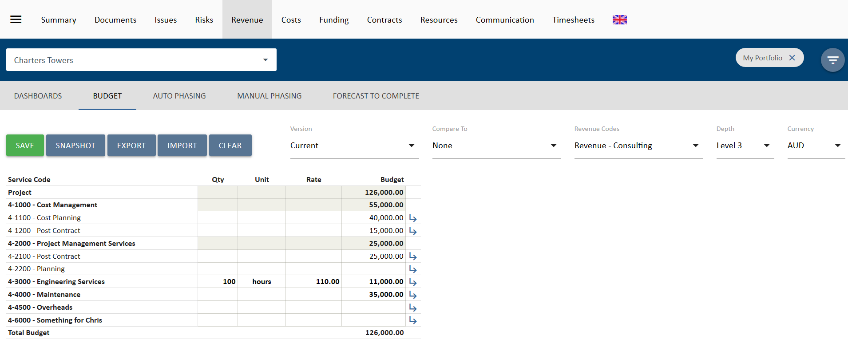
The Revenue budget system has three value fields (Qty x unit x rate) to capture each line item’s quantity, unit description field, and a rate. Data can be entered into these fields to determine a quick estimate of the potential Revenue or a total can be keyed in under the budget column if the estimate has been calculated in another system.
If the structure that is shown by default (i.e. your Chart of Accounts) does not provide sufficient detail, you can expand on the relevant code by pressing the arrow, and adding in the required detail:
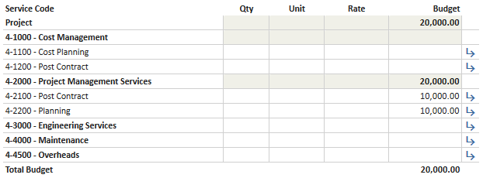
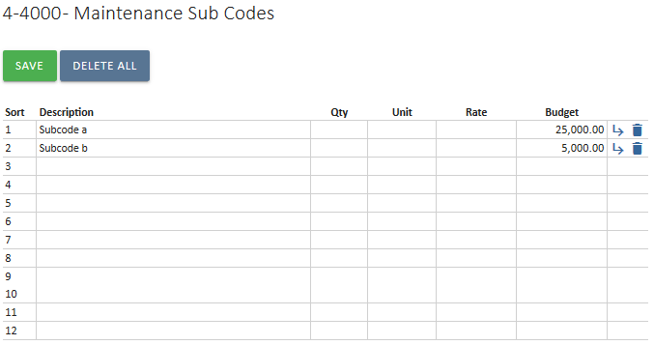
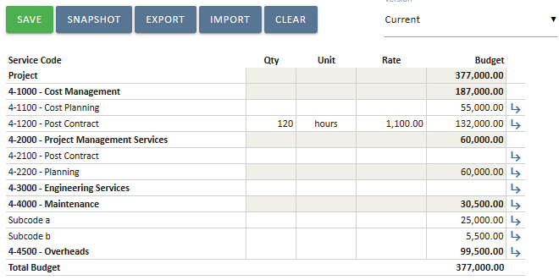

Revenue Phasing
The Revenue can be phased by clicking on the Manual Phasing sub navigation view.
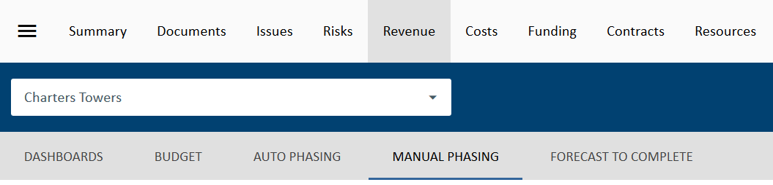
The resulting screen will be displayed:
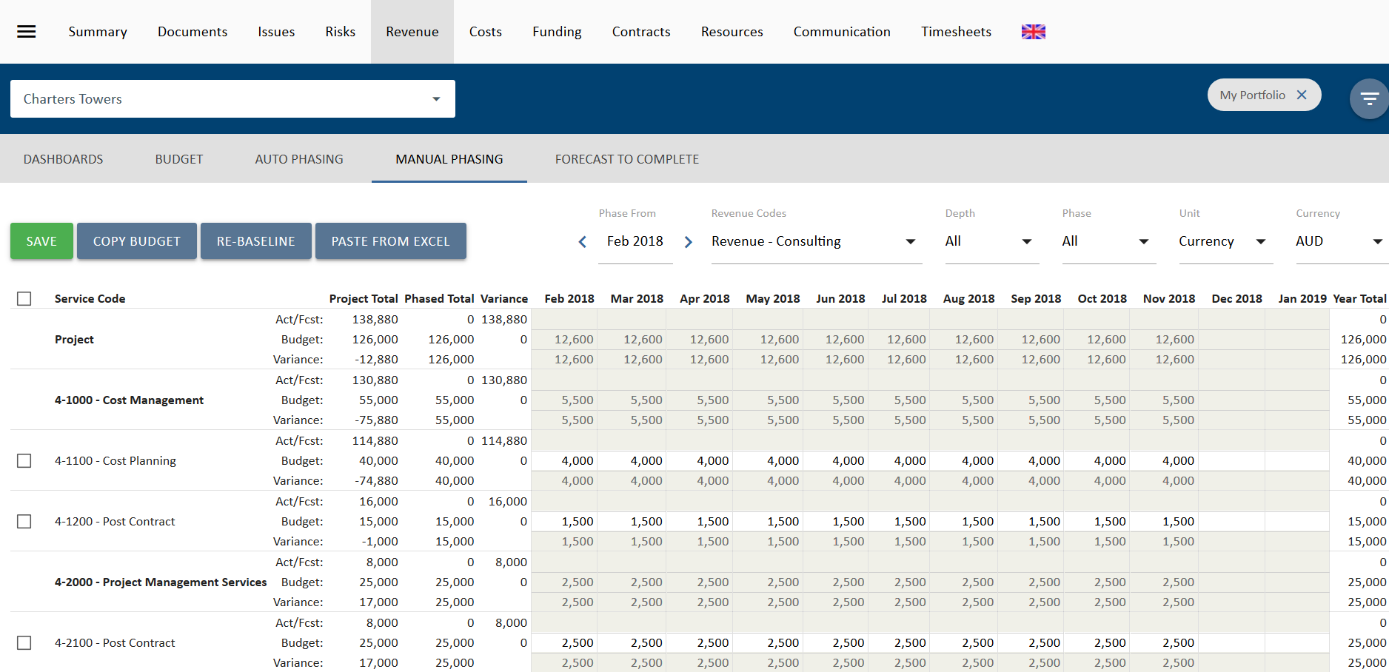
Revenue phasing can be done on a linear basis within the Revenue budget system by clicking on the Auto Phasing sub navigation view or manually by typing in the amounts or percentages month by month.

Auto-Phasing Revenues
The Auto-Phase view allows for phasing forecasts or budget for selected account codes over a date range, a specified time period, or by benchmark data, as per below:
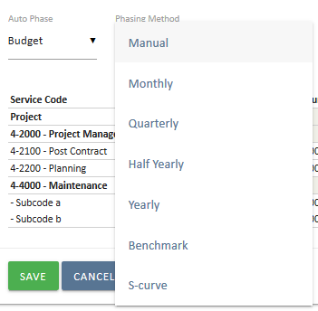

Manual Contract Phasing
To manually phase select a contract and then the Phasing tab on the navigation bar.
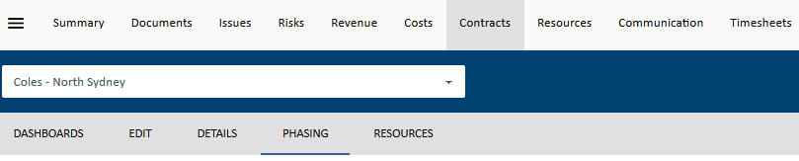
The fields are editable as they are not greyed out. You can see the Contract total in the left hand side.
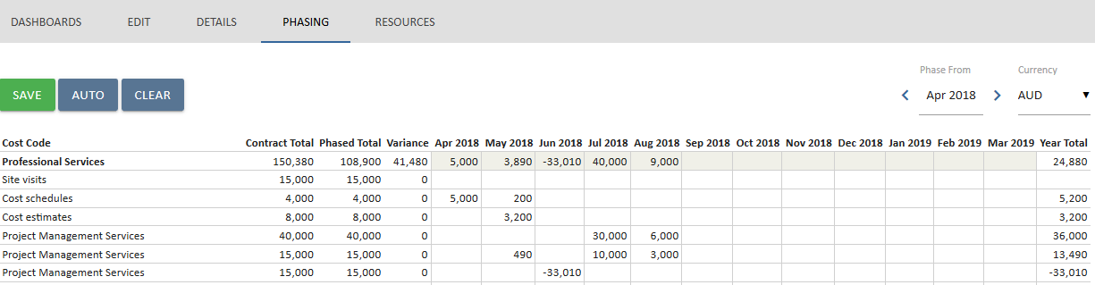

Enter in the values over the time period you need.
Select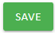and the phased total will be displayed. If you need to select another financial year you select the year ending drop down and continue to phase.
Select once you have finished.
The overall Revenues are displayed in the Revenue tab and by selecting the Revenues tab you will see a view similar to below providing a breakdown of the cost codes and amounts. You can select for financial year of ALL years to see whole of project.
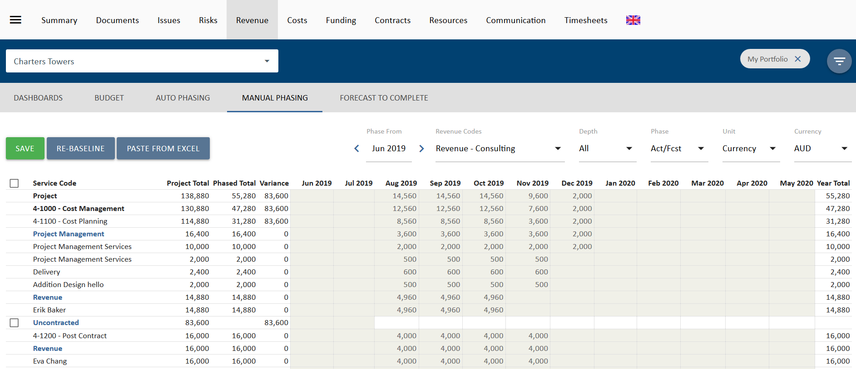
Once the revenue has been phased, this information can then be copied to the forecast line using the 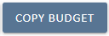 button.
It may be worth creating a snapshot of this estimate from time to time so you can track how the Revenue changes over time. To do this, click on the 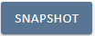button. Enter in a description and click save.

Estimating
New quotes and proposals can be estimated in the contracts system. Each deliverable estimated is mapped to the Revenue codes used in the previous section thereby updating the forecast Revenue for the project.
Creating Revenue estimations
Filter for the project you wish to work on via the Projects filter
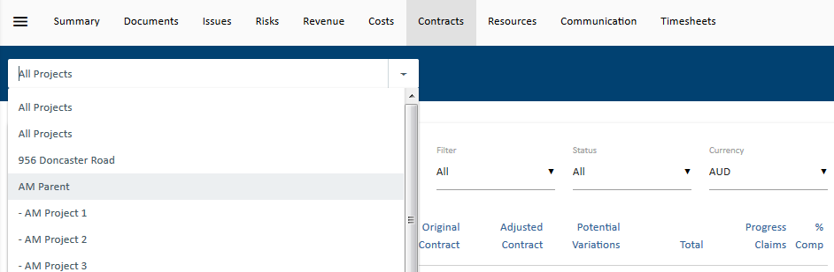
Go to the Contracts tab and click on the 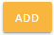 contract button and select the Revenue contract to build your Revenue estimation
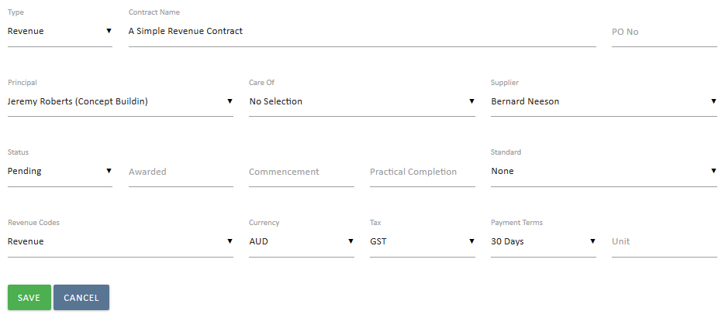
The following items are compulsory on the contract form to enable the contract to be created:
Type - used to select if the contract is a Cost or Revenue contract. For Revenue estimates the type is always revenue. If revenue is selected then internal resources will be available in the supplier field, while external contacts will appear in the Principal Field.
Contract Name – the name or description of your contract. This can be similar to the project name but may distinguish the type of service or product being offered in addition.
Supplier – this is the person who is lead contact for the company responsible for the deliverables.
- If the contract is a revenue contract then you are the supplier and a list of internal resources who have been allocated to the project during the project creation step (see previous session) are available for selection. Select the person who is responsible for client liaison for this project. This is a searchable field, so just type the person’s name and select them.
Status – The status reflects on the stage a contract is at.
- Pre-award or pre-sign-off a contract status can be set to Pending.
- If it is accepted by the client it is moved to an Active contract status.
- Once the work is complete it becomes Expired.
- If the contract isn’t awarded then it is Cancelled.
Revenue Codes or Cost codes – Chart of Account codes that each deliverable is applied against to track an overall Revenue.
- This is how the contracts module integrates with the Revenues and costs module.
- The Revenues and costs module display consolidated figures for all contracts on a project as well as for all projects in a program or portfolio. These figures are derived from the codes allocated to deliverables and variations in the contracts module.
Select 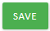 once you have added in the compulsory fields above and this takes you into the body of the form for deliverable creation.
The following are optional fields for the contract creation stage:
Principal – The principal is the contact person within the organisation that will be liable for payment of the resulting contract services. For revenue contracts, this is the client to whom you are quoting. (However, a principal is required to be entered so you can raise invoices or progress claims). This is a searchable field, so just type the person or company name and select them.
Care of – used if someone else is responsible for approving invoices for payment and hence need to be addressed to this person/company. This is a searchable field, so just type the person or company name and select them.
Awarded – Date the contract is won / approved and moved to Active. This can be a forecast date which will be useful for forecasting purpose
Commencement Date – the date the contract will start (if known) or started as per the contract document. This can be used to drive the deliverables schedule. Changing the commencement date changes all the deliverables by the same difference in the change. For example, push out the commencement date by one week and all start and end dates in the contract are pushed out by one week.
Practical Completion - Expected date when project will enter defects liability. (As lawyers can’t decide what this term means we leave it to you to decide). If not a construction job then this is the date that all deliverables will be completed.
Standard – The contract standard drop down displays standard Australian contracts. The selected value allows you to nominate the Australian Standard or General Condition contract that will be used to administer the project. This is purely for communication purposes so that others will know what type of contract you are administering. Your administrators can add in additional contracts if they are not displayed in the list.
Unit – This box allows for a default unit for time and material type deliverables. If the contract deliverables is long but the units are the same (e.g. days or hours) then typing in a default value here will result in each new line will have “days” or “hours”
Currency - this represents the currency the contract will be quoted and awarded in. UniPhi will convert the currency if it is different to the project currency when displaying the values in the Revenues and costs tabs.
Tax – defaults to GST but can be set to None if appropriate. Once the contract is saved it will now appear with additional details;
Related Templates – These templates are contract related templates. Each template will derive information from the contracts system
Billing Details – When you select a principal, their address details will be displayed here. If you have also selected a care of then the company name of the principal will be displayed and the address and attention to for the care of will be displayed underneath.
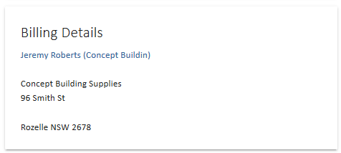

Creating contract deliverables
These are the building blocks for creation of the contract you are managing and will provide you the overall total. Deliverables are used to raise progress claims or invoices for your clients.
Contract Deliverables window – this is where you enter in the deliverables (services and materials etc.), assignments, dates and rates for the contract.
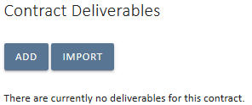
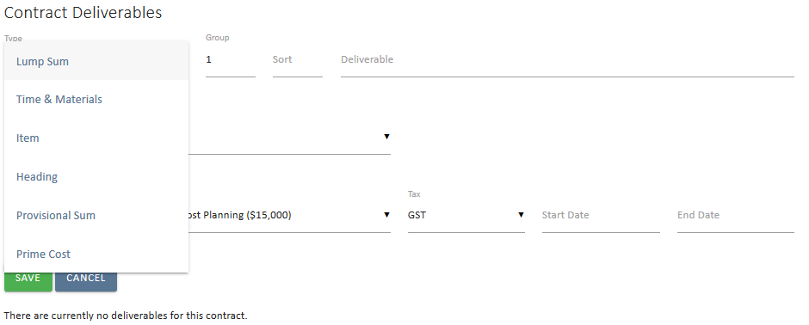
Deliverable Types: There are a number of different deliverables types and these are explained below. Please read carefully as the different types available depend on the client and your requirements.
Lump Sum – This is used when the contract is fixed price and will be progressively claimed against over time. Items classified as lump sum can have resources assigned to the deliverable. These assigned resources will then see the lump sum deliverable within their timesheet tasks. This means you can then have staff timesheet to the actual deliverables and track consumed time versus planned.
Time and Materials – This is when invoicing will be done based on effort multiplied by a rate. You will need to enter in a Quantity, Unit and Rate for each deliverable noting that the unit can come from the default unit set for the contract (as explained above).
Item – This type is selected when disbursements are included in the value of the contract. As disbursements are not progress claimed but claimed 100% in one invoice, they are differentiated in the list from lump sum deliverables. An item amount will not be included in the Agreed Revenue column of a “Lump Sum” view when rendering an invoice.
Heading – This inserts a heading rather than details. Please see next page for more details on Heading types and their purpose / use.
Disbursements – If disbursements are not included in the contract value then use this option when invoicing as the disbursement items will appear in the invoice but will disappear from your contract admin screen and will not be included in the agreed Revenue of the project (They will be included as revenue for the project though).

Heading Types
Heading types relate to the way information will appear in documents. Contract deliverables can be automatically included in proposals as work activity, contracts as schedule of works and invoices. The type of heading used will affect the way the information is presented in the final document.
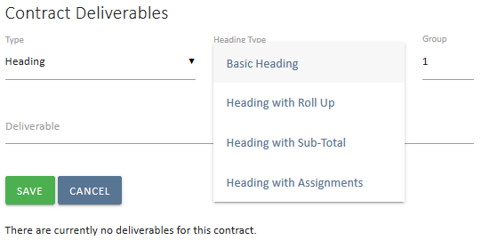
Basic Heading – Does no more than a normal heading in word
Heading with Roll-up* – Sums up the group of deliverables with the same order number and displays the heading line in documentation rather than the detailed deliverables underneath
Heading with Sub-Total* – Adds a total automatically in documents to the group of deliverables that have the same order number
Heading with Assignments – Used when a time and material deliverable will have multiple resources working on it. Note, this can be used as a way of calculating and tracking the lump sum value of a contract as only the heading is displayed in invoices and the layout option “lump sum” can be chosen in the invoice to layout with Agreed Revenue and previously claimed headings.
* The system knows what tasks to include under the roll up heading or sub-total heading by the Order ID. Giving deliverables the same order id means that they will be included in the same group as the heading with this order id.
Heading with Assignment or Time and Material:
- For tracking specific resource costs and revenue, it is always more efficient to use time and material when adding resources.
- Use the multi select for multiple resources then an assignment heading structure will automatically be created with the dates and codes for the deliverable automatically applied to each resource.
- Default rates will also be displayed for the resources selected based on the rates allocated to them in the resources tab.
You will notice a plus sign appears next to the deliverable description. This is for adding resources to the deliverable.
You can continue adding Headings with Assignments deliverables or add assignments/resources as you add each Heading with Assignments.
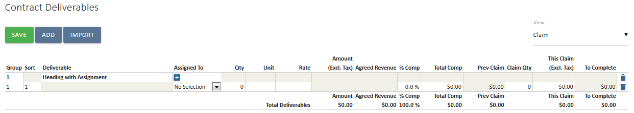
To add assignments, click on the 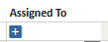 icon and an extra line will be displayed as per below. Select the resource and a Qty, Unit (if not set in the contract details above) and Rate (if this has not been set in Resources tab). 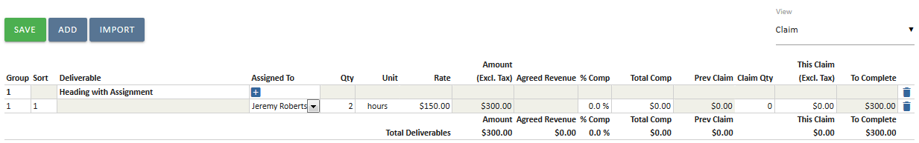
Screen layout on contract deliverables panel: Left = contract, right = invoicing
Everything to the left of the vertical line is contract information. Everything to the right of the vertical line is for invoicing.
Time and Materials Deliverables
These enable you to enter in a description and select a resource and quantity. Unit and Rate will be automatically populated with the default contract unit and the cost rate of the resource. These can be amended.
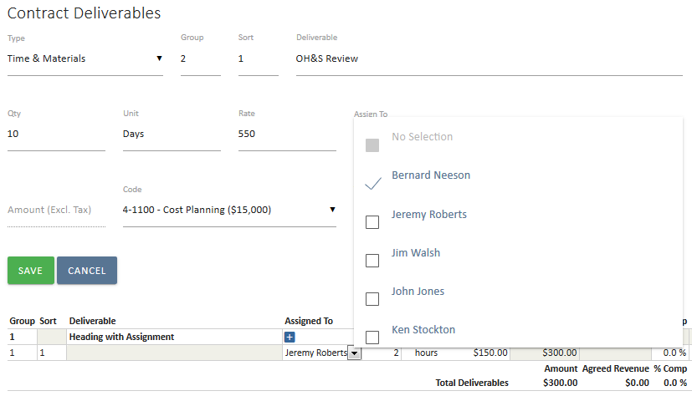
Entering start and end dates are optional but does impact on other elements of the system. The end date will be displayed in the timesheet of the resource assigned to the task and the contract invoice schedule can be automatically phased based on a linear model for each deliverable.
Lump Sum Deliverables
Allows for lump sum items to be captured within your project. Click the icon and a form will appear as per below. Select the Type dropdown box and then Lump Sum:
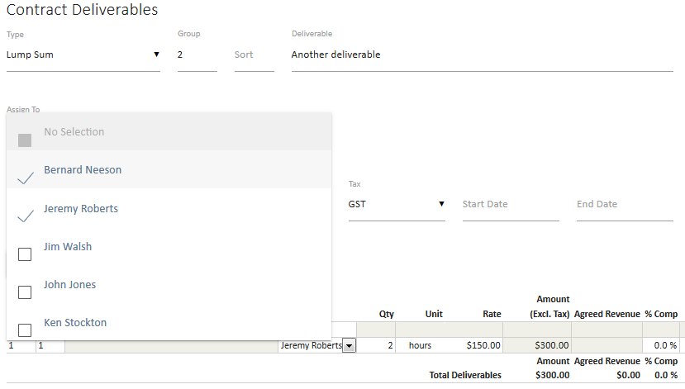
Use the multi select for multiple people to be assigned to the lump sum deliverable. It is also possible to add additional people by pressing the Add button and selecting people from the drop down list
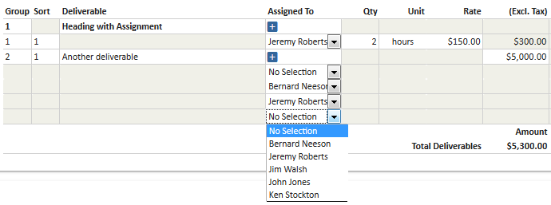
Click 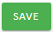 when you are finished adding all deliverables and the contract total will be displayed at the bottom.
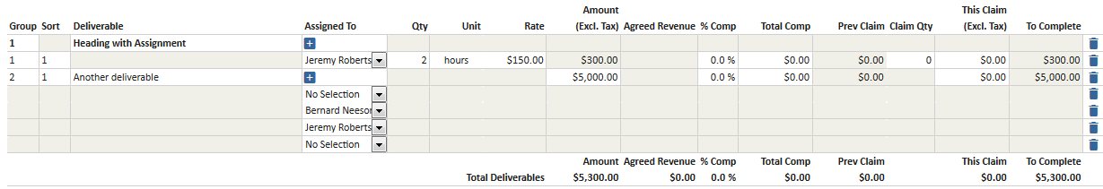

The Agreed Revenue
The agreed Revenue is populated when a contract document is signed off. It is always static text that can only be updated by signing off a UniPhi document that has been flagged as being the contract document making the contract deliverables a committed cost to the client and an agreed Revenue between the parties.
Large contracts and pagination
If your contract has more than thirty lines (including assignment lines) then it will paginate, or span multiple screens. The total displayed at the bottom of the deliverable list is always for the entire contract, not for the page. To view other pages, click the page number at the bottom of the panel. To see all, click All, but note this will take time to load. The best view to see all of the tasks is the “Accounting” view as it has less fields to display (see below for more on different contract views).

Contract Views
The system has four different views which (except for All) provide a subset of the data entered. This is due to the large amounts of data that can be captured in a contract. These views are All, Accounting, Claim and Schedule.“
The View filter within the contract provides options to change the view and you can add in data start and end dates against deliverable, amend GST and cost codes, and raise progress claims.

All View
As the name sugges, ths will display all fields. It is useful to get the compete picture for your contract such as claimed amounts, CoA codes, and start/end dates. As this is an extensive view, the data may be quite wide and requre yout oscroll to the right in order to see all of the information
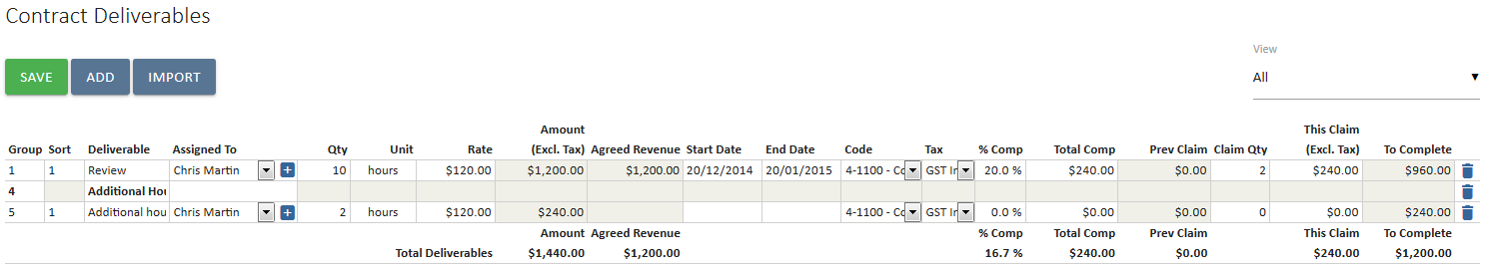
Claim View
Claim view is the default view and displays everything except account codes, GST selections and start and end dates. This view is used for raising invoices. Everything to the right hand side of the vertical line relates to progress claims to date. Each invoice will have its own claim quantity and over time the total hours will increase.
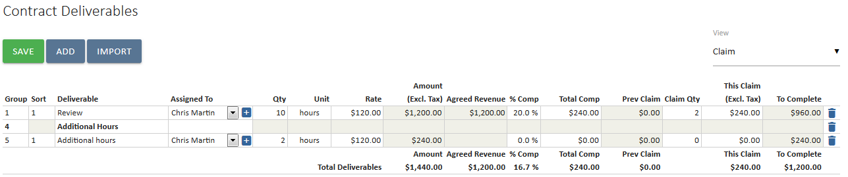
Schedule View
The schedule view enables you to capture expected start and end dates for deliverables. This will flow through to the lifecycle schedule and allocated hours per resource over this period. By capturing this information it is possible to get an understanding of forward workload for staff and identify where over allocation issues may exist. Note, it will soon also be possible to display a Gantt of this information for your client’s benefit.
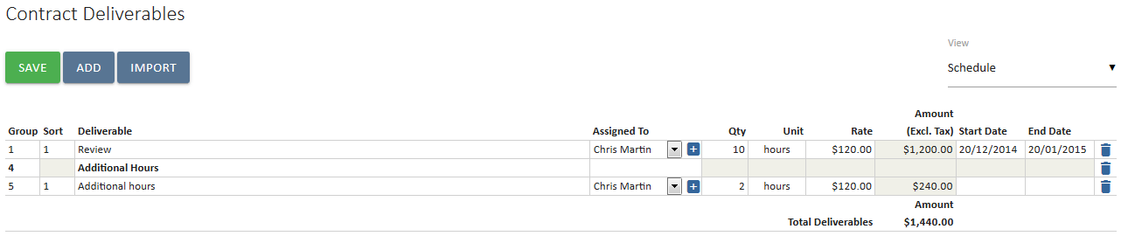
Accounting View
This view allows you to check that the correct Revenue code has been selected
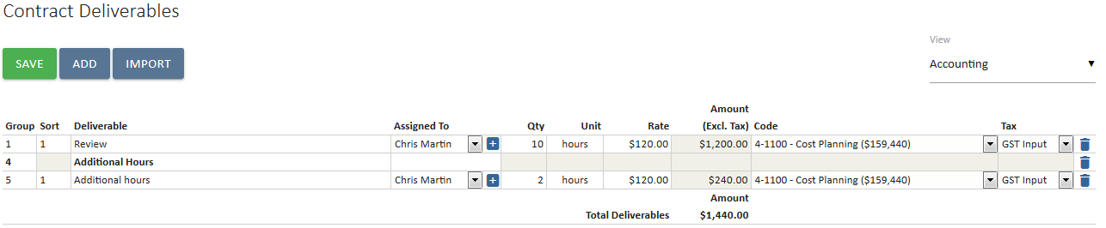

Recommendation View (Cost Contract Only)
Utilised to recommend the amount that should be claimed by cost managers prior to raising a certified progress claim.
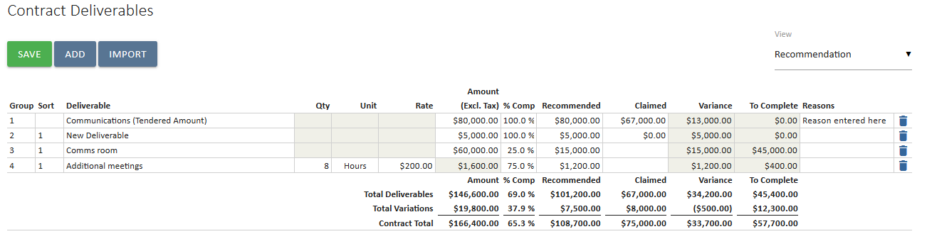

Dates and Time sheeting
The start dates and end dates are also used in the timesheet system to members of the project team to filter their timesheets to only display deliverables that are scheduled within a certain timeframe. This allows the project member to create a more manageable timesheet. If there are no dates but there is a qty and a rate entered then all tasks will be displayed in the timesheet by default when the project is added.
Timesheets date will be displayed underneath the claim as per the screenshot below:
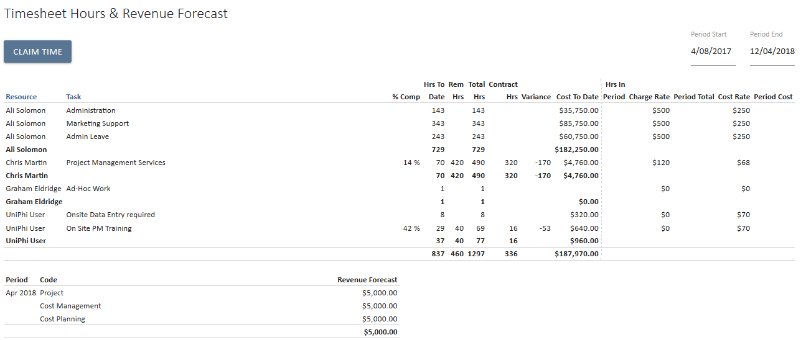

Importing contract deliverables – from Excel

UniPhi allows for Contract Deliverables to be imported directly into the contract page via an Excel spreadsheet or imported from the Resources module.
To import form Excel, per the screenshots below, we are using the sample files to import deliverables.
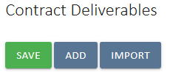
In the Contract Deliverables tab, click on Import
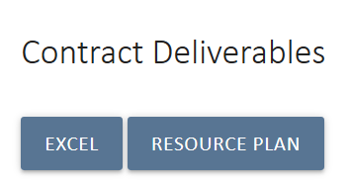
The click on Excel and then the Sample File and save the Excel file.
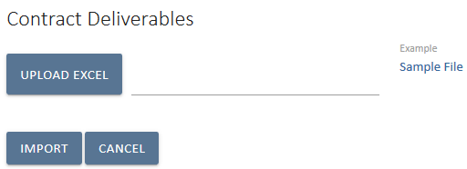
Opening the Excel file will reveal a sample data structure that must be followed for a successful import. It is a useful starting point that the end user refers to the sample file.
The following should be noted before proceeding further with importing deliverables:
- Row 1 in the sample file should not be deleted. This Row is required for successful importation of deliverables.
- Each row in the spreadsheet should be treated as an individual row in the contract deliverables page in the UniPhi contracts page.
Creating contract deliverables are shown below, starting with a basic heading type called Design.
Two deliverables are then added for this heading type. Architectural Services being a time and material deliverable and On Site survey being a lump sum type.
The corresponding Chart of Account code is planning which has a specified code, PL2. Once all deliverables have been entered, the range name “Deliverables” must be specified. Range names can be specified via the Name Manger in Microsoft Excel.
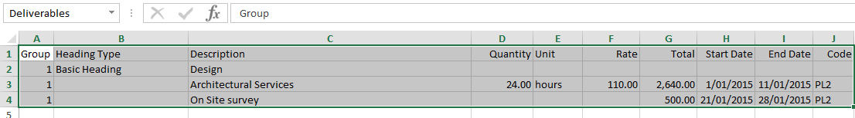
After the range name has been specified, save the working file, browse to select the file and click the import button.
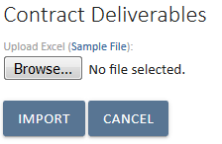
The contract deliverables should now be successfully imported into UniPhi.
Column A: Group – This column corresponds to the Group field in the contract deliverables page. Enter the Group number of deliverables as you would if manually entering deliverables in UniPhi.
Column B: Heading Type – This column allows the user to specify if a particular heading type is to be used for deliverables. Enter the heading type for the corresponding row. Enter the Heading Type for the heading row only – not for all the deliverable rows that are associated.
Column C: Description - Enter the deliverable description in this column. For heading rows, enter the name of the heading.
Column D, E, F, and G: Time & Material – The Quantity, Unit, Rate and Total columns should be filled in if the deliverable is a Time and Material type. If it is a Lump Sum then leave these columns blank and enter the total in Column G. Summation formulas are accepted for calculation purposes.
Column H and I: Schedule Dates – These columns represent the Start and End dates. Enter the dates in dd/mm/yyyy format.
Column J: Code – This column requires the Chart of Account code to be entered. Only the code itself should be entered, not the full name of the account. Refer to the Chart of Account for the applicable codes.

Importing contract deliverables – from Resources

Alternatively, UniPhi allows you to convert a resource plan into a contract. For information on resource planning, refer to the UniPhi 15 Resource Planning Manual.
In the Contract Deliverables tab, click on Import
Then select Resource Plan.
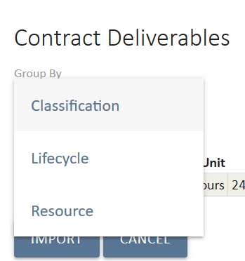
UniPhi allows for three ‘Group by’ import options:
- Classification – groups resource hours by rate classifications
- Lifecycle – groups resource hours by lifecycle then lists them by resource
- Resource – lists hours by resource
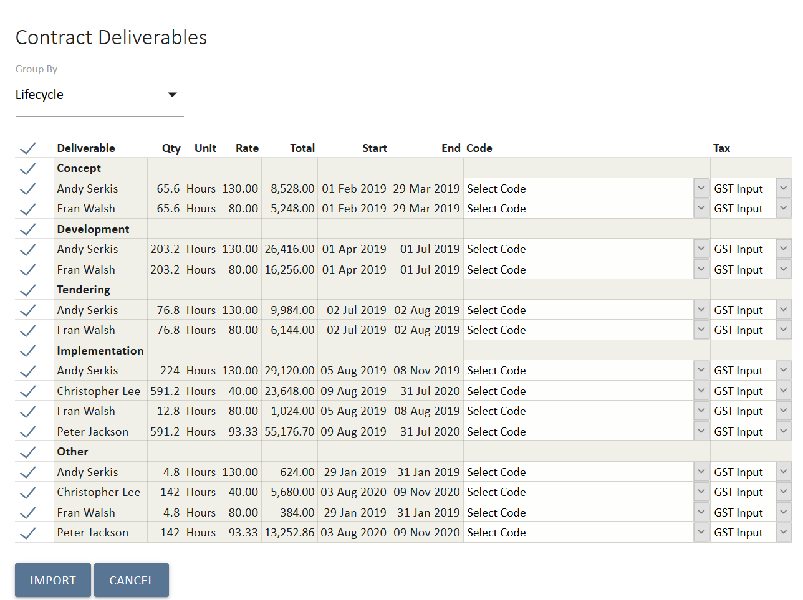
In the example above, Lifecycle is selected and the resource hours are grouped under headings by the corresponding lifecycle. If there are any lines you do not want to import, then uncheck them in the left-hand column. Select the appropriate revenue codes and then select Import 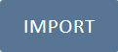 to complete the import.
Large contracts and pagination
If your contract has more than thirty lines then it will paginate in the screen. The total displayed at the bottom of the deliverable list is always for the entire contract, not for the page. To view other pages, click the page number at the bottom of the panel. To see all, click all, but note this will take time to load. The best view to see all of the tasks is the “Accounting” view as it has fewer fields to display (see below for more on different contract views).

Contract Maintenance
Once the contract is won and moved to the Active phase, contract maintenance is required. UniPhi needs to be updated to provide the management of contracts. This data feeds into reporting and enables the Project Manager to track claims that are required, those in progress and those completed, within a date range. Tracking and monitoring contracts can highlight issues to be addressed such as too many time sheeted hours listed and no variation to claim them. This allows the Project Manager to address issues and engage proactively with clients earlier rather than later.
The Contracts module Dashboard view provides a snapshot of the status of the contracts and therefore the health of the project, the data is also utilised in reports.
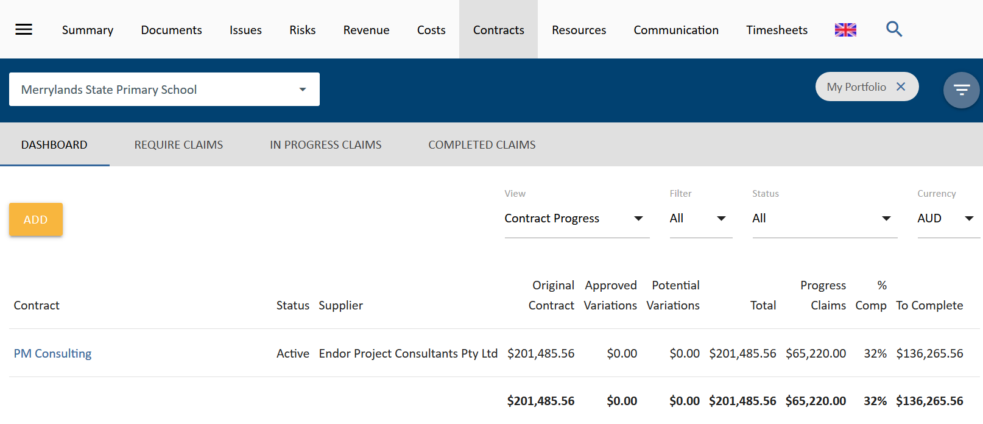
There are four available views from the Sub Navigation. These are:
- Dashboard, lists contracts and their status shown above
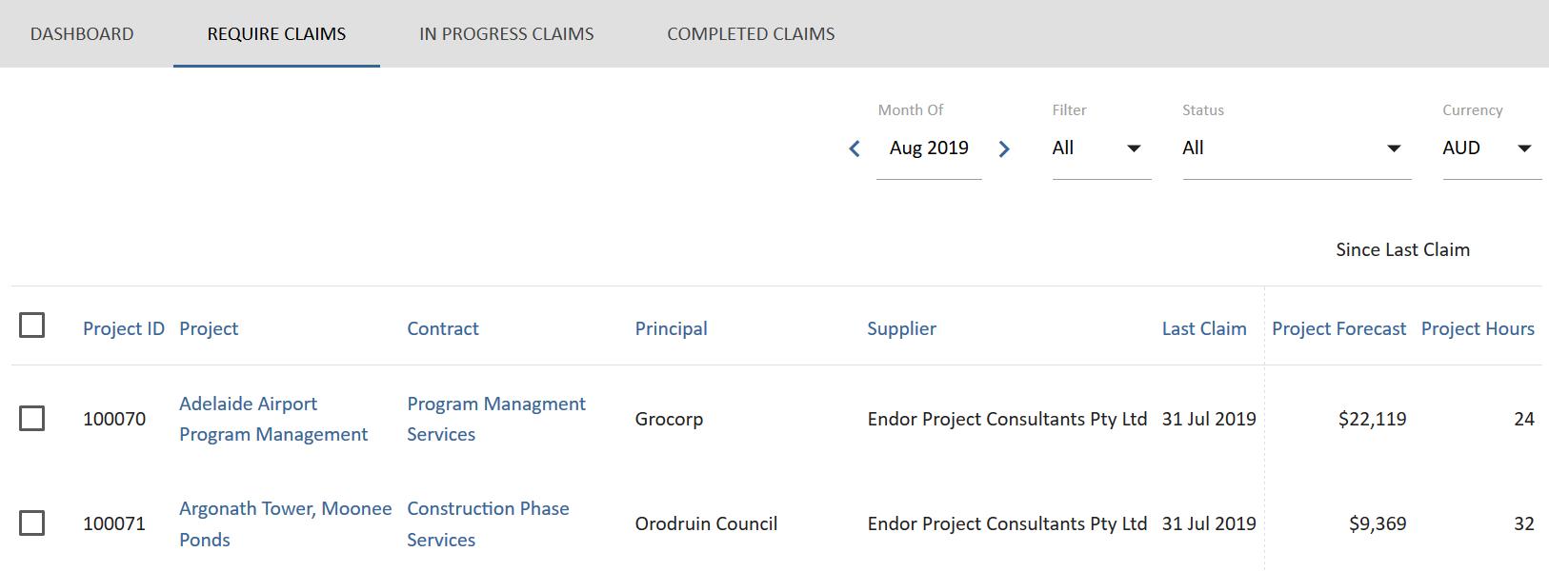
- Require Claims, shows projects and contracts that may require claims done or invoices issued
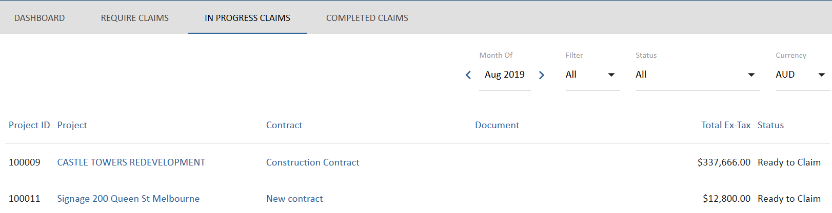
- In Progress Claims, shows claim or invoices that have been commenced but not yet signed off.
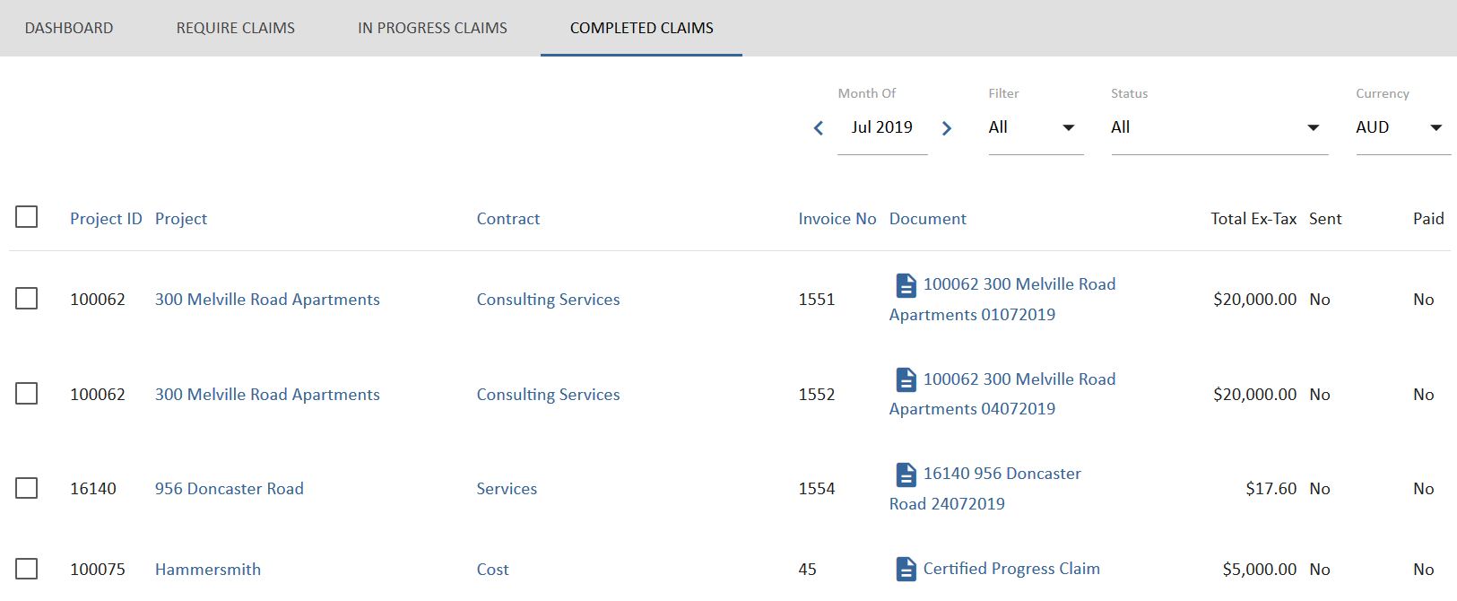
- Completed Claims, show claims and invoices that have been signed off and their status including if the have been sent and paid.

Contract maintenance involves;
- Moving the contract from pending to active
- uploading the contract agreement against the contract
- tracking % complete of individual and all contracts for a project or program of works
- scheduling or rescheduling deliverables dates
- phasing or re-phasing of contract Revenues and costs for cash flow purposes
- adding variations and extensions of time
- certifying claims for payment
- raising invoices or progress claims
- viewing and generating variation and extension of time registers
- communicating to clients

Creating an Invoice
You need to update the progress of the % complete or add in claim quantity of the deliverables and variations in the Contracts Deliverable & Claims form similar to the view below:
On updating the deliverables and variations select 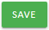 and the claim amount will be displayed, as will any previously claimed amounts and % complete of the contract.
Once updated, invoices and progress claims can be raised by selecting the relevant document in Related Templates panel.
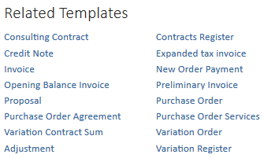
Selection of the Invoice will; populate the document wizard and follow the steps that are similar to those listed in the checklist shown below. You can select any of the steps and go back and forward using the checklist.
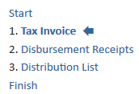
A sample invoice is shown below:
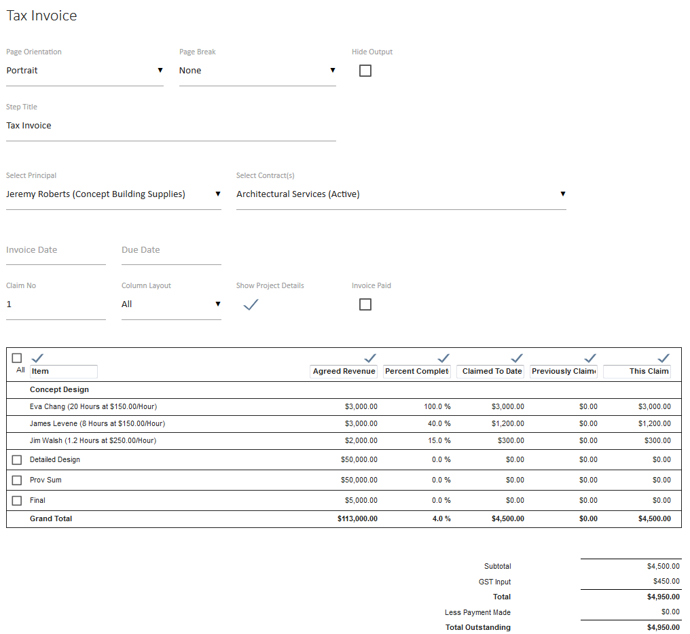
- select the contract you want to claim for or the principle
- enter the invoice date (the last invoice date is recorded for you )
- the claim number is populated – you can edit this field
- if this is an invoice that has already been paid – then select the check box
- Selecting the various check boxes allows the output format to show or hide the various deliverables and columns. It is also possible to modify the column headings, if required.

Note there are four layouts you can select to display the invoice in the finished document to suit your client requirements. These will each display a different heading for the columns in the table for both deliverables and variations.
Select the drop down to choose your preferred option
You can change these whilst working in the invoice to review how they look
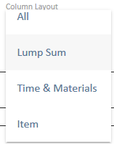

Lump Sum
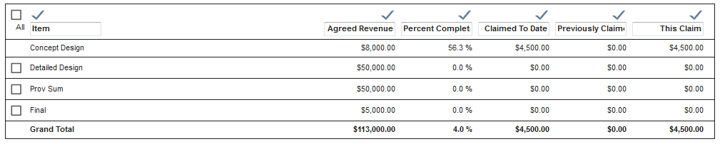

Time and Materials

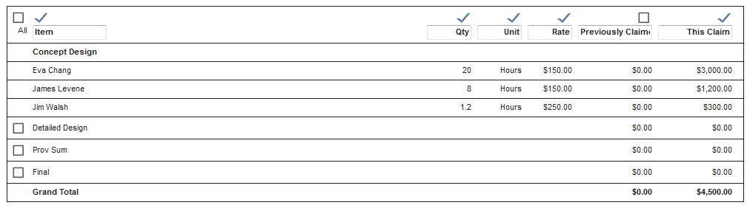
Item
Once you have completed the document, it will need to be signed off so the information is then captured into the accounting system.
Once an invoice is signed off it will also update the Contract Summary with the progress complete and amount claimed to date.
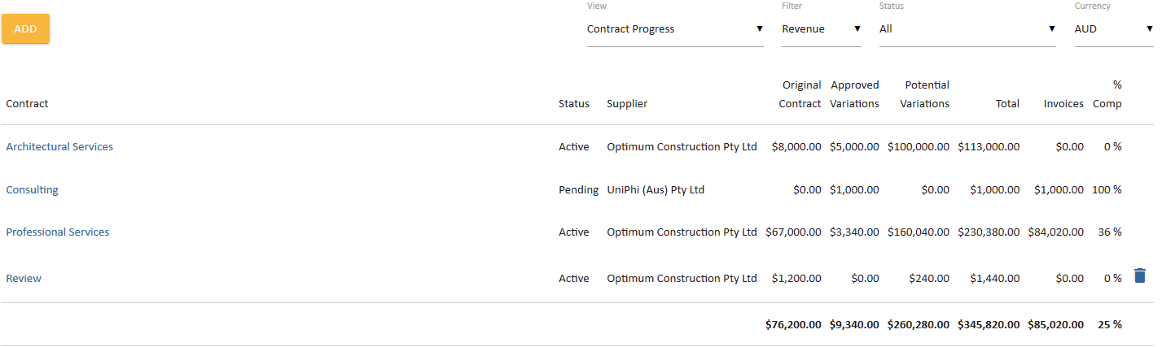
The invoice can be emailed to the client and a transmittal captured for your records.
The revenue contract provides a register for deliverables, variations, extensions and invoices.
These can be located once you have drilled into the contract by selecting Details.
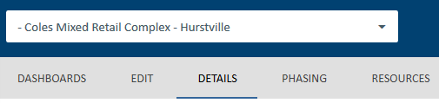
The navigation menu is used to return to the contract dashboards page
To return back to edit the contract select the edit contract option which will take you back to the body of the contract.

Contract details and registers
The Contract Details will also be available and we can see if a signed off contract document has been attached by the document icon and name present in this box. This will mean you have an original contract Revenue displayed in the Contract Summary view
The contact details provides a snapshot of the contract and details of principles and suppliers, if no addresses or contact information appears you can update this in Portfolio> Resources >All projects by selecting the resource name and updating their details.
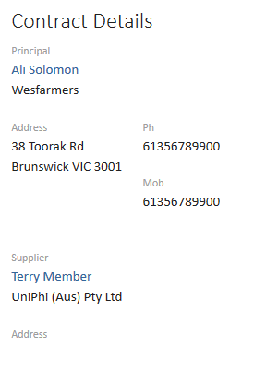

Contract registers
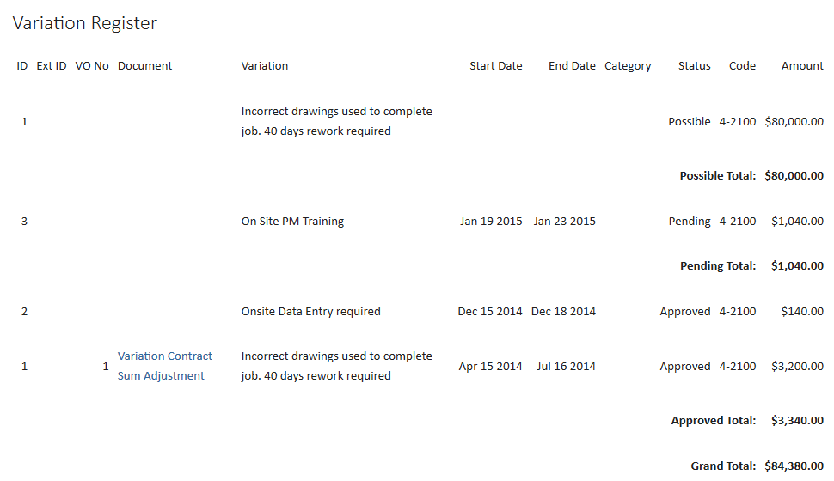
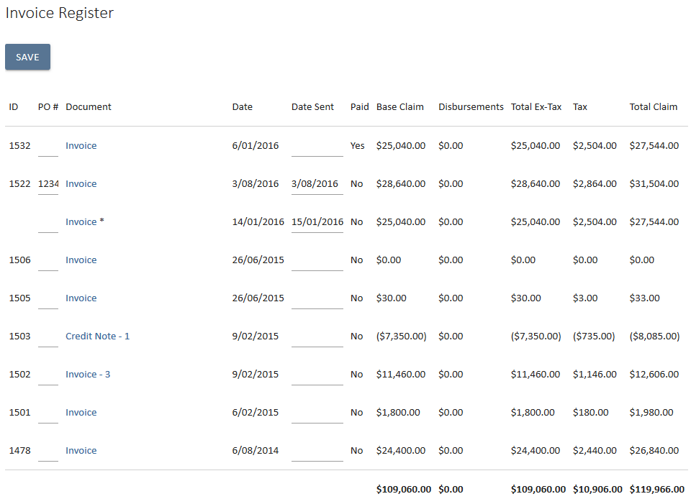
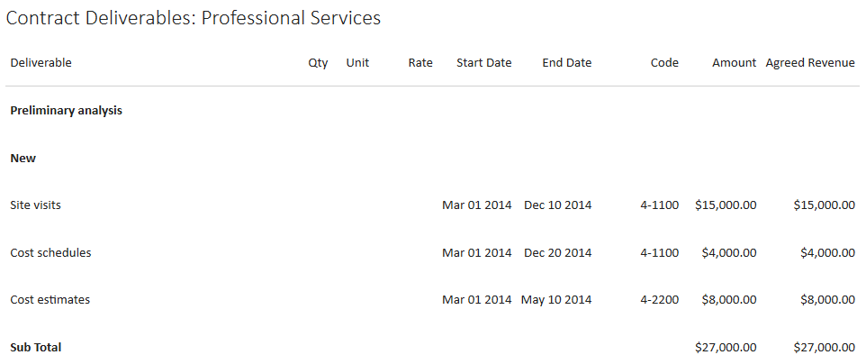

Cost Contract registers
The cost contract will display the deliverables and variations registers and instead of invoice it will have the progress claim and extension of time available.
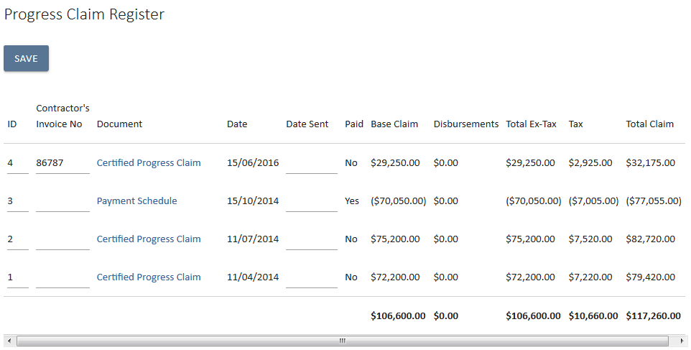
Note documents that are linked to a revenue or cost contract will also appear in the Related Documents Register seen below.
Documents can be populated from within the registers by selecting the link to populate the html version. On those that are not signed off you can edit.
You can email a document to your client once the html version is opened and it will capture the date sent in your document register.
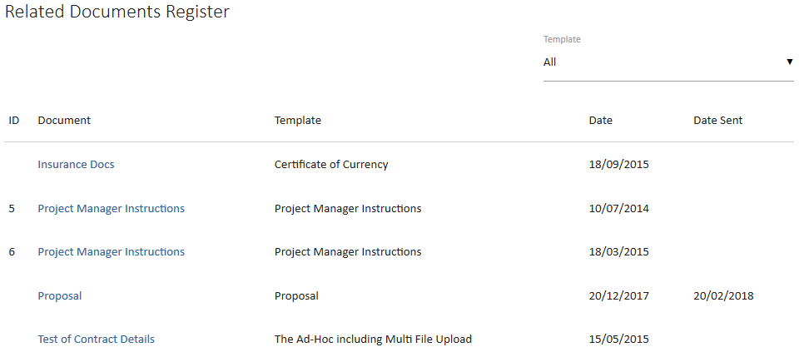

Contract Auto Phasing
In the Contracts tab for your project select a contract & select the Phasing Tab
Select the schedule view and you will see the start and end dates fields. The phasing of the deliverables will be based on these dates if they are entered
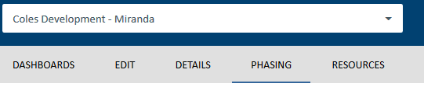
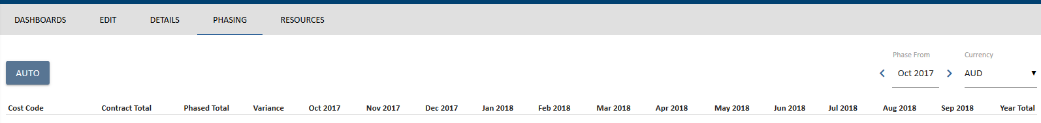
The contract deliverables are listed down and their contracted value is displayed next to them. You can Auto Phase a contract or manually edit the phasing fields and distribute costs over time if you choose.
To Contract Auto Phase select the tick box.
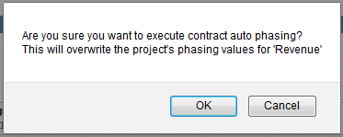
You will be prompted asking you are you sure you want to contract phase as this will override Revenue phasing that occurs in the Revenue Tab. If you have entered a Revenue Budget and phased using Revenue phasing prior to the contract phasing being activated a budget will appear.
If you have not then no budget will be entered on the budget line, or appear in the summary against phased budget. Select OK and phasing will be completed.
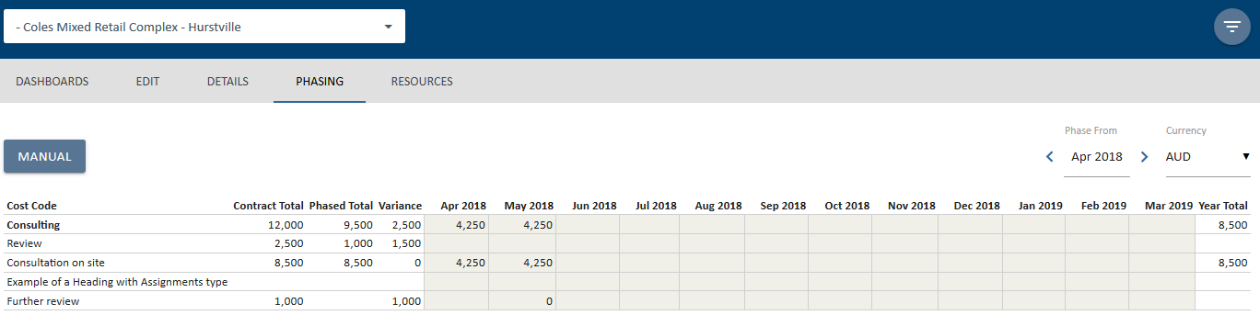
Notice that the cost of the contract has been distributed evenly across the term of the contract. If the contract carries over to the next financial year, you will need to select the next financial year from the Phase From: date selector to view the cost amounts for the next 12 months.
You can only Auto Phase a contract after you have added a deliverable (or deliverables) to it.
You can see below that the Revenue > Revenue Phasing table displays the contracted values in the Act/Fcst row
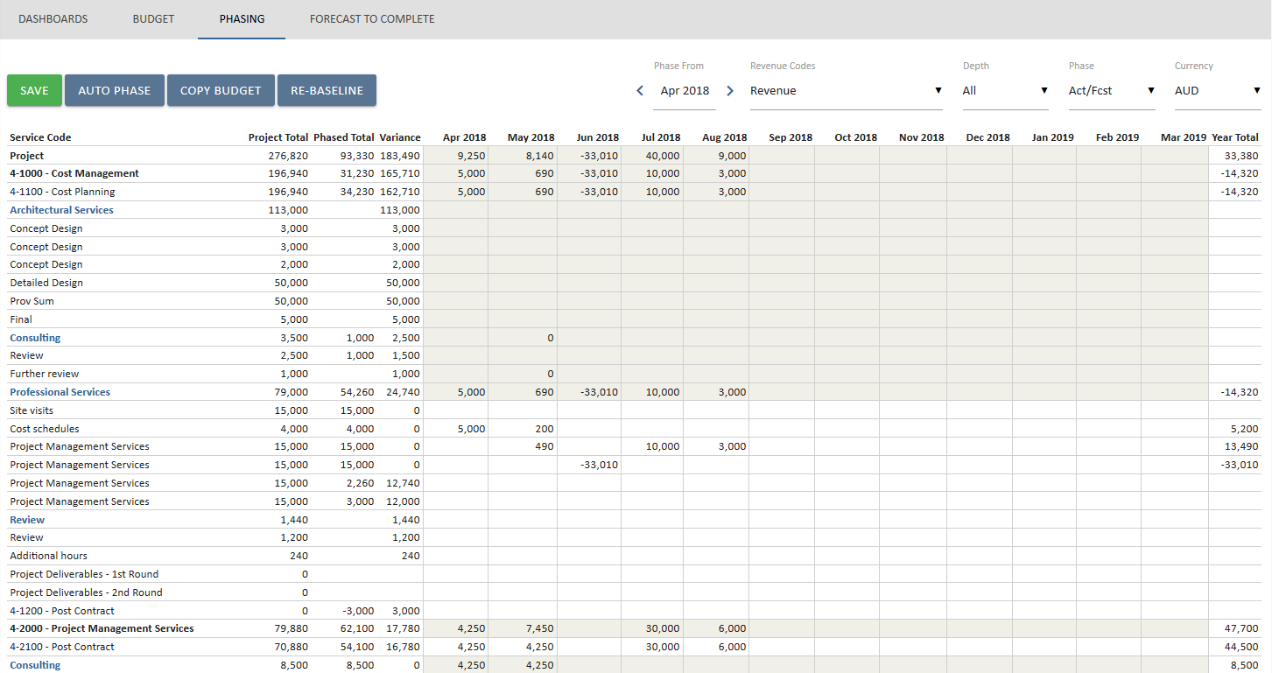
Selecting Contract from the Depth dropdown or selecting Act/Fcst from the Phase dropdown will show the contract phasing. Therefore selecting a budget level from Depth or Budget from phase dropdown will show the budget phasing. By selecting All from both menus, the comparison between the two is visible.

Manual Contract Phasing
To manually phase select a contract and then the phasing module.
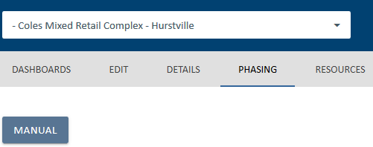
Click the Manual button in order to manually phase contracts.
The fields are editable as they are not greyed out. You can see the Contract total in the left hand side.
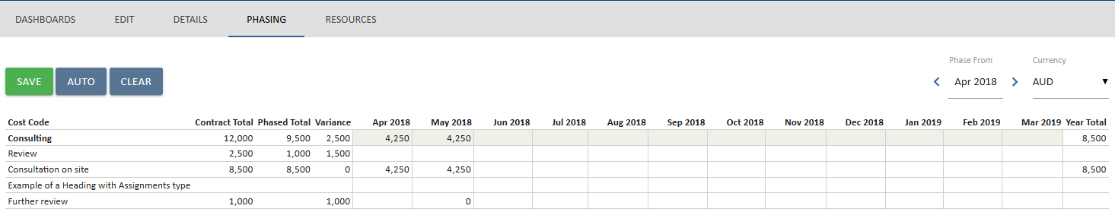

Enter in the values over the time period you need. Select save and the phased total will be displayed. If you need to select another financial year you select the year ending drop down and continue to phase.
Select save once you have finished. The overall Revenue are displayed in the Revenue tab and by selecting the Revenue tab you will see a view similar to below providing a breakdown of the cost codes and amounts. You can select for financial year of ALL years to see whole of project.
Timesheets
UniPhi features a fully featured timesheet module. The timesheet module is available to all licenced users, and integrates with the data and information that has been captured within the Contracts tab. The timesheet module follows UniPhi’s principle of distributed data capture. In this case, many users enter their own time sheet hours, which then allows the project manager to view all hours that have been expended per project and per contract.

Adding projects to your timesheet
In order to allocate time to a project, you need to add the project or projects to your timesheet tab. Navigate to the Timesheet module.
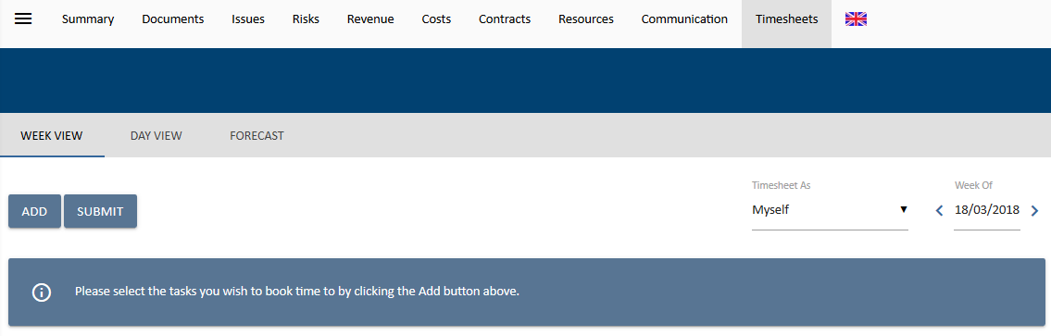
When you press the Add button you will be presented with the option to choose the project that you need to allocate your timesheet hours to:
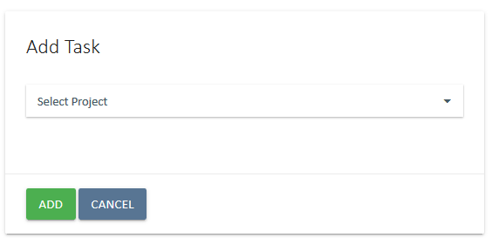
When a project is selected, you will be presented with all possible timesheet entry items. The items are made up of Contract Deliverables, and Standard Tasks.
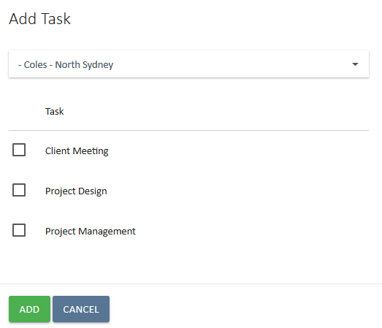
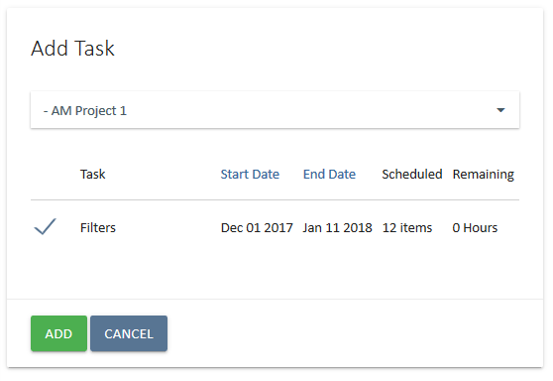
In the above example, the top group of tasks relate to contract deliverables. It is possible to identify these tasks as contract deliverables by the additional date and schedule information.
When selecting a project from the project drop down list, you may be presented with a large list of tasks, you may narrow down the selectable options by only viewing the tasks that are assigned to you.
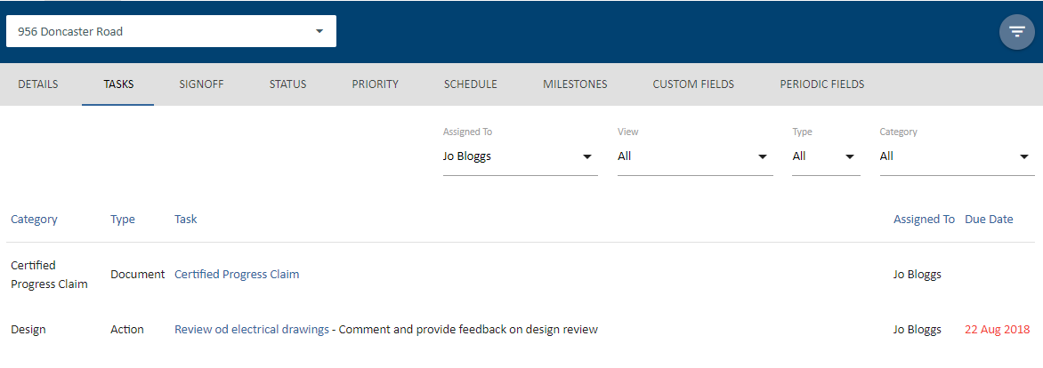
Place a tick against each task that you need to assign your timesheet hours to, and press save.
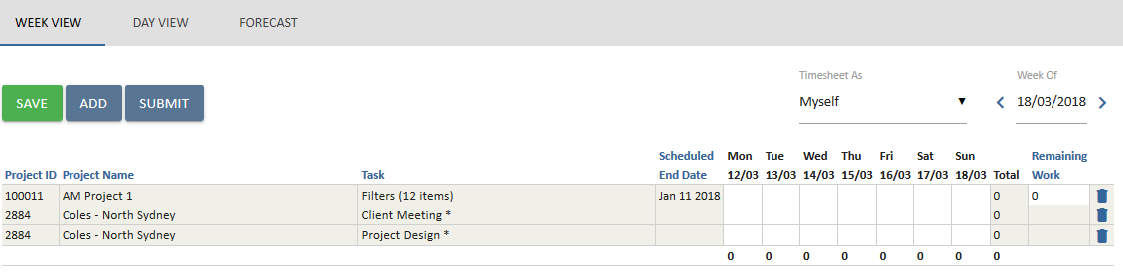

Adding Timesheet Hours
Once all of your projects and tasks have been added to your Timesheet task, it is simply a matter of adding in the hours that have been worked. As time is added per deliverable, the remaining work total will decrease. If you calculate that more time will be required to complete the specified task, you can manually enter the required time in the Remaining Work field.
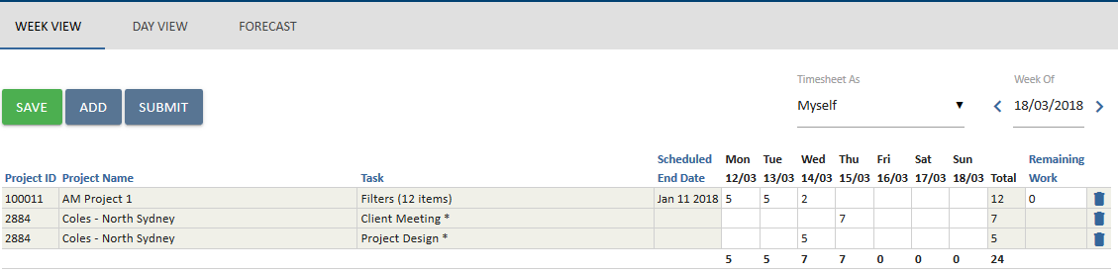
Once you have entered your timesheet hours, remember to save your data. At the end of the week, you also need to submit your timesheet by pressing the Submit button.

Removing Projects from Timesheest
As you complete the work and tasks that have been assigned to you, or if you add a task by mistake, you can remove them by pressing the Delete icon which is located on the far right.

