UniPhi 15

Financial Management
Training Manual

Contents
Course Aim 4
Overview 5
Filters 6
Key Performance Indicators 8
Cash Flow Reports 9
Revenue by Project 9
Cash Flow by Period 10
Cash Flow by Year 11
Profitability Reports 12
Project Analysis Report 12
Portfolio Profitability by Project 15
Project Profitability 17
Resource Planning Reports 19
Forward Workload Forecast 19
Admin Reports 21
Invoice Listing 21
Time Dashboard 34
Phasing a Revenue Budget 43
Comparing Budgets 47
Cost Budget Summary 48
Estimating 49
Contracts Views 58
All View 59
Claim View 59
Schedule 59
Accounting View 60
Recommendation View (Cost Contracts only) 60
What document status should I use? 67
Contract Maintenance 67
Contract maintenance involves; 68
Lump Sum 71
Item 72
Contracts details and registers 73
Contract registers 73
Cost Contract registers 74

Course Aim
This course is designed to take UniPhi project managers through the internal financial management of their projects. UniPhi has been developed to add value to senior managers in the quoting, performance managing and reviewing of a projects internal performance. By internal performance we mean its profitability, cash flow and schedule.
How to use this Training Manual
As you read this manual you will notice the following icons recurring which will help to highlight and enable you to quickly locate activities and summary areas, they will also assist with tips for keeping out of trouble.
Puzzle Piece:
The puzzle piece appears at the beginning of each session and any major section to mark the overview of that item’s content or concept.
Cogs:
The cogs denotes a step by step activity to be completed using UniPhi by the participant relative to the section it is located in.
Light bulb:
The light bulb denotes a helpful hint or tip you should be aware of.

Screen dumps have been used throughout the manual to demonstrate what you should be viewing as you move through the activities. They are for illustrative purposes only. Details such as dates, budget figures and other entered text/data may vary.

Financial Reporting

Overview
Financial reports assist in tracking the performance of bids, profits and cash flow at a project, program and portfolio level. Reports and Dashboards are an integral part of UniPhi and combine data such as costs, Revenue, time sheet hours and contracts into a variety of views for the end users.
Data for these reports are input against projects and aggregated to provide real time financial information to be displayed and exported as selected by the end user.
They provide the ability to;
- Quickly identify the correct report to run to answer the performance question you are asking.
- Explain what each element within the report is saying and identify where a project is going astray.
All Reports are located in the Reports Module found in the side bar menu and there are a number of categories with a variety of reports available. These are displayed below.
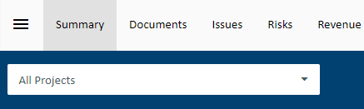
Select the side menuand select Reports.
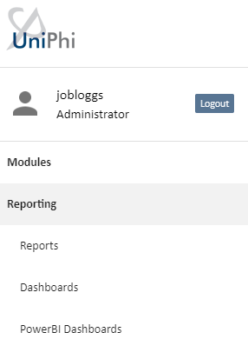

Filters
UniPhi can tag projects with unlimited classifications (through the adding of project custom fields by your System Administrator). These classifications can then be used to perform portfolio reporting.
Standard filters across reports are typically include;
Sector
Sectors generally are market segments your business is looking to operate in.
Project Types
Project types can be linked to sectors and reflect the type of work being carried out (e.g. refurbishment projects versus new build projects in the Commercial Construction sector or Oil Rig versus Open Cut Mine in the resources sector or Classroom versus Library in the Education sector etc.).
Service Line
The service line filter enables portfolio reporting across services to see which service is growing, declining or stable. This has traditionally been handled in a company’s chart of accounts. This is no longer required in UniPhi.

Location
The location filter needs to be put into the context of your business. Is it the project location, the office location or an area representing a location (e.g. a mine site). If all of the above need to be measured and reported then additional project location custom fields will need to be added by your system administrator. There are two levels to locations. The first is the specific location (e.g. a city or site) and the second is a grouping of locations into regions (e.g. a State). Selecting a location aggregates data across all projects either being managed by the office in that location or where projects are located. Selecting a region aggregates all projects that have locations within that region.
Lifecycle
The lifecycle filter is the most important filter in the UniPhi platform. It is the key piece of functionality controlling a stage gate approach to projects. Each phase represents a hold point for approval. This is where the project will seek approval to proceed based on reaching some key milestone. For example reaching a front end loaded index greater than 1 in a new mine or a net present value greater than 0. Lifecycle phases can be grouped into pre-sale and post-sale phases. This then enables UniPhi to group potential versus committed revenue as well as analysing win/loss ratios for bids made.
Format
This enables you to view the report in a variety of ways so you can export into other applications and send data to external sources who do not have a UniPhi licence.
- HTML
- CSV
- Excel
- PDF
- TIFF

Other filters available and generally located in the financial reports are;
- Financial Year – enables selection of past and current financial years
- Cost Budget Version - selects the cost budget version you would like to display as you can have multiple versions in UniPhi as cost budgets are base lined and updated over time
- Revenue Budget Version – selects the revenue budget version you would like to display as you can have multiple versions in UniPhi as budgets are base lined and updated –enables a comparison over
- Display –displays Gross or Net Sales
- Period – displays financial period of twelve months for example Feb2011/Feb 2012
- Currency – displays currencies selected
- Chart of Accounts - displays chart of accounts selected
- Cost Codes – displays project cost codes
- Internal Revenue Codes – displays internal Revenue codes

Key Performance Indicators
UniPhi uses information entered into the Revenue, Costs, Contracts, Resource and Timesheet modules to calculate project KPI’s from an internal perspective. These can be found in the Summary module in the Status sub navigation option.
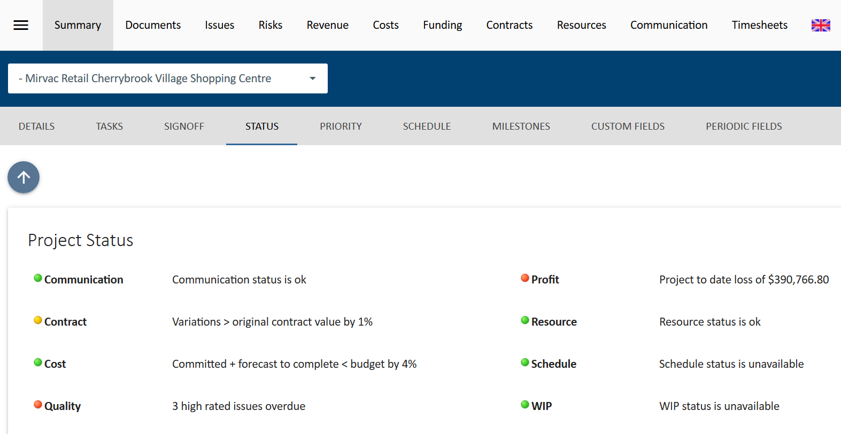
The standard KPIs are listed below
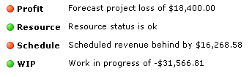
The indicator description will differ depending on the issue, measure. For example, it may be that the estimated profit at completion of the project is still good but the current actual profit is negative. This would flag the profit KPI as red in the same way as the example above has been flagged red for the estimate at completion profit being negative.
Resource KPIs are measuring over-allocated resources, projects lacking resources or where a mandatory role has not been filled.

The Schedule KPI is measuring how well the project is performing to planned billings. This is calculated by looking at the sum of the phased revenue budget to the current date and comparing that to the earned value of the project. Earned value is calculated as the % complete x the estimated revenue at completion otherwise known as the forecast revenue.
WIP is measured as the difference between the invoiced value of the project and the earned value. It represents how much has been earned and is yet to be billed.

Cash Flow Reports

Revenue by Project
This report displays the total amount of revenue for a specified date range including the breakup of each project that contributes to the overall total. Depending on the dates selected, the report will have some months as actual revenue and other months as forecast revenue, and depending on the accounting system integration, the data may display earned revenue rather than invoiced revenue. Each filter on the report header is sortable along with the role and resource selected. This report also includes a cumulative revenue and a revenue by period graph.
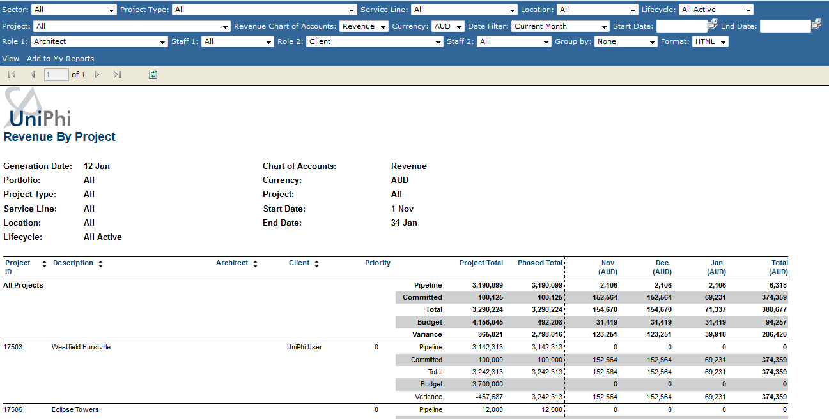

Cash Flow by Period
The cash flow by period report is looking at internal revenue and internal cost codes to calculate a bottom line free cash flow. This report will only work if resource costs have been added to the costs module or if you are estimating the cost/benefit differential of a project and have included all costs in the Costs module.
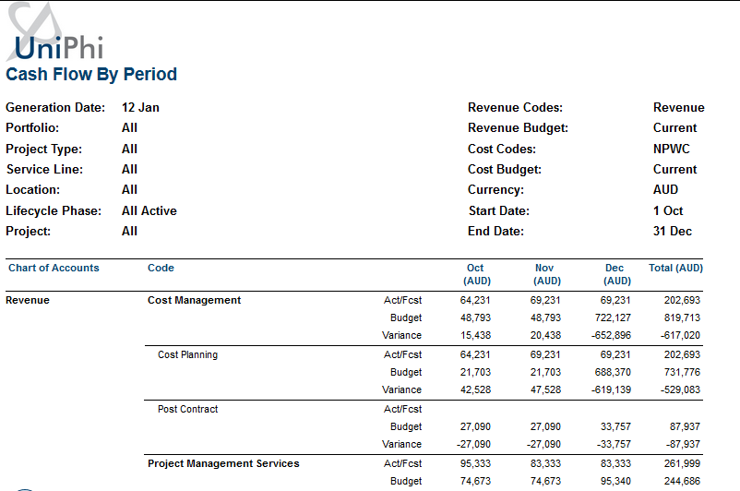

Cash Flow by Year
This report is the same as the previous report but grouped year by year instead of month by month. Each project is expandable to show detailed cost against the chart of account specified.
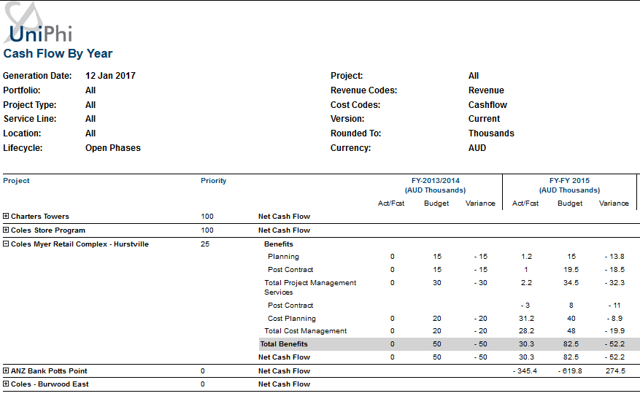

Profitability Reports

Project Analysis Report
The purpose of the report is to provide users with an overview of their portfolio of projects financial performance and to assist financial reviewers in consolidating month end work in progress calculations. Data is entered to generate fields for the first five columns of the report. After that, all other fields are calculations or drawn directly from the relevant Accounting System.
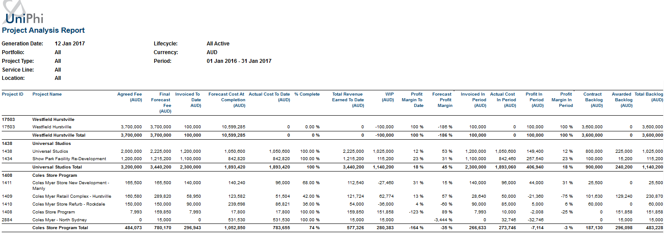
The data for the Project Analysis report comes from the Contracts module in UniPhi. Phased Revenue forecasts are not relevant. Sometimes there are discrepancies between the month by month phasing and the total Revenue. This can create differences between this report and other reports listed below.
The table below describes each number based field and where in UniPhi data is populated:
Field | Description
A - Agreed Revenue | The agreed Revenue represents either the signed off contractual amount agreed with the client (including any approved variations to the original contract amount) OR if no evidence exists of an agreed Revenue, it displays the "Invoiced" value. The agreed Revenue is automatically recognised when a signed off document with contract deliverables exists in UniPhi and variations are marked as approved.
B - Final Forecast Revenue | The final forecast Revenue is the estimate total Revenue possible for this particular project. This can be adjusted by changing deliverable values or adding possible variations. This figure drives the revenue earned to date calculation. It is essential that remaining hours and any disbursement costs are forecasted (see below). It is costs that determine % complete and % complete that determines revenue earned to date. So if you add variations to a Revenue then add the hours that will be required to implement the variation to the resource plan.
C - Invoice To Date | This value is derived from the phased actual for the project and is imported from your accounts system. UniPhi imports values in batches and hence there can be a delay between entering an invoice and seeing its value in the report
D - Forecast Cost at Completion | This is made up of submitted timesheet hours multiplied by the historical rates for each resource plus the remaining hours multiplied by the current rate plus any actual and forecasted disbursements. Timesheet hours are updated every time a person submits hours on the job. Remaining hours can be adjusted at any time. Forecast disbursements are updated in the costs module against the disbursement code listing (This is all detailed later in this document). Disbursements are imported from the relevant accounting system.
E - Actual cost to date | Actual costs are timesheet hours multiplied by the historical cost rates for each resource plus actual costs displayed in the costs module (generally project disbursements).
F – % Complete (E/D) | % Complete is measured by dividing the actual costs to date by the forecast cost at completion.
G - Total Revenue Earned to Date (F x B) | Total revenue earned to date is calculated by multiplying the % complete by the final forecast Revenue. This represents the accounting concept of recognising only revenue you have earned not what you have invoiced.
H - WIP (G – E) | WIP or "work in progress" is calculated by subtracting invoiced to date from revenue earned to date. Negative WIP means you have invoiced ahead of effort. This will result in an accrual adjustment to revenue down to recognise what has been earned. The reverse is true for positive WIP. WIP is thus a current asset that makes up a part of the companies working capital. The lower the WIP the better.
I - Profit Margin to date ([C - E]/E) | The invoiced profit margin is used to compare against the earned profit margin to test for glaring forecasting errors. The margin is calculated by dividing the invoiced profit to date by the invoiced revenue to date value.
J - Forecast Profit Margin ([B - D])/B | This metric displays the expected profit margin at completion. A significant difference between invoiced and at completion margins indicates forecast error. The most likely culprit is the remaining hours estimate.
K - Invoiced in Period | Displays the value of invoices raised in the period (i.e. current month). The current reporting month is a filter selected in the report. It defaults to the latest closed accounting period.
L - Actual Cost in Period | Displays the value of costs in the current month. The difference between K and L is the invoiced profit.
M - Contract Backlog (A - E) | Contract backlog represents the value of forecast Revenue yet to be contracted. Hence it is the difference between the agreed Revenue and invoiced to date. The total contract backlog represents the volume of work that is committed but not yet invoiced. If this number is trending down then the business is invoicing more than it is winning in new work and hence is contracting as a business. This ratio is known as booked to burn ratio
N - Awarded Backlog (C - A) | Awarded backlog is the difference between the agreed Revenue and the final forecast Revenue. It represents the amount yet to be awarded by the client.
O - Total Backlog (M + N) | Total backlog represents work yet to be invoiced and is the sum of the two backlog figures

Portfolio Profitability by Project
The portfolio profitability report is a core UniPhi report. The key purpose of this report is to be able to track progress and final forecast profitability to a baseline. The report consolidates all projects into the Revenue chart of accounts and internal cost charts of accounts. It adds in the time sheeted hours and estimated remaining hours to display the actual month, actual year to date and full year profit forecast compared to budget for the business.

The data for the portfolio profitability report derives from Actual revenue = invoiced revenue.
Earned revenue for the month and for the project to date and Estimate at completion revenue uses the same methodology as the Project Analysis Report
Budget revenue in the month and to date comes from the phased budget in the Revenue module. Revenue budgets are set up and phased in the Revenue module. These are different to the agreed Revenue and final forecast Revenue in the Contracts module.
Actual and estimate at completion costs for the month and project to date use the same methodology as the Project Analysis Report.
Budgeted hours are phased linearly using the lifecycle phasing dates. These phased hours are then multiplied by the current rate and any phased budgets are added to determine budget costs in the period and to date.
Budget at completion is the total budget hours multiplied by the current resource rate plus total disbursements budget in the Costs module.
Note the "Filter" dropdown limits the at completion figures to the end of the financial year and hence is based off the phased Revenue rather than the contract values.

Project Profitability
The project profitability report is a sub set to the portfolio profitability report which enables you to drill into the detail of a specific project to analyse any issues with the financial performance at the project level.
The report displays the actual revenue, cost and profit versus budget and earned values for month and project to date as well as the estimate at completion versus budget at completion.
Actual revenue for the month and project to date based off imported actual values from the relevant accounting system
Earned revenue uses the same methodology as the project analysis report but displays this by account code
Budget revenue in the month and to date is based off total budget hours for each resource phased by the dates in the project lifecycle and multiplied by the current resource rate plus phased disbursements in the costs module.
Estimate at completion revenue gets its values from two sources depending on whether the user wishes to see the whole of project life or financial year. The values are split into potential and committed.
If the whole of life filter is selected then potential revenue is all non-committed revenue contracts plus possible and pending variations on both committed and non-committed revenue contracts and committed revenue is all committed revenue contracts plus all approved variations.
If financial year is selected then the values come from phased Revenue for that year rather than from the contract values.
Budget at completion revenue is budget hours multiplied by current resource rates plus disbursement budgets.
Costs are split out into individual resource costs and disbursement codes to more closely analyse the costs of the project. Each resource will have a budgeted cost to date and in the month and this can be compared to the actual as well as the earned to determine performance. Note the weakness in the metric is the linear phasing of budget hours. However, if dates for each lifecycle phase are entered then this linear phasing could be accurate for some projects.
Schedule variance is the difference between budget values and earned values. This metric is displaying whether you are earning the Revenue at the same pace as you had planned and whether the hours worked on the job plus disbursements are occurring at the same pace as you had planned. Hence it is to do with schedule slippage and assists in determining whether the project is slipping and whether additional variations will be required to take this into account.
Cost variance is the difference between actual values and earned values. Hence, this metric is on the revenue line in this report is the same as WIP in the project analysis report.
This report can assist with whether to recognise a higher invoiced value than earned value as profit or as negative WIP. If the cost variance is negative and the contract is fixed price lump sum then it could be that the project has been completed for less effort than was expected and hence the negative cost variance should be booked to profit.

Resource Planning Reports

Forward Workload Forecast
This report is an aggregated report summing up Revenue per service line and location, grouped by region. The values entered into this report are assumed to be expected invoice values month by month.
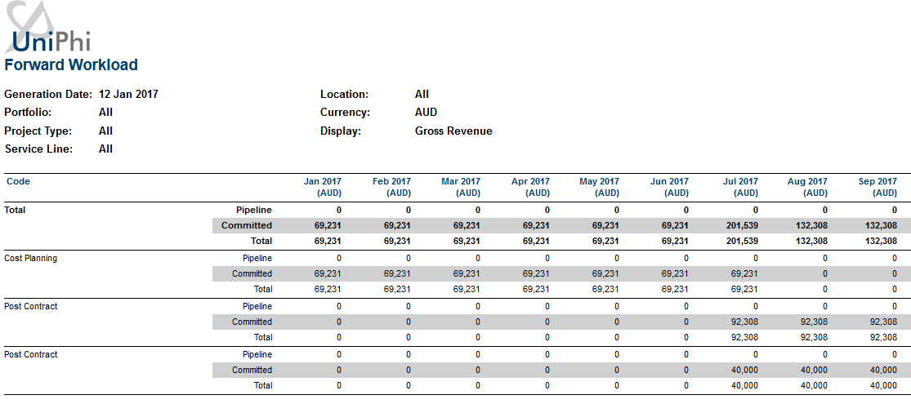
Unlike the Project Analysis Report, the Forward Workload Forecast is based off phased Revenue in UniPhi. Revenue can be phased either at the contract level or the service code level.

Phasing Revenue via the contract ensures that the values reported in the Project Analysis Report match with the forward workload. Currently, the forward workload reports gross Revenue.
There is no adjustment on those projects with large sub-contractor components. This can inflate the revenue line when using this report for workload estimates. The report can display backlog forecasts as well as pipeline on a risk adjusted basis or grossed up to 100%. These are all adjusted via the filters within the report.

Admin Reports

Invoice Listing
The invoice listing report will show all transactions that make up revenue and direct expenses during a financial period. This report will be a combination of the invoices raised listing the transactions and disbursements or direct project costs.
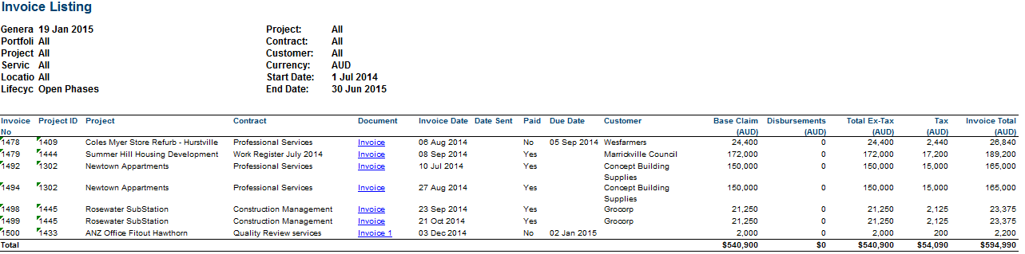

Create a Project
Projects need to be created and data attributed to provide information that’s utilised at the reports and dashboard level. Each business identifies information to be captured against the project that is utilised in their reports and dashboards.
- Projects are generally created when they require a quote to be generated.
- Creating the project involves entering the name of the project, classifying it (e.g. Sector it belongs, lifecycle phase etc.), assigning resources and estimating the timeline for the lifecycle phases.
- Most projects are created in a pre-sale phase (e.g. submission, tender )
- Creating the project in this phase allows for UniPhi to calculate win/loss rates by tracking which quotes move to a post-sale phase and which move to a completed phase without entering a post-sale phase (e.g. Cancelled or Lost)
Each lifecycle phase contains two start and end dates per phase, a baseline and an actual/forecast. The baseline dates enable you to measure actual and forecasted progress versus original schedule. Assigned resources can have effort estimated against the relevant phases in the resource planning section and from this a forward workload for all resources in the company can be analysed.

Creating a New Project
Go to the Summary module and make sure “All Projects” is selected from the Project filter.
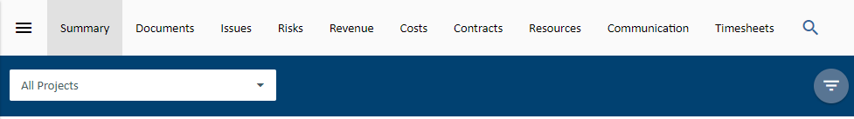
Click and following form will appear:
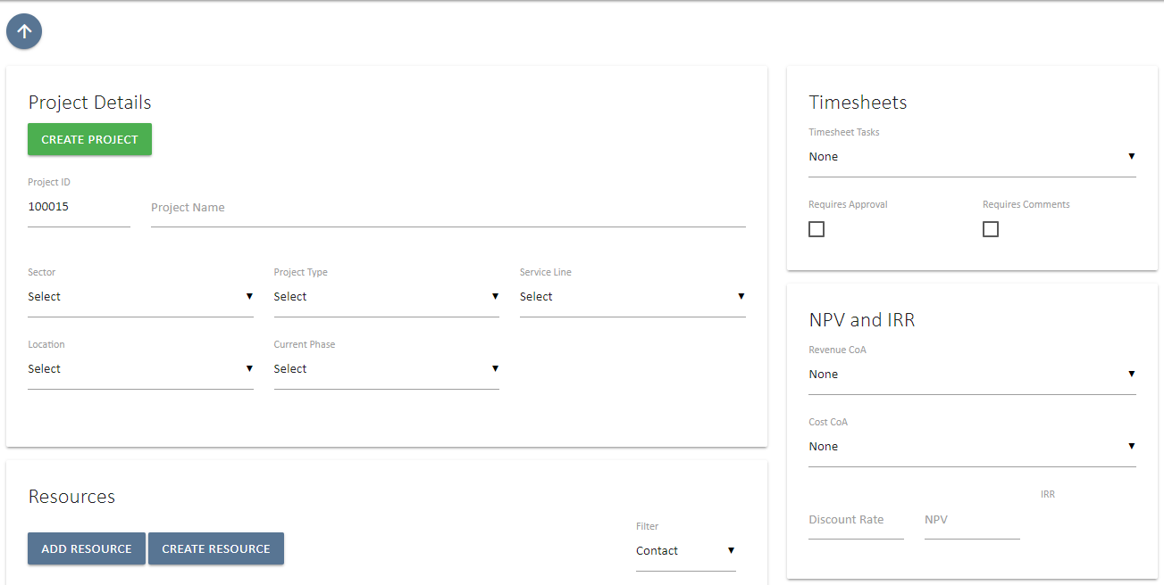
Fill in the following fields, Project Name, Sector, Project Type, Service Line, Location and Current Phase. A Project ID is generated automatically.
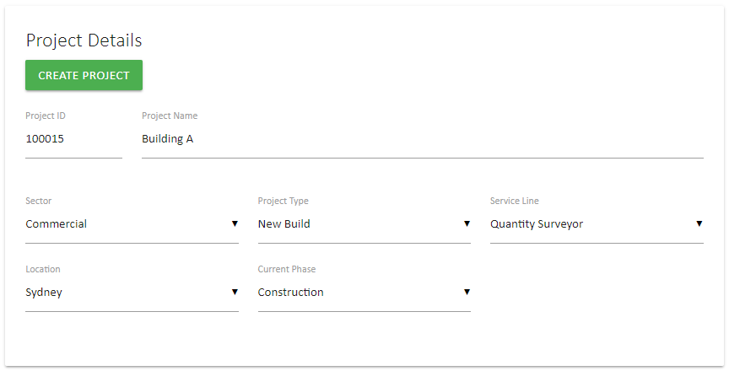The next panel is for adding resources.

Adding Resources
An important component of creating a new project is adding resources. If a resource/contact already exists in UniPhi, simply press the 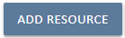 button and select Contact or Asset from the dropdown filter.
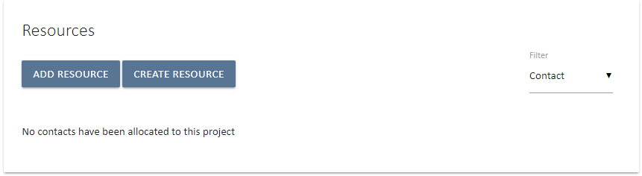
Start typing the person’s name, and select that person to add to your project.
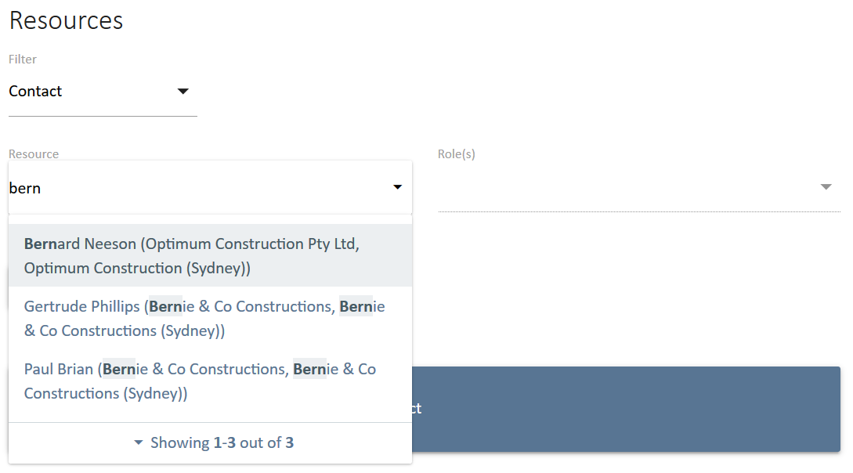
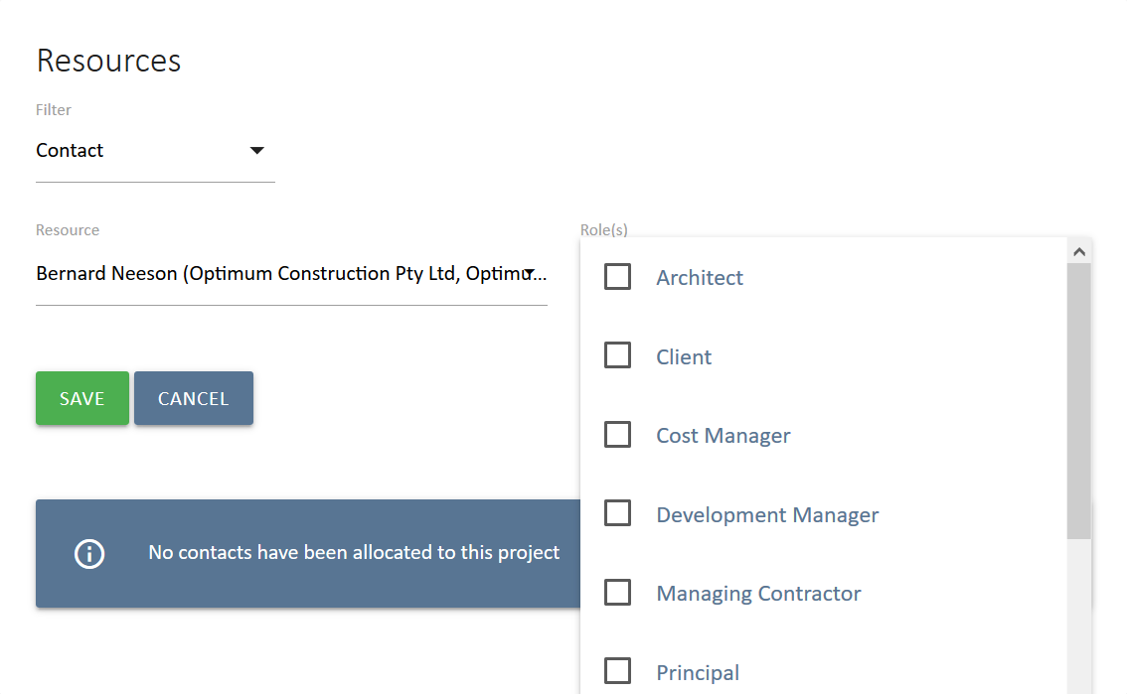
Next simply select the role(s) that they will perform on the project and Select 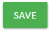 to add the resource.
Note if you are uncertain of the resource name that you would like to add, you can press the space bar and all names will be displayed to you.

Creating Contact Resources
If the resource contact does not already exist you can create a new resource. Resources in UniPhi are split into 2 main types: Contacts and Assets.
To create a resource when setting up a new project, click 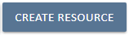. Contact Custom Fields are setup by a user with an Administrator access level.
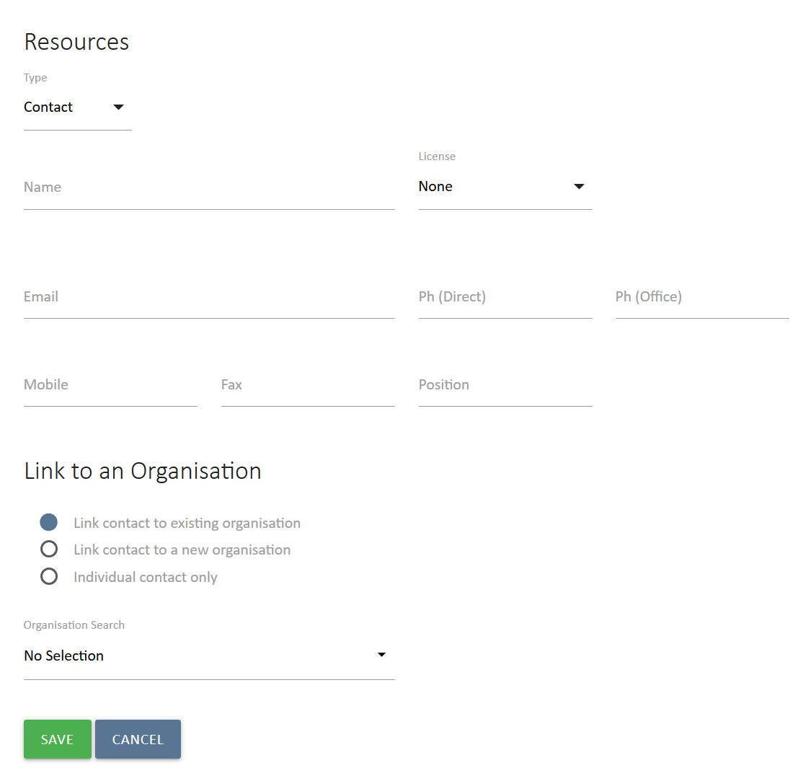
If the resource you are creating belongs to an organisation not currently in the system, this can also be created. By selecting you will be presented with the view as seen below.
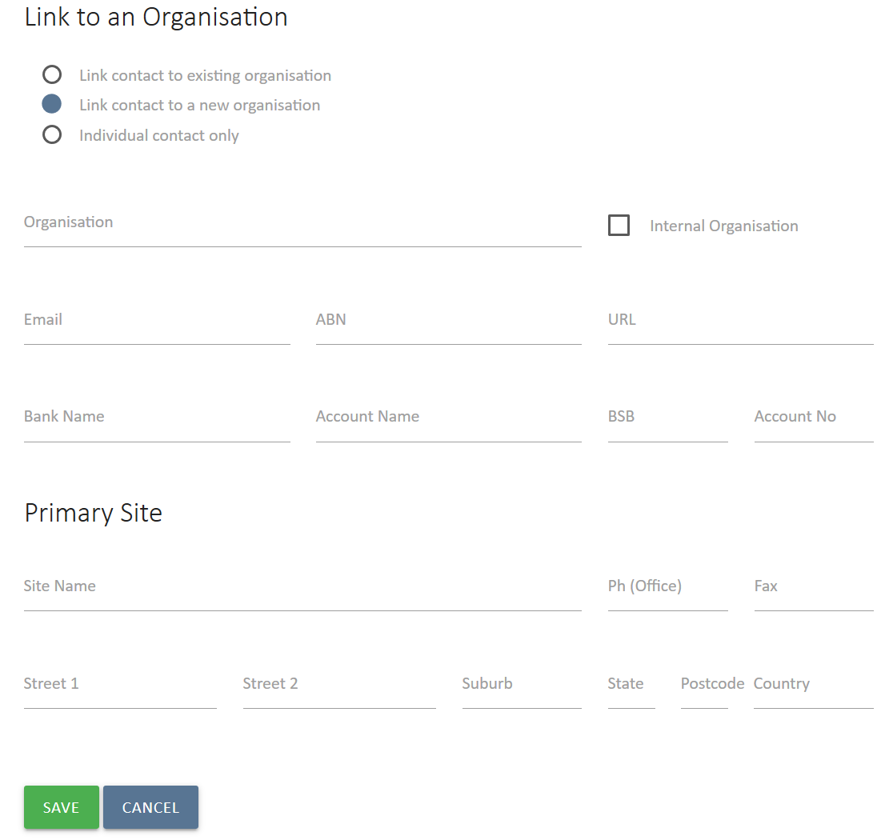

Click 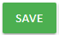 to add the resources to your new project. The default role of a newly created resource will be Team Member. From here you can use the Roles: dropdown to re-assign each resource to their correct role on the project.

Creating an Asset Resource
You can also create Assets in UniPhi as Resources. To create an Asset when creating a new project, select the Asset option from the Resource Type dropdown menu. Doing so will give you the following view
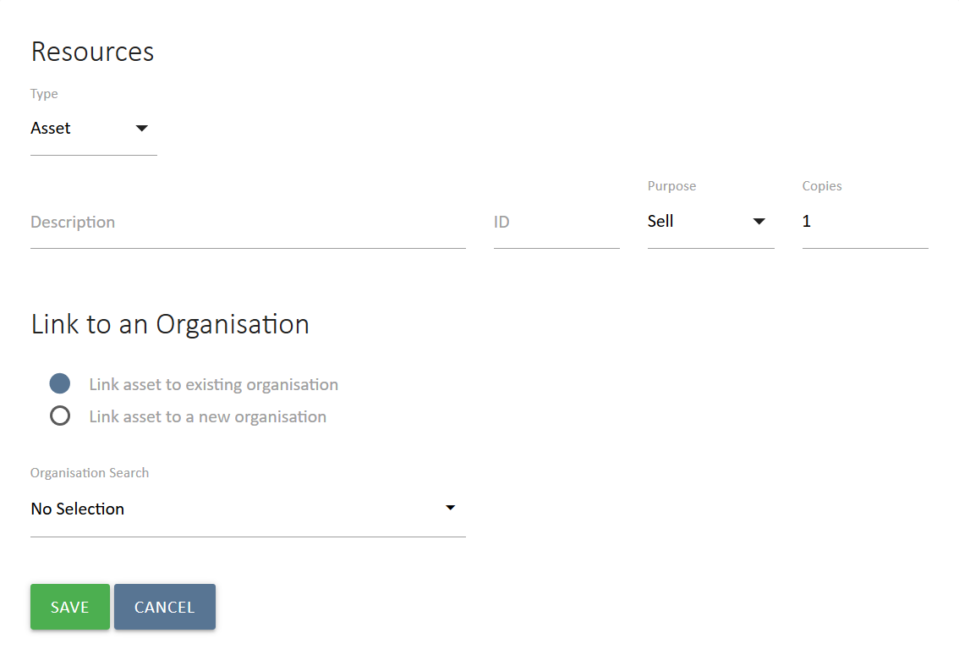

Resource Details are mandatory fields. Additional custom fields can be added by an Administrator as a way of capturing more details about each resource.
Similarly to the process used when creating a Contact Resource, if an Asset belongs to an Organisation that doesn’t exist, you can simply create a new organisation.

Adding and Deleting Roles to existing Resources:
Adding Roles: You can assign additional roles to a resource at any time. Select the dropdown to the right of the resource and select the role you want to add:
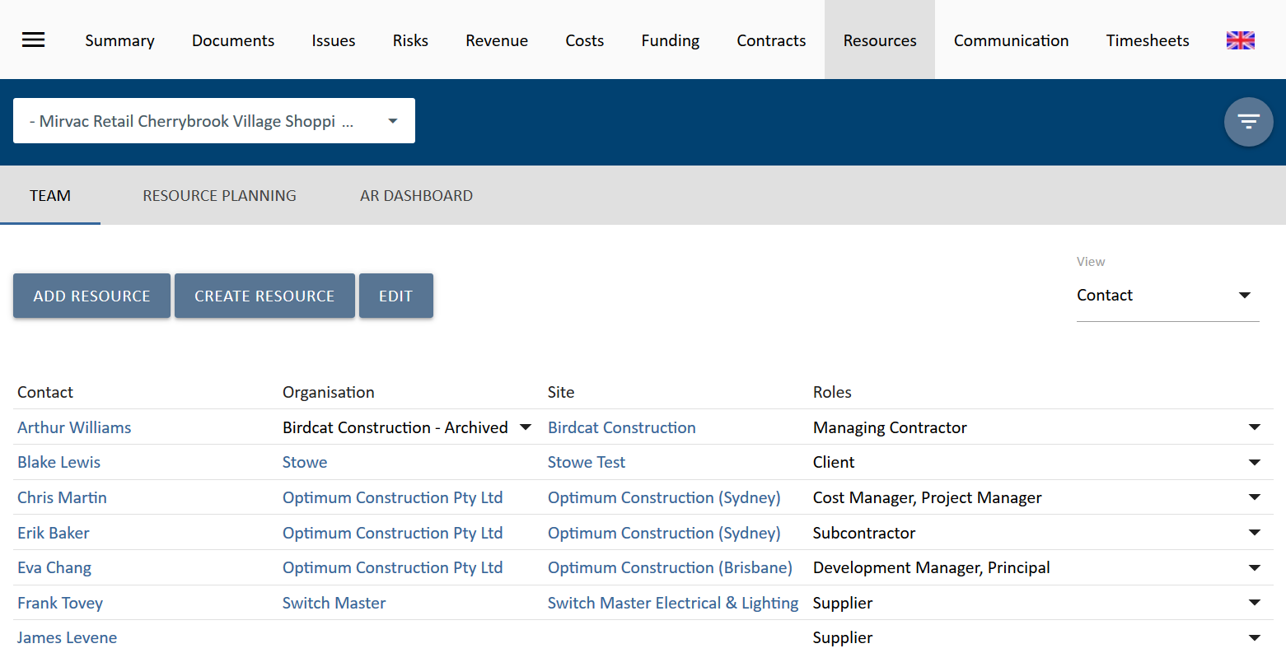
Deleting Roles: To remove a role select the dropdown button next to the role you wish to remove and untick the role.
What if my resource is not in the list?
If a resource is not shown in the resource list you will need to enter them in to your resources database. To do this, Go to Portfolio > Resources.

Optional Fields: Not all fields are relevant to all projects / portfolios and can be ignored. If a field is mandatory you will not be able to create the new project and will be notified with a red warning message.
Parent Project: UniPhi allows for a program of works within a portfolio to have an unlimited number of “child” projects underneath it. This is managed through selecting the Parent Project that the newly created project belongs to. Parent projects will consolidate budgets and contract costs and revenue for all children allocated to it. The Parent project will also display issues and risks that exist across the program (i.e. within each child)
The resulting project filter will look like this:
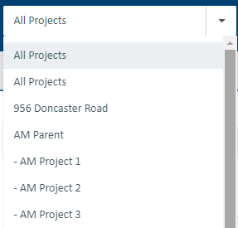
Priority: Companies can devise their own Project Prioritisation Framework which the user creating the project can complete to establish a projects’ priority. The prioritisation framework is displayed at the bottom of the create project screen. If you complete the Project Prioritisation Framework the result will automatically populate in this field once the project is created. Alternatively you can enter in a priority manually. Project prioritisation allows team members to make discretionary decisions over work that needs to be completed at the same time. Knowing which project has a greater priority to the organisation can assist in the decision making, reducing the management time required to review and prioritise tasks.
Private Project: If this box is ticked only resources assigned to the project can view it. Use great caution when selecting a project to become private as it is possible for the project to become invisible, i.e. if no resources are assigned to a project and it becomes Private.
Win %: As explained in the introduction to the session, projects are generally created when a quote or proposal is required. When Revenue, costs and hours are estimated, UniPhi will automatically adjust these Revenue in reports by the win % allocated to the project. The win % represents the probability that the organisation will win the job. The end result is a risk adjusted resource plan and cash flow forecast for the business. Win/loss ratios displayed in the Submissions dashboard can assist the user in determining a value for this particular field.
Revenue %: The Revenue % functions the same as the win % thereby compounding the risk adjustment factor. The Revenue % adjustment reflects the likely reduction in Revenue that will occur through contract negotiation phase.
Project Description: This is a useful reference to other members of the project team as it provides a high level summary about what the project is aiming to achieve. It is a free text field and the data contained within this panel can also be used to pre-populate documents generated from UniPhi.
NPV: NPV stands for Net Present Value and is used when determining the value of real asset investments. It is the end result of a cost benefit analysis. While it is possible to compile a cost benefit analysis in UniPhi (your project profitability is one example of this), most cost benefit analysis are compiled outside of the system. The end result NPV can be keyed in here so that the portfolio NPVs can be consolidated and analysed in the summary dashboard.
Currency: UniPhi supports an unlimited number of foreign currency translations. The currency selected here will be the default currency for the project and will be used to determine the currency project Revenue and costs have been estimated in. It is possible to have mixed currencies for contracts in the project but these will be converted to a common currency in the Revenue, costs and reports module. The currency selected by default in these modules is based off the default selected here. It can be changed by the end user if they wish to see the end results converted into other currencies.
Risk Contingency COA: UniPhi’s risk management module allows for the build-up of a dollar value for risks in the project cost budget. Risks identified have contingency values allocated to them. The total of which is then transferred to the project budget via the relevant contingency code selected. Risk contingency dollar values are applied to costs, not revenue, so this is only relevant when managing a project cost budget. The code list available is all code structures that have “Contingency” codes flagged in their chart of accounts
Risk Contingency Code: The account codes that have been flagged as contingency codes in the chart of accounts selected are displayed here. Selecting one code will provide for a default code selection when creating risks. This default can be changed for each risk identified but the default selected here should be the most common contingency code (e.g. construction contingency).
Timesheet Tasks: defaults to a predetermined list that is visible to add work hours against the project when time sheeting. Standard tasks are used when work is completed on a project without specific contract deliverables. Examples of this type of work would be support work for a product that has been already commissioned or project management during a defects liability period in the construction industry.
Requires Approval: This option is selected if all timesheets entered and submitted require an oversight and approval.
Timesheet approval in UniPhi is based off the access level of roles on the project. If a project role has a program manager access level (as appose to a project manager or team member access level) then people in this role are able to approve submitted timesheets.
Rejecting a timesheet reverts the timesheet back to a “saved” state rather than a “submitted” state. The person submitting their timesheet can then amend and re-submit for approval. If timesheet approval is not selected then timesheets can still be reviewed in both the contracts module and via reports.
Timesheets can be “rolled back” to allow the team member to correct the error and re-submit. Only submitted hours are displayed in the contracts module while saved but not submitted hours can optionally be displayed in the timesheet reports.
Requires Comments: Select if daily comments next to each task are required for successful submission of timesheets. If this is selected, staff will not be able to submit their timesheets unless they have entered text in the comments field.

When you have finished entering in all the relevant data, create your project by scrolling to the top and clicking on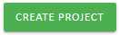.

Project Summary: Once you have created your new project, you are taken to the Project Summary page. Here you can view the Project Status and Project Details boxes. You can access this summary detail at any time by selecting the project from the Project filter: when in the Summary module:

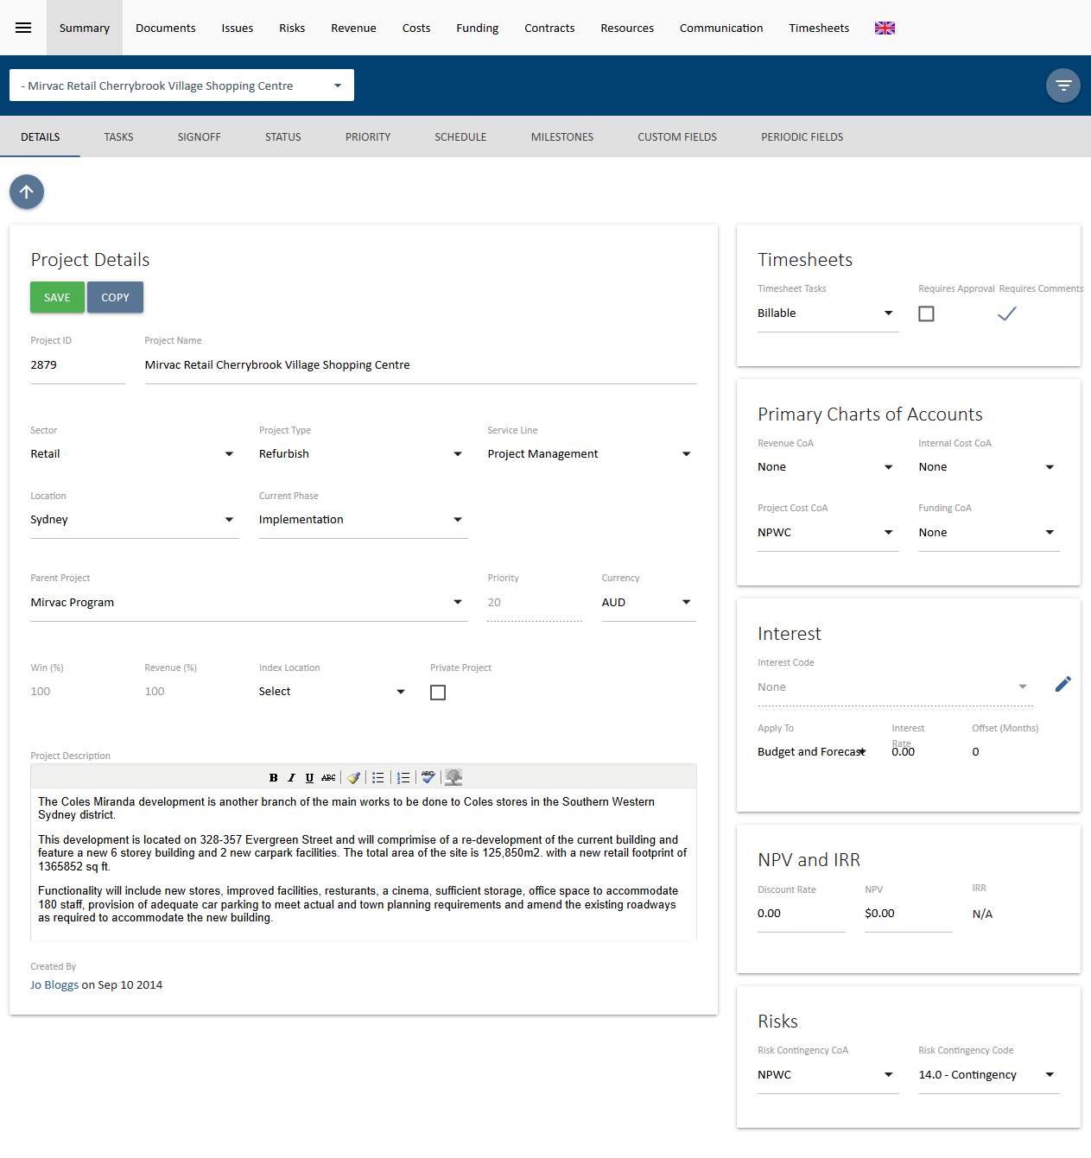

Scheduling dates
Dates are used to assist in resource planning, forecasting costs to complete, the timeline dashboard displaying the baseline, actual and forecast dates for the project over time.
Project Schedule Dates view
In the Summary module, select you project, then select Schedule form the sub navigation options.
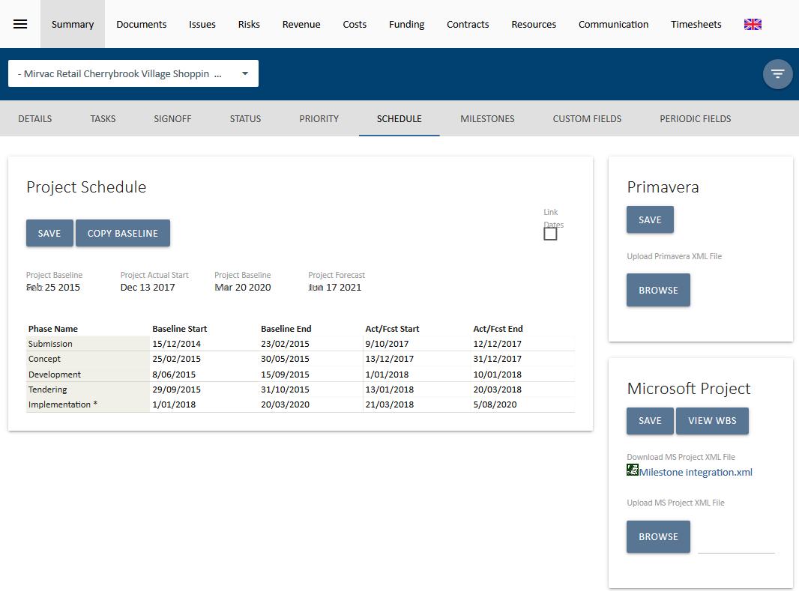
Begin by entering in the baseline dates. Even though it is optional, it is fundamental for these dates to be nominated in order for UniPhi resource planning to work correctly.
Once baseline dates are entered, use the Cope Baseline 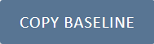 button to copy them to the forecast.

Time Dashboard
All Projects with timelines are displayed via the Reporting module > Dashboards modules
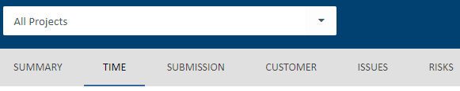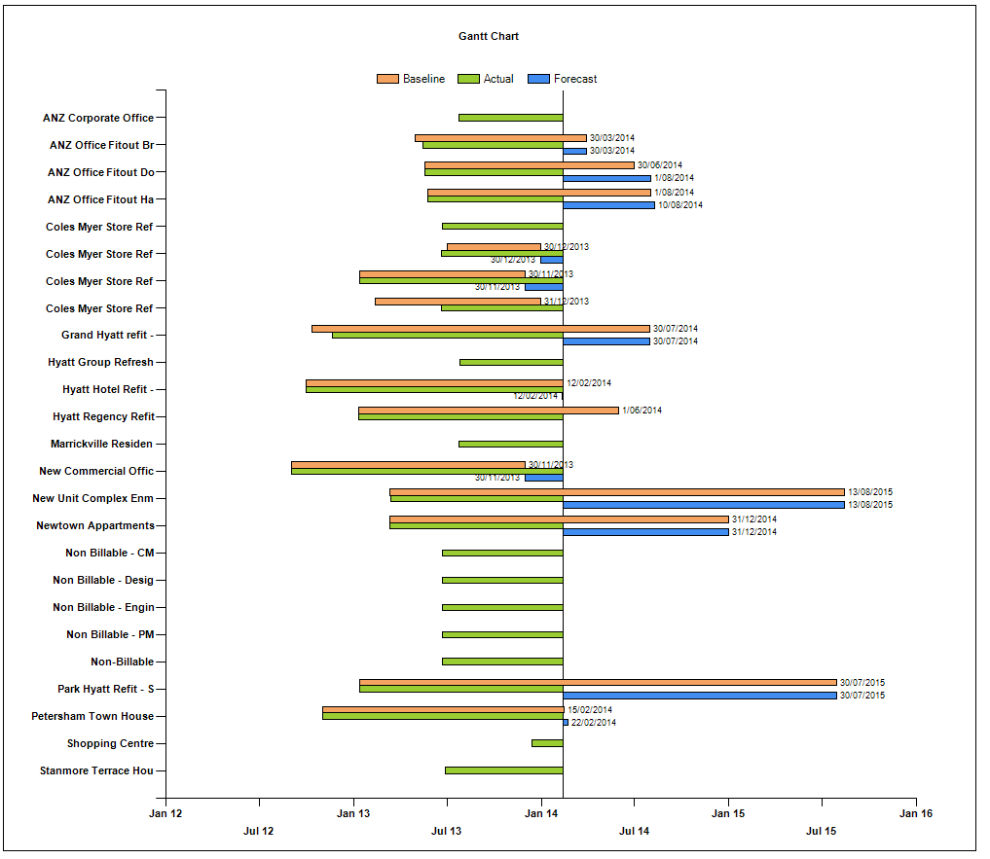
A number of filters are available to assist users / managers to focus on particular projects or groups of projects. For example, use the Project Type filter to only display all projects assigned to that type. Click the filter icon on the top right . Change the Project Type dropdown to have New Build (or the appropriate selection for your deployment) selected and click Apply.
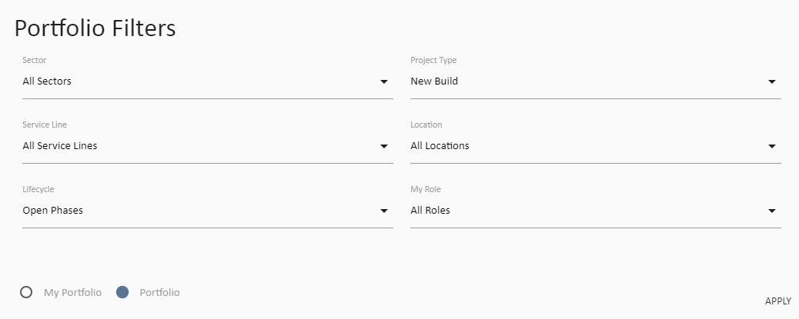
The result is shown below.
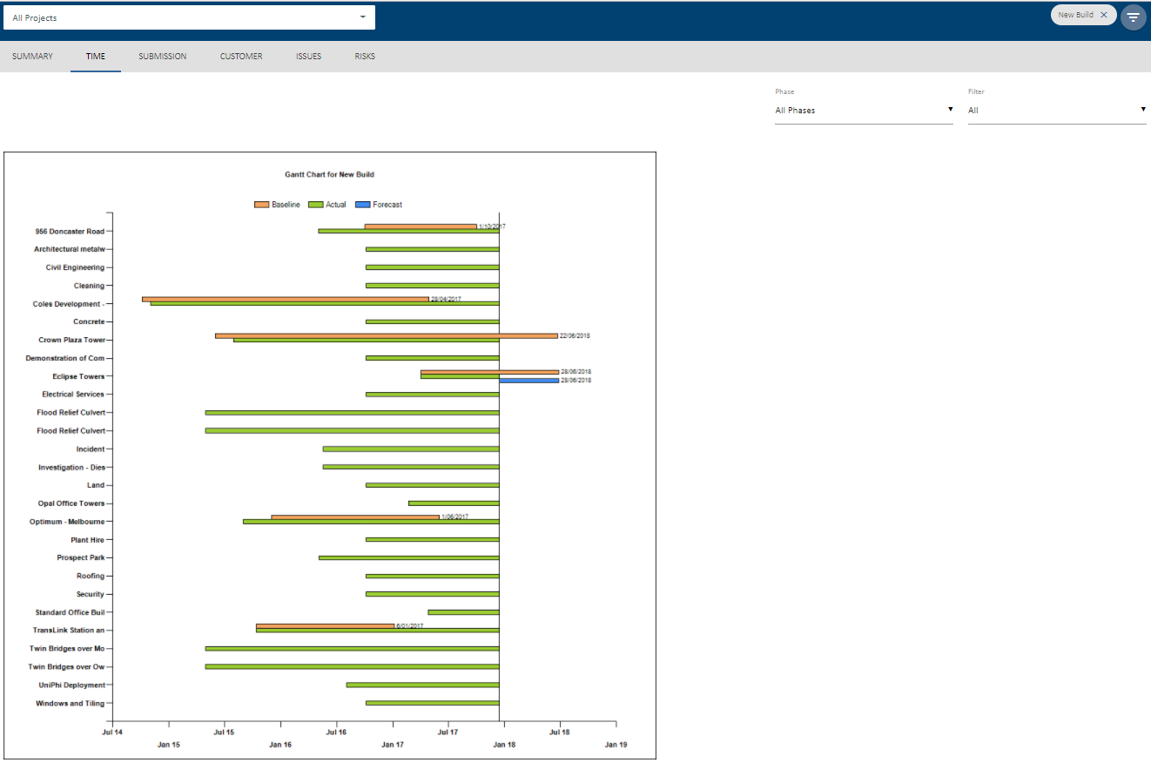
You can view a project’s detailed timeline and Gantt chart by going to the Summary module and drilling in on the project using the Project filter.
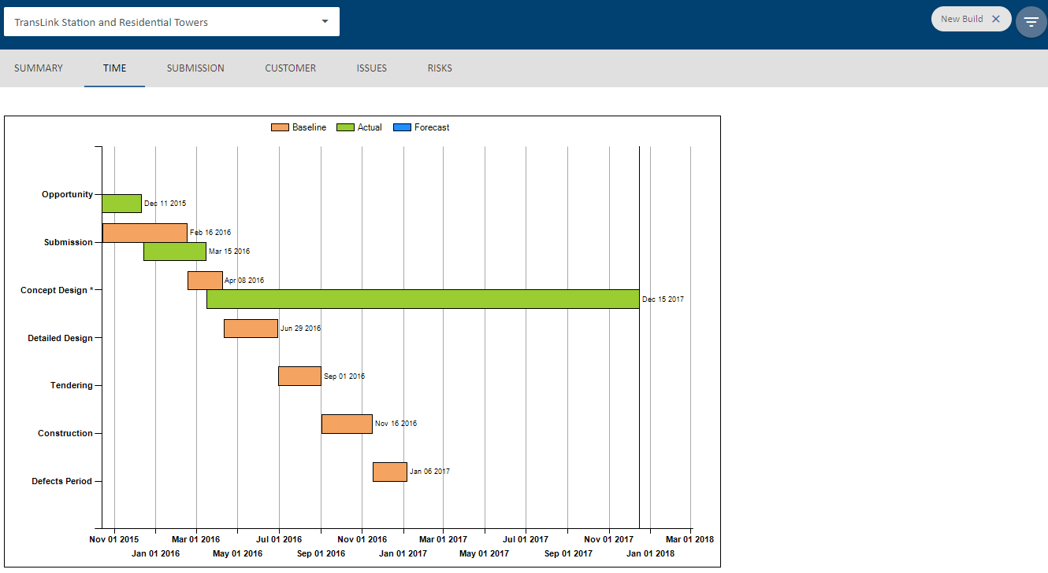
From the Project Summary page click on the 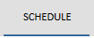 button. As forecasts and actual dates are added a Gantt chart displays the timeline by lifecycle phase.

Dates are used to assist in resource planning, forecasting costs to complete and for the timeline dashboard displaying the baseline, actual and forecast dates for the project over time.

Revenue estimations, quotes and proposals
UniPhi captures a range of information which can then pre-populated into a UniPhi document, e.g. generating a proposal for a client. The system is not prescriptive and is flexible enough to capture high level or detailed estimates. The benefits of tracking Revenue estimates in UniPhi is the flow on effect of assessing success rates across the different portfolio sectors, establishing resource effort estimates and forward workload as well as risk adjusted income forecasting both month by month and for a financial year.
Initial Revenue budgets can be populated in the Revenue module. This baselines the speculative opportunity, which can then be risk adjusted using Win % and Revenue % assessments. 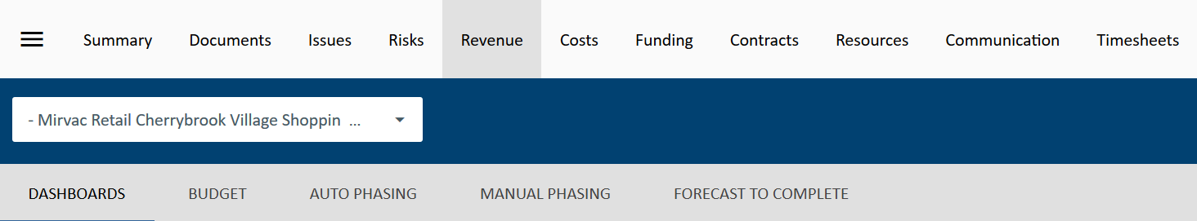
The build of the estimate is then created in the Contracts module.
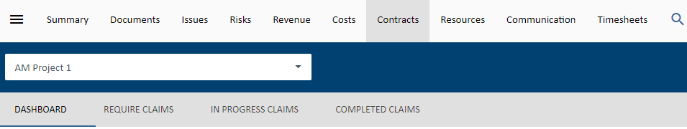
Deliverables are created and the Revenue estimate will be created. The total value will appear in the deliverable window.
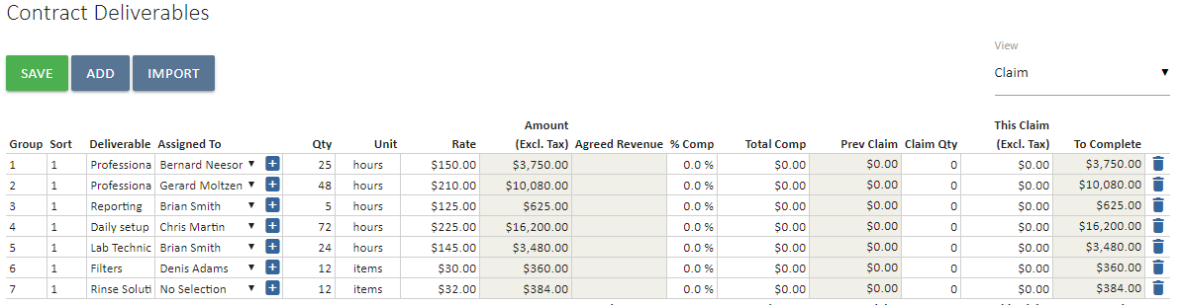
Deliverables created with resources and schedule dates applied will appear in resources timesheet.
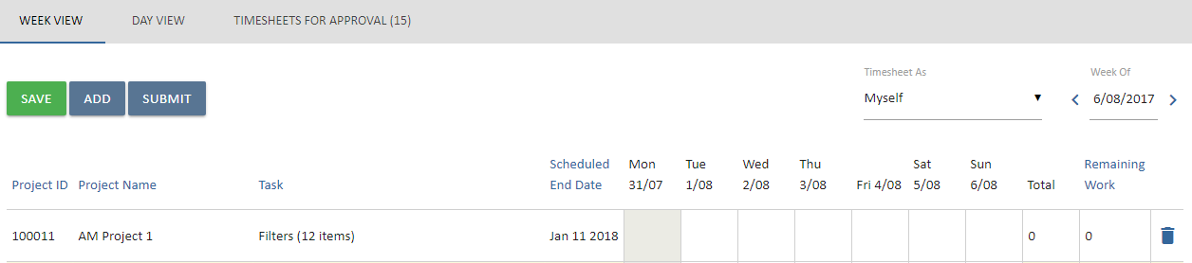
Resource hours required to generate the Revenue can be entered into the resource planning module
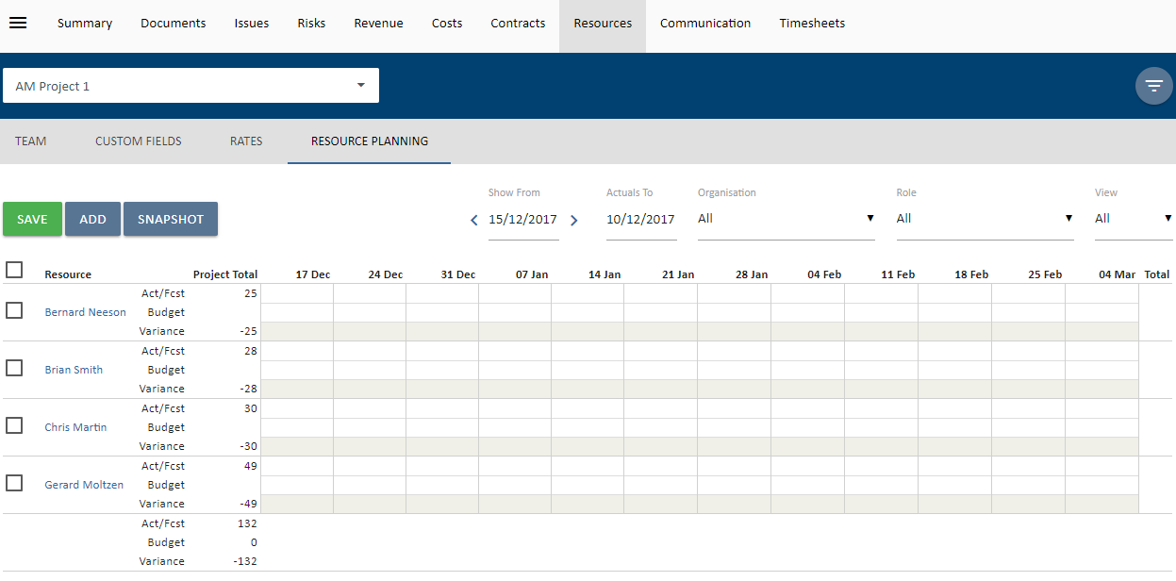
Revenue and costs can be phased month by month (adjusted for the Win and Revenue % figures entered for the project)
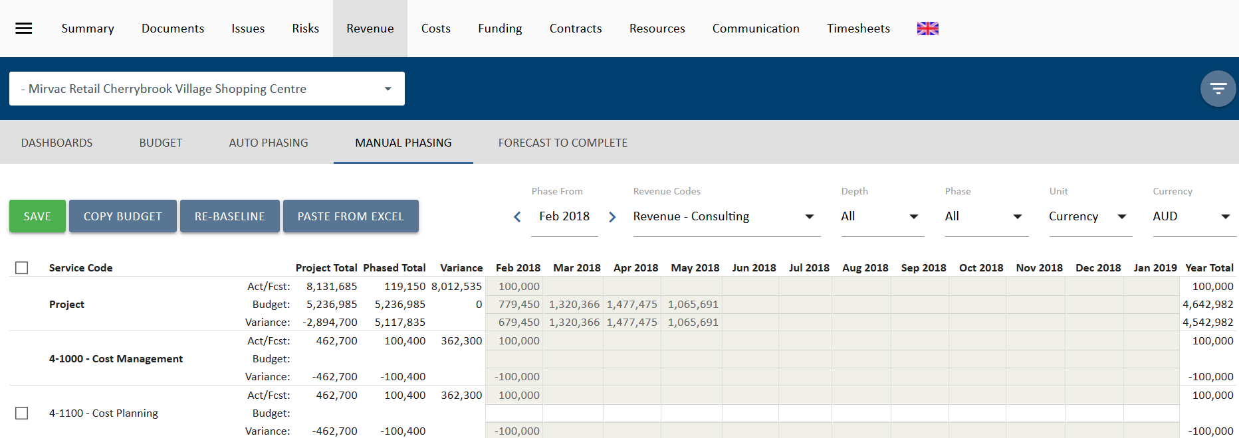
All of this information can then be leveraged into the actual quote or proposal document using UniPhi’s document management system.
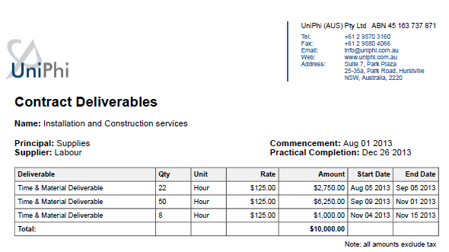

All UniPhi information can be integrated into documents and communicated to the client and project team via email and version controlled.
Emailed documents are time and date stamped to create a transmittals register
Data in once – enables population of contracts, documents, timesheet task, resource planning, Revenue and cost phasing feed into reports
UniPhi philosophy of enter data in once and use many times is prevalent in the creation of Revenue estimations and creation of quotes, proposals through to contract documentation
Revenue Budgets
When a project is in its early pre-sale phase, an estimate of the potential Revenue can be made in the Revenue module. The Revenue budget screen has an “N” level code structure which allows Revenue estimates to be structured to the appropriate level of granularity. By default, the Revenue structure as defined in your Revenue Chart of Accounts will be displayed.
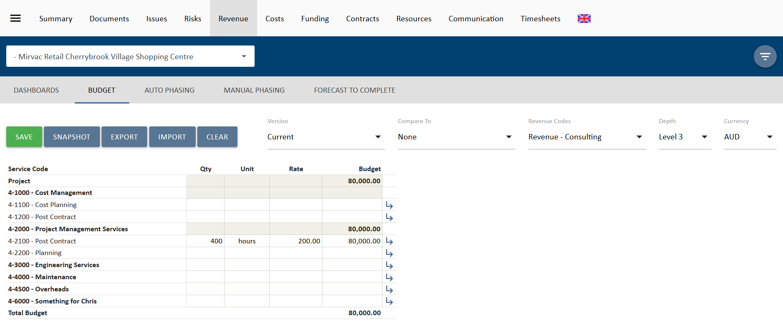
The Revenue budget system has three value fields (qty x unit x rate) to capture each line item’s quantity, unit description field, and a rate. Data can be entered into these fields to determine a quick estimate of the potential Revenue or a total can be keyed in under the budget column if the estimate has been calculated in another system.
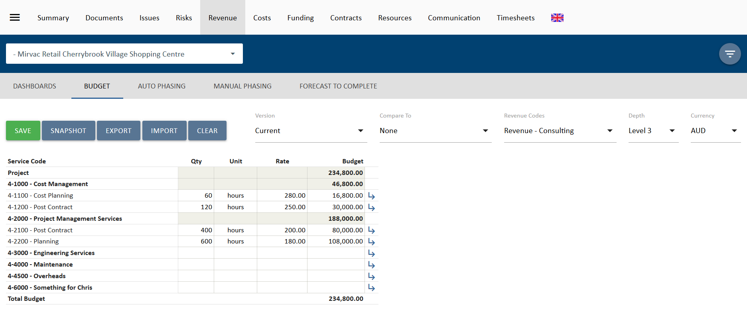
If the structure that is shown by default (i.e. your Chart of Accounts) does not provide sufficient detail, you can expand on the relevant code by pressing the magnifying glass, and adding in the required detail:
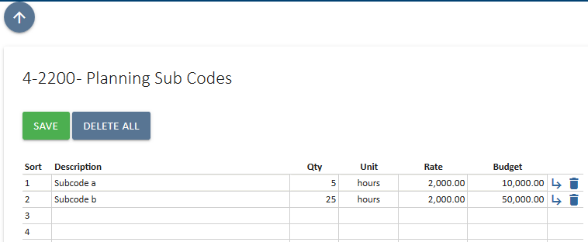
Once saved, clicking the will take you back to the Revenue Budget screen & now there will be an additional Depth level, Level 4 in this case. Selecting Level 4 will reveal the entire budget.
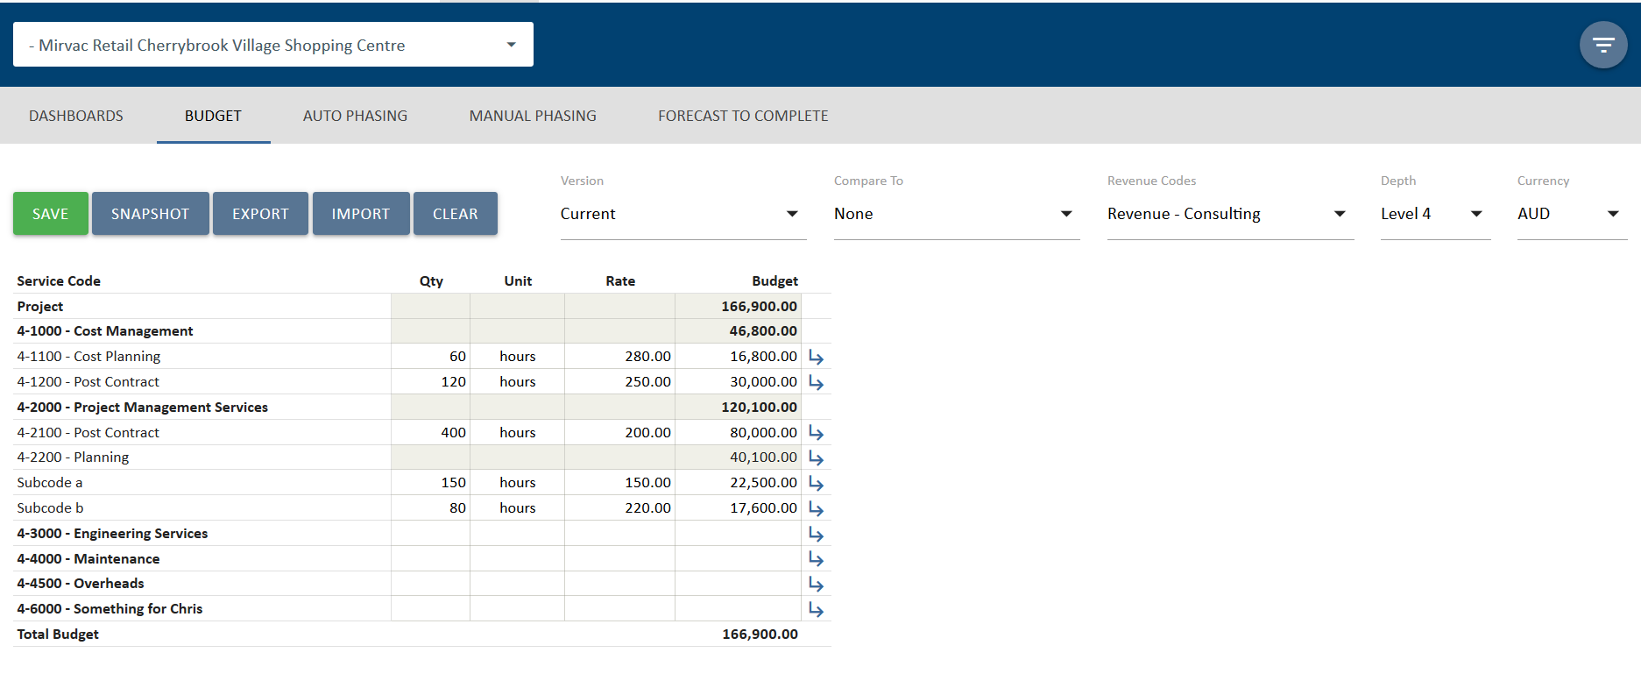

Importing Budget via Excel
As a faster method of creating your budgets, you may also choose to import your data into UniPhi from Excel. The excel sheet may be configured by an individual, or by exporting a similar budget from UniPhi and then importing the extracted format into your required project.
- Filter for the project you wish to work on from the Projects filter
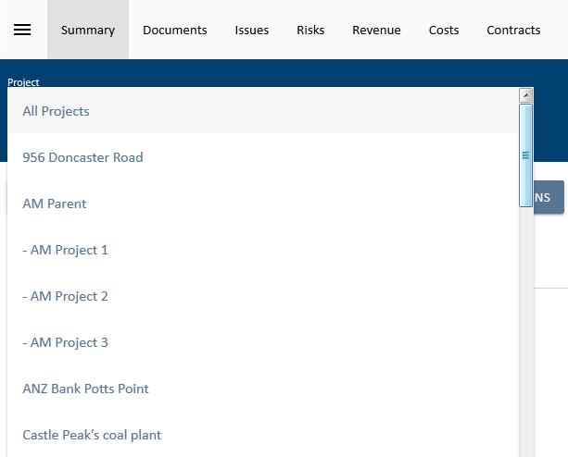
- Click on the Revenue module 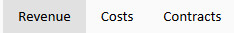and then on the navigation bar.
- Firstly, in order to generate an excel template which contains your cost code structure, click on 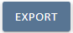
- Within the excel template, either copy/paste your budget from another system or spreadsheet in order to align it with the required format to import into UniPhi.
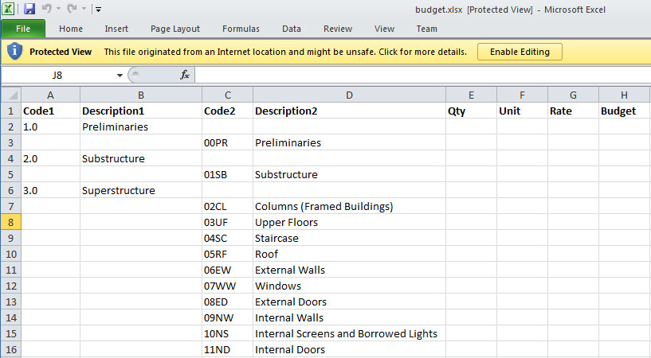

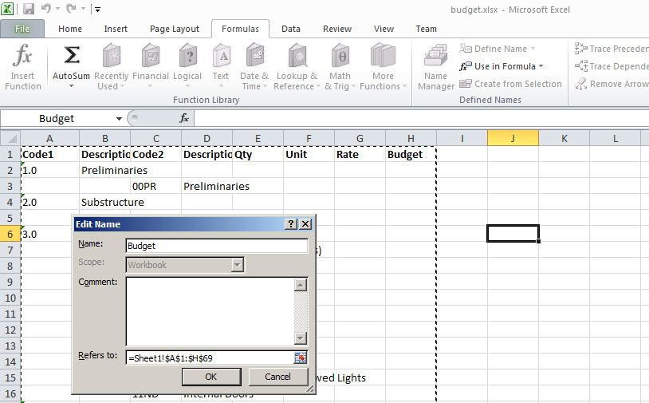
Note that the spreadsheet template has a name range called Budget which encompasses the rows and columns to be imported back into UniPhi.
- Once you have filled in the budget spreadsheet template, click on 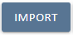 in order to bring those values into UniPhi.
The most important thing to note here is that the Levels of information are structured so that Level 1 is captured in Column A under the heading Code1 and its description is captured under the Description1 heading. Level 2 must be indented so that is appears under the heading of Code2 with the corresponding description being noted under Description2. Multiple subsequent levels may be added so long as the same structure is used. For example a sub-set of Preliminaries may be added by inserting a column called Code3, and Description3.

Phasing a Revenue Budget
The Revenue can be phased by clicking on the 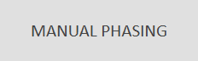 icon. The resulting screen will be displayed:
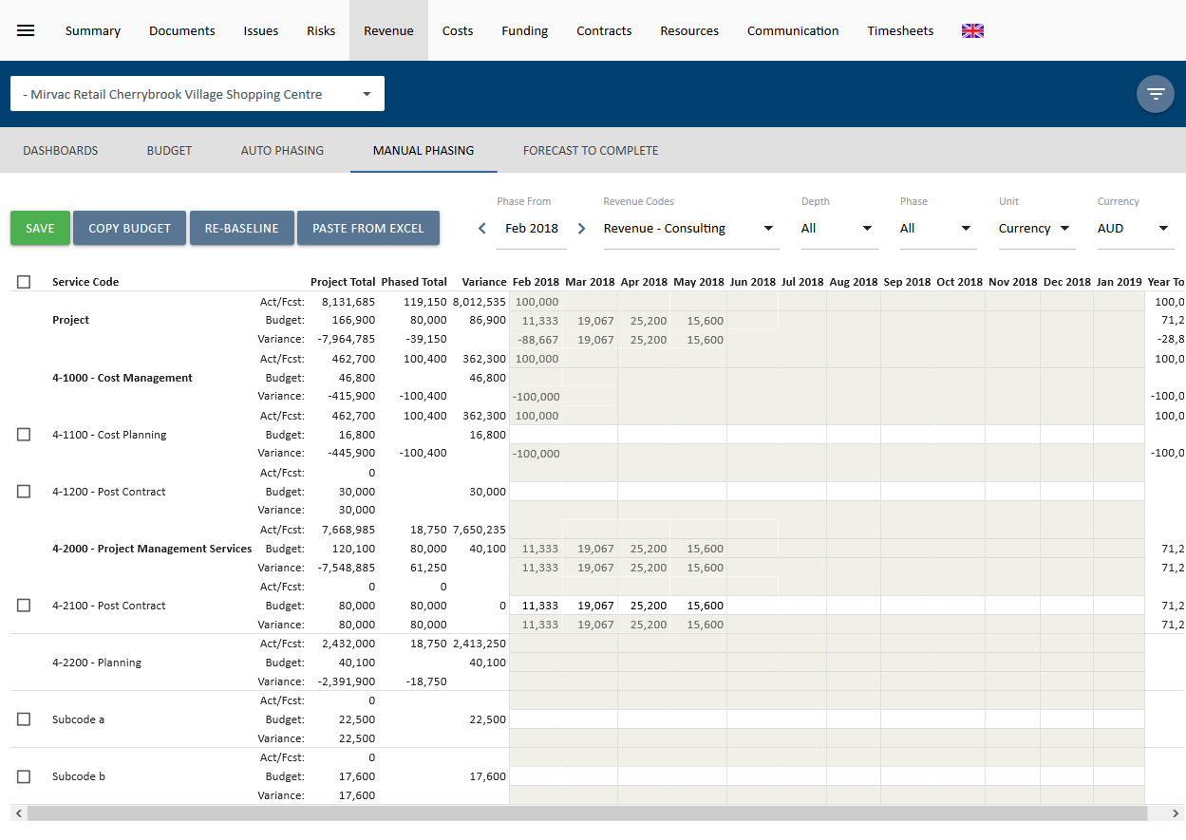
The above view presents the Depth level of All. The Depth filter displays the phased budget to be presented at the desired level. This is a useful way to hone in on a particular budget level. For example viewing a budget phase at Level one will show a high level summary view of the phased budget, whereas selecting the All level will include each depth level, and any corresponding contract values. (See Contract Phasing for more info)
The Phase filter gives the user the option of specifically phasing either the Actual/Forecast Revenue, the Budget Revenue, or both.
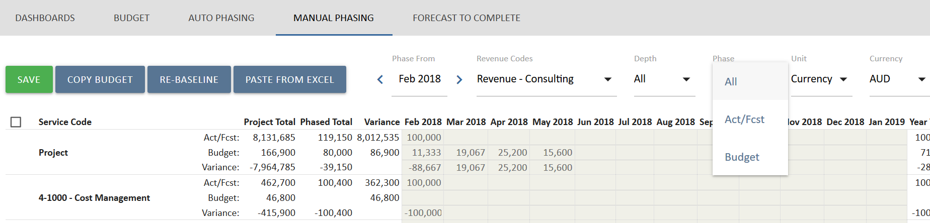
Phasing can be done via a number of methods, including linear, monthly, annually, or according to an s-curve algorithm. To perform an auto phase, press the 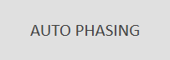 view.
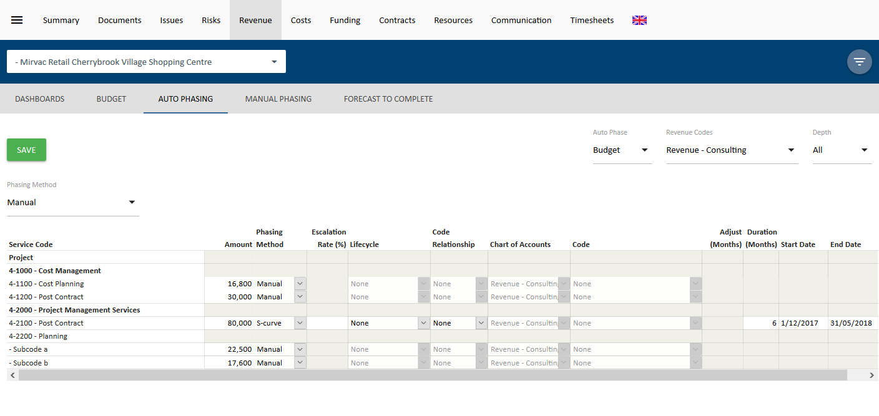
The Global Options panel allows user to select the following:
Auto Phase – Select whether the Budget or Forecast is to be phased.
Phasing Method – UniPhi allows users to phase according to various methods. Benchmarking method phases the current budget according to actuals from previously completed projects. Alternatively a linear method such as Monthly, Quarterly, Half Yearly, and Yearly are available.
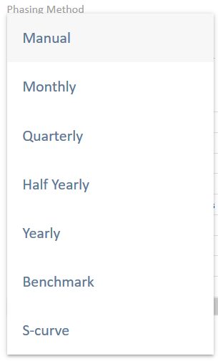
Once your phasing method has been selected you may choose to apply phasing to a particular lifecycle phase or simply phase at a global whole of project level. When phasing according to any of the options you will be presented with set of configurable phasing options.
If phasing via a linear method, you will specify the start and end dates:
If phasing via Benchmark method you will be presented with organisation specific custom fields that allow you to selectively choose projects of a similar size and nature. The projects that are displayed within this screen are those which have moved to a completed status in UniPhi.
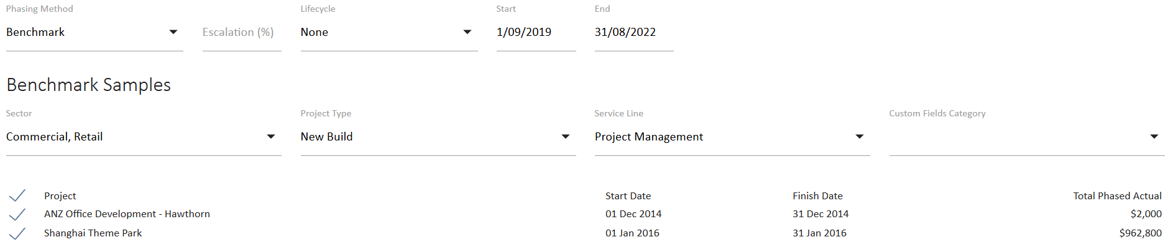
Selecting the Manual phasing option allows you to specify how each line item is to be phased.
Once the phasing method has been selected, the fields for individual line items will be editable therefore the user is able to overwrite the Global Options at each individual line item.
When phasing Cost budgets you are also able to adjust the start date. In effect this retain all of the phasing that has been applied to your project to move backwards (project delay) or forwards (early commencement), without losing any of your information. You may also wish to shift the start dates of select line items, or to shift all phased costs.
Where a relationship exists between costs or Revenue line items, you can auto-phase accordingly. In the example below the Post Contract work is set to commence once the cost planning workshops have been completed. UniPhi will recognise this relationship and phase automatically.
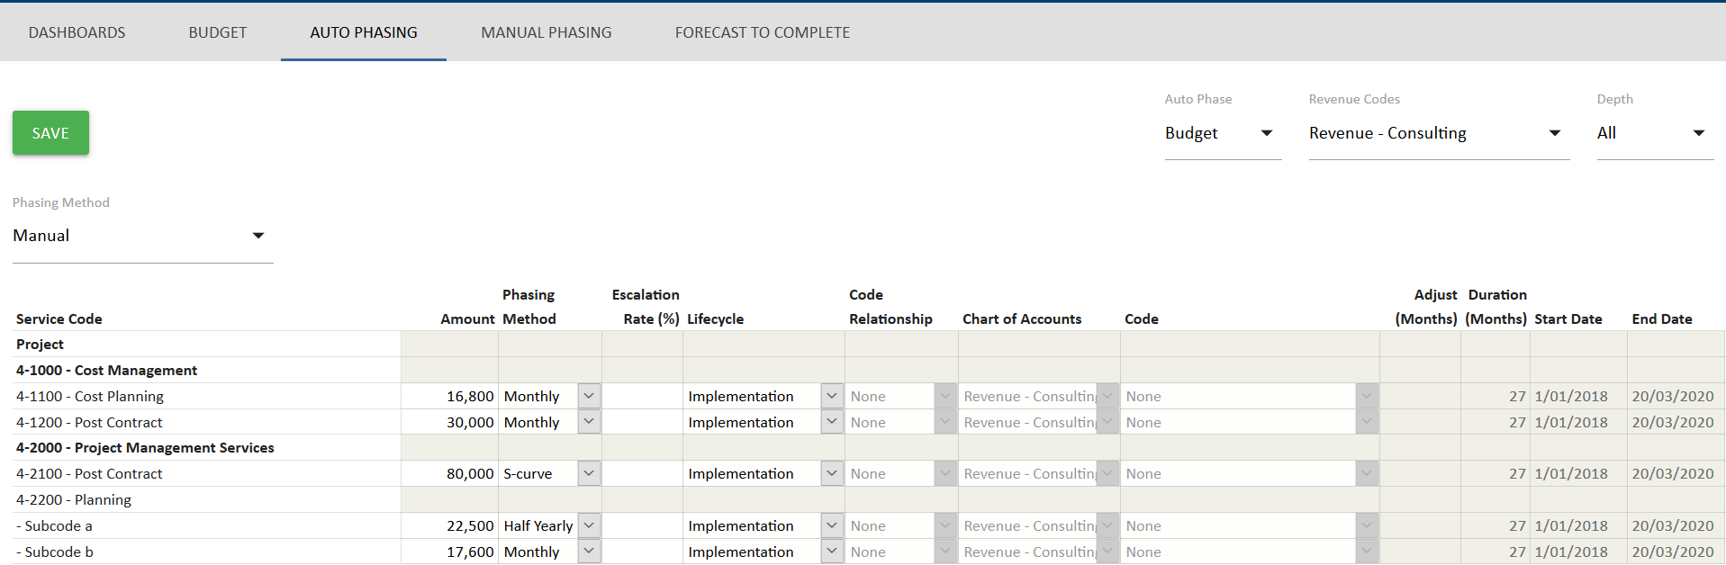

Importing Actuals or Forecast values
UniPhi allows the importation of values for projects against account codes via a CSV formatted file. This allows the user to either import actuals (closed financial periods) or forecast (open financial periods).
The CSV sample file can be found when “All Projects” is selected in the Cost or Revenue module. This function and the instructions that follow will work for both.
- Download the sample CSV file by clicking Import Phasing icon 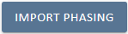 and clicking the Sample File link.
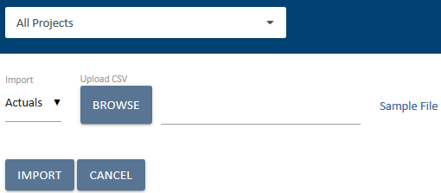
- In the sample file, there are 4 required columns to fill. Each row relates to a $ value entered in UniPhi against an account code for a particular month end, for a particular project.
You can enter data for multiple projects to be imported within the same csv.
- Once the data is entered, save the file as a CSV and import into UniPhi. Ensure to correctly select whether the import will be Actual or Forecast.

Paste Phasing from Excel
It is also possible to paste phased data directly from an Excel file. This can be done for Actuals, Forecast and Budgets.
- In the Revenue module in the Manual Phasing view select Paste from Excel to open the Paste Form Excel window.
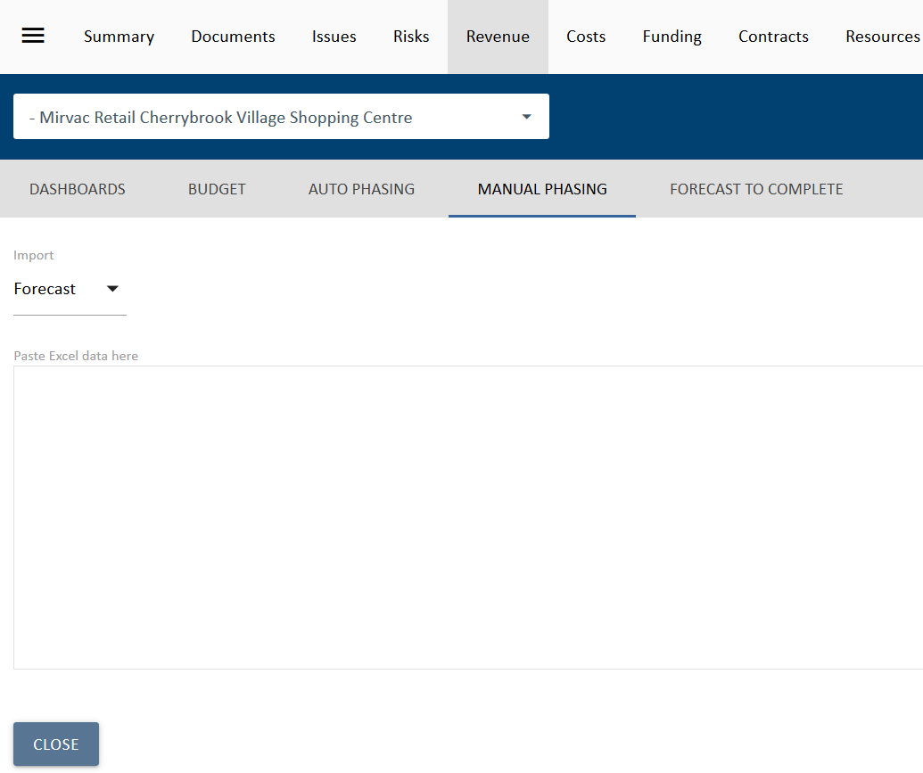
- Select if you want to import Actuals, Forecast of Budget from the drop-down selection.
- Select the data you want to paste in form you Excel spreadsheet and copy it in Excel (Ctrl-C).
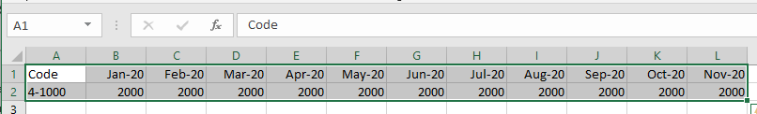
- Paste the data (Ctrl-V) into window below the text “Paste Excel data here”.
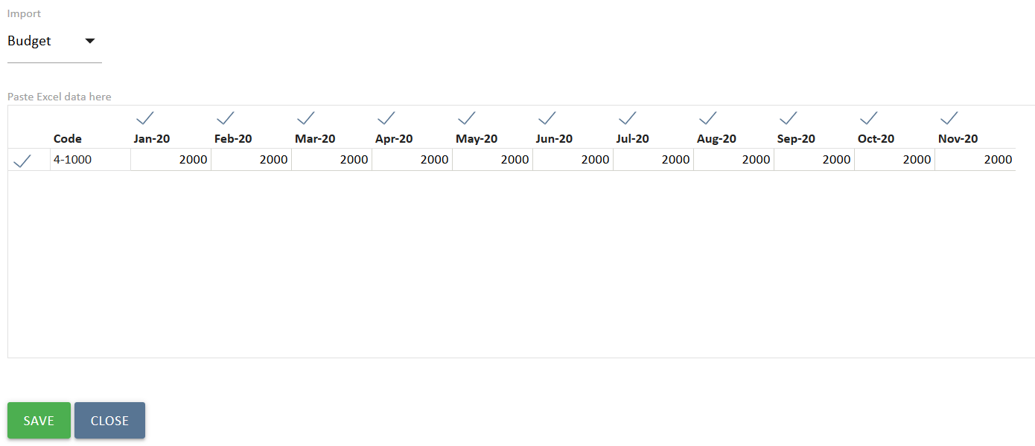
- UniPhi will validate the data. If everything is ticked then it is fine to import. Select Save .
Actuals and Accounting integration – if your UniPhi deployment as linked to a financial or accounting system, then you will not be able to import actuals (CSV or Paste from Excel) for internal costs and revenue Charts of Accounts. This is because the financial system is the source of truth for this data.

Create Budget Snapshot
When a budget that has been agreed with key stakeholders, it should be baselined. Subsequent budget versions (snapshots) can be captured at any time throughout the project.
- Budget Snapshots can be captured at any time, and they can be specified as being an official budget version (e.g. either Original, and/or Approved) or neither. To create a snapshot you need to select. 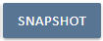
- Enter in the description of the budget, for example “Pre-Tender Estimate” and enter a date for the snapshot.
- To mark a snapshot as Original or Approved, simply create a document with a Budget control (e.g. Budget Change Request) and select the relevant snapshot from the “Version” dropdown list as shown below.
- It is important to note that it is possible to create a budget as Original and Approved at the same time. Doing so, will overwrite any pre-existing Original and Approved budgets. When the document is signed off the process is complete.
- To overwrite a Budget, the snapshot needs to be created in the document and approved. Creating a snapshot with the same version number in the Cost module will give the following error message.

Overwriting a budget snapshot
If you enter in the snapshot description the same name as a previous snapshot, the system will overwrite the old snapshot with the new one. You will be prompted to confirm you want to overwrite the old budget.

Comparing Budgets
Once you have create a snapshot of your budget, you will be able to compare budget versions. This is useful to analyse the impact to your budget as changes are made. To compare your budget versions, simply select the relevant snapshots available in your Version, and Compare To drop down boxes. This will then display variance at the project level, and at the code structure level.
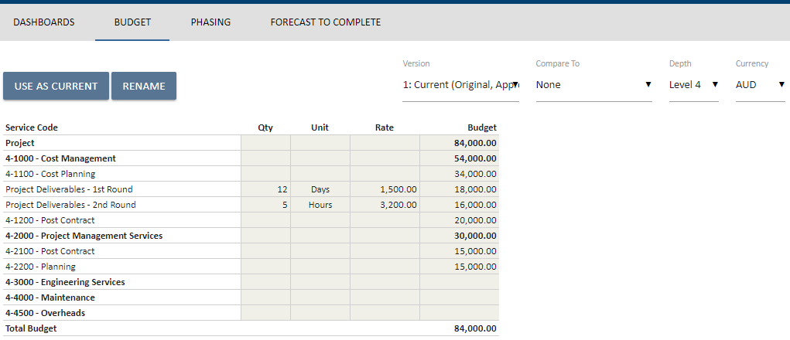

Cost Budget Summary
UniPhi will display your cost budget summary within the Cost module.
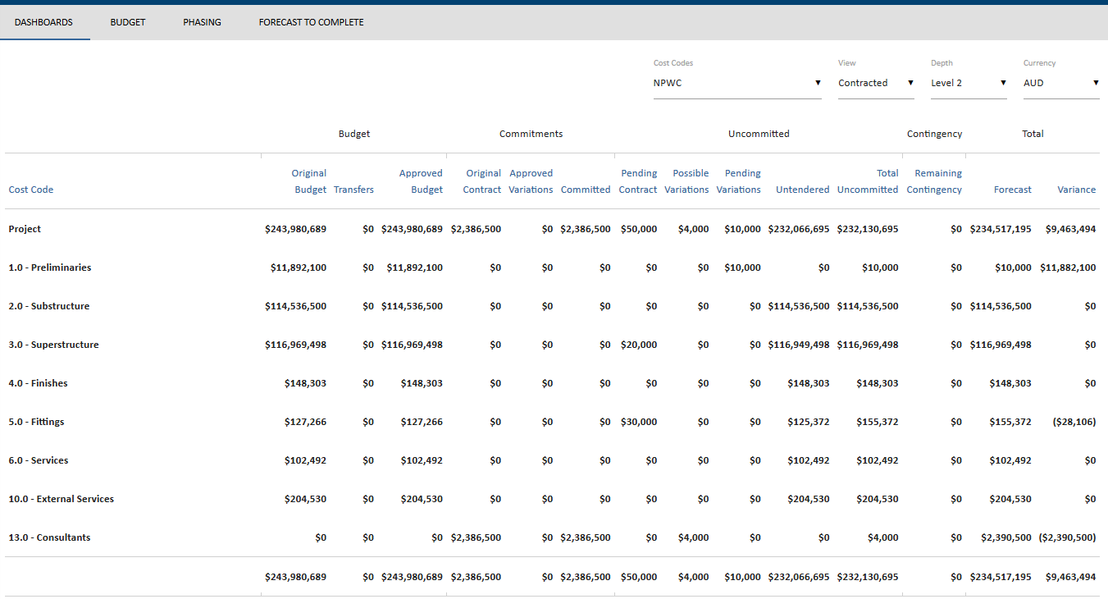
The grouping of information is such that your Budget will show:
- Original version, the current budget and any transfers which have occurred.
- Commitments, which groups your original (i.e. signed off) cost contracts, and any approved variations to total your commitments.
- Untendered column, displays any amounts which are anticipated, but not yet committed. The columns displayed in the untendered column include pending contracts, possible and pending variations, and untendered amounts.
By default UniPhi won’t know what the amount of untendered costs is, until you enter this information.
Untendered Amounts and Forecast to Complete
PIMS will report and display the untendered amount in one of two ways – automatic calculation, or manual calculation. The easiest way for most people is to use the Forecast to Complete auto calculate feature.
Go to your cost module, project budget, and press the forecast to complete.
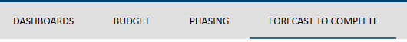
You’ll notice that the Untendered column is now editable. 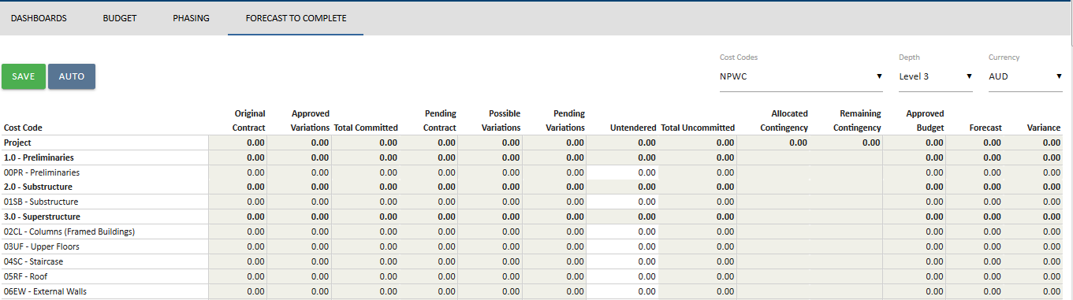
You may choose to enter these values manually, or select the Auto button. This feature takes the budget amount and subtracts any committed signed off cost contracts
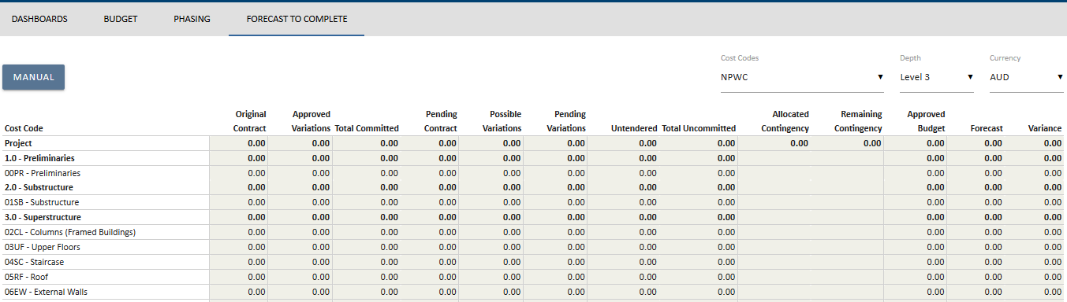
The untendered amounts will then appear in the cost module, and in the cost reports.

Estimating
New quotes and proposals can be estimated in the contracts system. Each deliverable estimated is mapped to the Revenue codes used in the previous section thereby updating the forecast Revenue for the project. This can then be used to re-baseline the phased budget by clicking on the 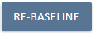 button
Creating Revenue estimations
Filter for the project you wish to work on from the Projects filter
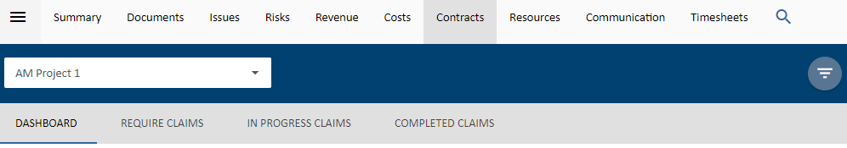
Go to the Contracts module and click on the 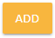 contract button and select the Revenue contract to build your Revenue estimation
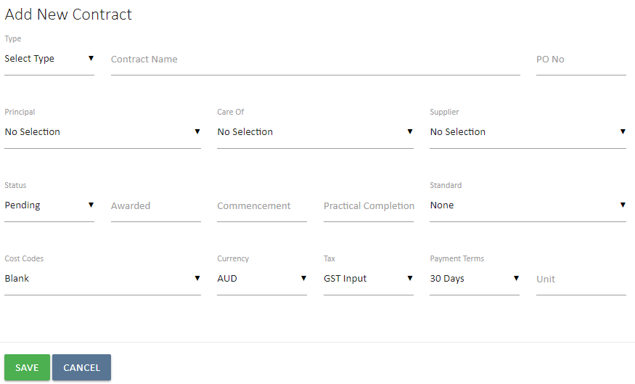
The following items are compulsory on the contract form to enable the contract to be created:
Type used to select if the contract is a Cost or Revenue contract. For Revenue estimates the type is always revenue
- If revenue is selected then internal resources will be available in the supplier field and vice versa for Principal.
- If cost is selected, then external resources will be available for selection in the supplier field.
Revenue contracts can form part of an overall cost to the project or be the head contract for the contractor with sub contracts being cost contracts. The former method is used by project managers or cost consultants representing a client and the latter method is used for lead contractors. If you are none of these types of organisations then the costs contracts is unlikely to be used and you will mostly select revenue contracts.
Contract Name – the name or description of your contract. This can be similar to the project name but may distinguish the type of service or product being offered in addition.
Supplier – this is the person who is lead contact for the company responsible for the deliverables.
- If the contract is a revenue contract then you are the supplier and a list of internal resources who have been allocated to the project during the project creation step (see previous session) are available for selection. Select the person who is responsible for client liaison for this project.
- If the contract is a cost contract then the supplier list comes from external resources that have been allocated to the project during the project creation step. Select the person you are going to liaise with on the supplier side.
Status – The status reflects on the stage a contract is at.
- Pre-award or pre-sign-off a contract status can be set to Pending.
- If it is accepted by the client it is moved to an Active contract status.
- Once the work is complete it becomes Expired.
- If the contract isn’t awarded then it is Cancelled.
Revenue Codes or Cost codes – Chart of Account codes that each deliverable is applied against to track an overall Revenue.
- This is how the contracts module integrates with the Revenue and costs module.
- The Revenue and costs module display consolidated figures for all contracts on a project as well as for all projects in a program or portfolio. These figures are derived from the codes allocated to deliverables and variations in the contracts module.
Select once you have added in the compulsory fields above and this take you into the body of the form for deliverable creation.
The following are optional fields for the contract creation stage:
Principal – The principal is the organisation that will be liable for payment of the resulting contract services. For revenue contracts, this is the client to whom you are quoting. (However, a principal is required to be entered so you can raise invoices or progress claims).
Care of – used if someone else is responsible for approving invoices for payment and hence need to be addressed to this person/company
Awarded – Date the contract is won / approved and moved to Active. This can be a forecast date which will be useful for forecasting purpose
Commencement Date – the date the contract will start (if known) or started as per the contract document. This can be used to drive the deliverables schedule. Changing the commencement date changes all the deliverables by the same difference in the change. For example, push out the commencement date by one week and all start and end dates in the contract are pushed out by one week.
Practical Completion - Expected date when project will enter defects liability. (As lawyers can’t decide what this term means we leave it to you to decide). If not a construction job then this is the date that all deliverables will be completed.
Standard – The contract standard drop down displays standard Australian contracts. The selected value allows you to nominate the Australian Standard or General Condition contract that will be used to administer the project. This is purely for communication purposes so that others will know what type of contract you are administering. Your administrators can add in additional contracts if they are not displayed in the list.
Unit – This box allows for a default unit for time and material type deliverables. If the contract deliverables is long but the units are the same (e.g. days or hours) then typing in a default value here will result in each new line will have “days” or “hours”

UniPhi resource planning from contracts
It is crucial to have Units for each time and material described if you are going to import time from the contracts system into the resource planning system.
Currency - this represents the currency the contract will be quoted and awarded in. UniPhi will convert the currency if it is different to the project currency when displaying the values in the Revenue and costs modules.
Tax – defaults to GST but can be set to None if appropriate. Once the contract is saved it will now appear with additional details;
Related Templates – These templates are contract related templates. Each template will derive information from the contracts system
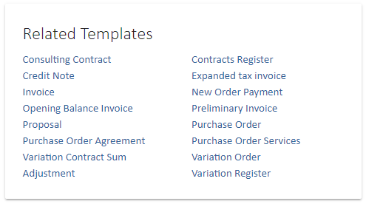.
Billing Details – When you select a principal, their address details will be displayed here. If you have also selected a care of then the company name of the principal will be displayed and the address and attention to for the care of will be displayed underneath.
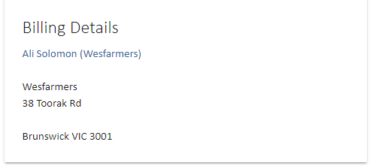
Creating contract deliverables
These are the building blocks for creation of the contract you are managing and will provide you the overall total. Deliverables are used to raise progress claims or invoices for your clients.
Contract Deliverables window – this is where you enter in the deliverables (services and materials etc.), assignments, dates and rates for the contract.
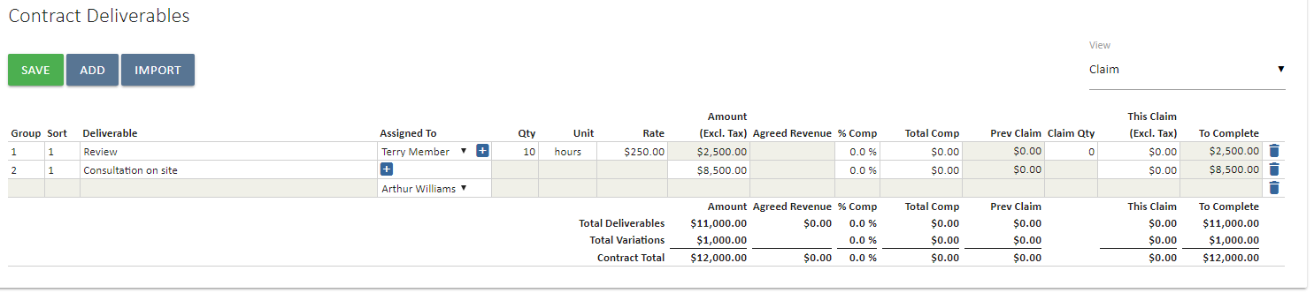
Deliverable Types: There are a number of different deliverables types and these are explained below. Please read carefully as the different types available dependant on the client and your requirements.
Lump Sum – This is used when the contract is fixed price and will be progressively claimed against over time. Note you can use a rolled up heading with time and material below it to invoice lump sum while tracking time and material on the job. This means you can then import resource hours into the resource planning screen, have staff timesheet to the actual deliverables and track consumed time versus planned.
Time and Materials – This is when invoicing will be done based of effort x a rate. You will need to enter in a Quantity, Unit and Rate for each deliverable noting that the unit can come from the default unit set for the contract (as explained above).
Item – This type is selected when disbursements are included in the value of the contract. As disbursements are not progress claimed but claimed 100% in one invoice, they are differentiated in the list from lump sum deliverables. An item amount will not be included in the Agreed Revenue column of a “Lump Sum” view when rendering an invoice.
Heading – This inserts a heading rather than details. Please see next page for more details on Heading types and their purpose / use.
Disbursements – If disbursements are not included in the contract value then use this option when invoicing as the disbursement items will appear in the invoice but will disappear from your contract admin screen and will not be included in the agreed Revenue of the project (They will be included as revenue for the project though).
Heading Types: Heading types relate to the way information will appear in documents. Contract deliverables can be automatically including in proposals as work activity, contracts as schedule of works and invoices. The type of heading used will affect the way the information is laid out in the final document.
Basic Heading – Does no more than a normal heading in word
Heading with Roll-up* – Sums up the group of deliverables with the same order number and displays the heading line in documentation rather than the detailed deliverables underneath
Heading with Sub-Total* – Adds a total automatically in documents to the group of deliverables that have the same order number
Heading with Assignments – Used when a time and material deliverable will have multiple resources working on it. Note, this can be used as a way of calculating and tracking the lump sum value of a contract as only the heading is displayed in invoices and the layout option “lump sum” can be chosen in the invoice to layout with Agreed Revenue and previously claimed headings.
* The system knows what tasks to include under the roll up heading or sub-total heading by the Order ID. Giving deliverables the same order id means that they will be included in the same group as the heading with this order id.

Heading with Assignment or Time and Material:
- If possible, it is always more efficient to use time and material when adding resources.
- If you use the Ctrl or Shift key to select multiple resources then an assignment heading structure will automatically be created with the dates and codes for the deliverable automatically applied to each resource.
- Default rates will also be displayed for the resources selected based off the rates allocated to them in the resources module.
Click the 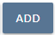 icon and a form will appear as per below. Select the Type dropdown box and then Heading. Then select the Heading Type dropdown and select Headings with Assignments.
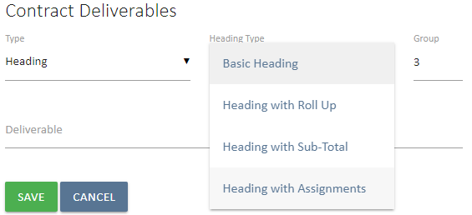
Add in the Deliverable description and then select 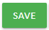
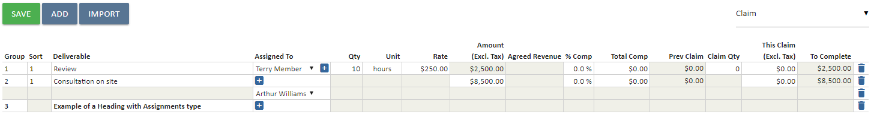
You will notice a plus sign appears next to the deliverable description. This is for adding resources to the deliverable. You can continue adding Headings with Assignments deliverables or add Assignments/ Resources as you add each Heading with Assignments. To add assignments, click on the icon and an extra line will be displayed as per below.
Select the resource and a Qty, Unit (if not set in the contract details above) and Rate (if this has not been set in Resources module).

Screen layout on contract deliverables panel: Left = contract, right = invoicing
Everything to the left of the vertical line is contract information. Everything to the right of the vertical line is for invoicing.

Time and Materials Deliverables
These enable you to enter in a description and select a resource and quantity.
Unit and Rate will be automatically populated with the default contract unit and the cost rate of the resource. These can be amended.
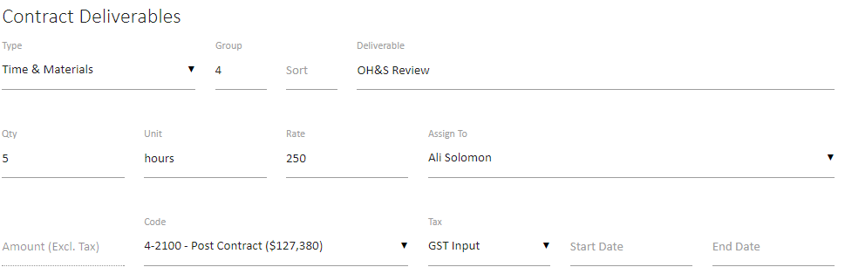
Entering start and end dates are optional but does impact on other elements of the system. The end date will be displayed in the timesheet of the resource assigned to the task and the contract invoice schedule can be automatically phased based on a linear model for each deliverable.
In the Contract Deliverables card select Add 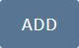.
Select Time and Materials from the Type drop down
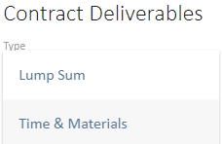
Click when you are finished adding all deliverables and the contract total will be displayed at the bottom.
The Agreed Revenue
The agreed Revenue is populated when a contract document is signed off. It is always static text that can only be updated by signing off a UniPhi document that has been flagged as being the contract document making the contract deliverables a committed cost to the client and an agreed Revenue between the parties.
Large contracts and pagination
If your contract has more than thirty lines (including assignment lines) then it will paginate in the screen. The total displayed at the bottom of the deliverable list is always for the entire contract, not for the page. To view other pages, click the page number at the bottom of the panel. To see all, click all, but note this will take time to load. The best view to see all of the tasks is the “Accounting” view as it has less fields to display (see below for more on different contract views).

Contracts Views
For revenue contracts, the system has four different views which (except for All) provide a subset of the data entered. This is due to the large amounts of data that can be captured in a contract. These views are All, Accounting, Claim and Schedule.“
The View filter within the contract provides options to change the view and you can add in data start and end dates against deliverable, amend GST and cost codes, and raise progress claims.
For cost contracts there is an additional view called recommendations – this can be utilised for cost managers to validate the amount being claimed by sub-contractors prior to a certified progress claim being raised.

All View
Displays all fields and is only useful if you have a wide screen monitor with a large screen resolution (greater than 1280 x 800).
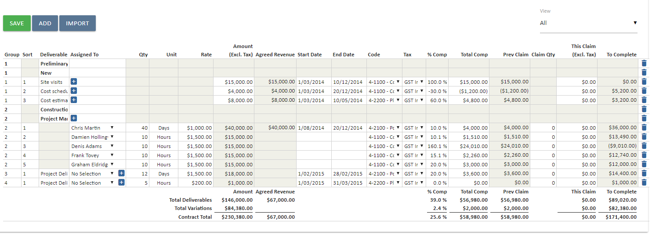
Claim View
Claim view is the default view and displays everything except account codes, GST selections and start and end dates. This view is used for raising invoices. Everything to the right hand side of the vertical line relates to progress claims to date. Each invoice will have its own claim quantity and over time the total hours will increase.
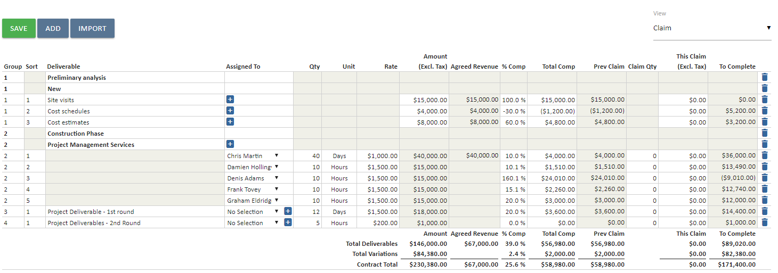

Schedule View
The schedule view enables you to capture expected start and end dates for deliverables. This will flow through to the lifecycle schedule and allocated hours per resource over this period. By capturing this information it is possible to get an understanding of forward workload for staff and identify where over allocation issues may exist. Note, it will soon also be possible to display a Gantt of this information for your client’s benefit. 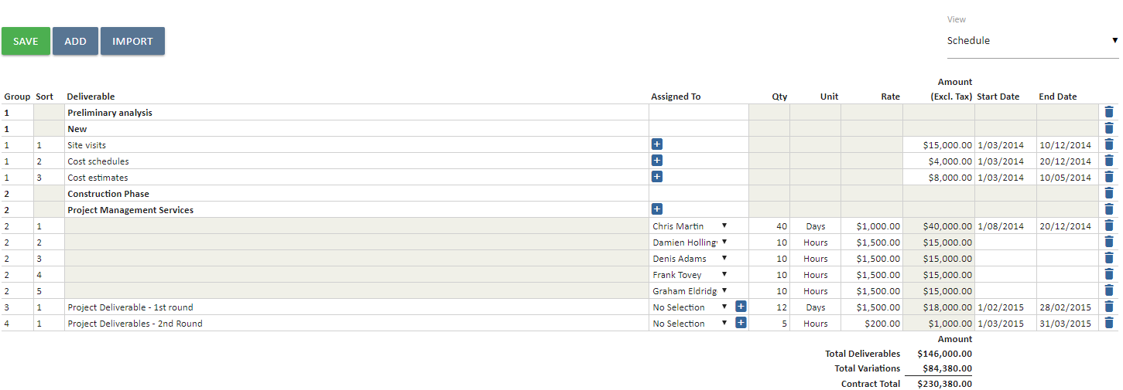
Accounting View
This view allows you to check that the correct Revenue code has been selected
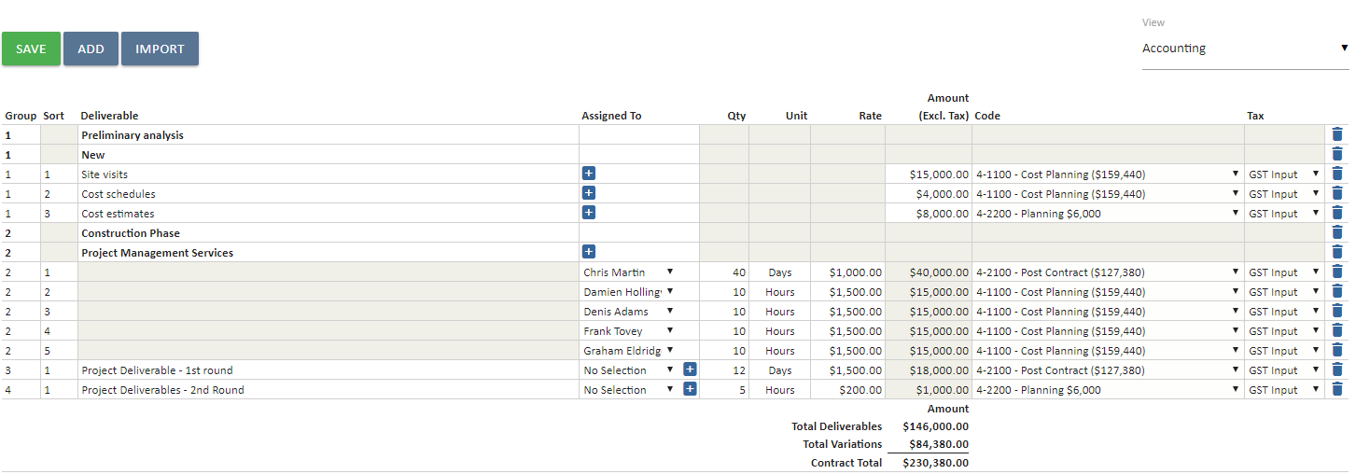

Recommendation View (Cost Contracts only)
Utilised to recommend the amount that should be claimed by cost managers prior to raising a certified progress claim.
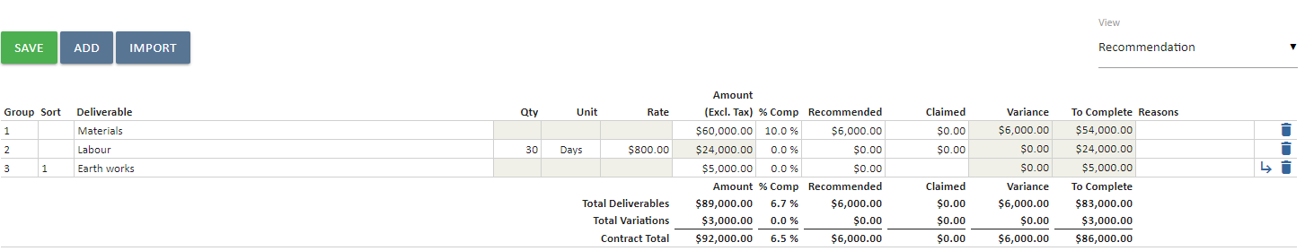

Dates and Time sheeting
The start dates and end dates are also used in the timesheet system to assist team members to filter their timesheets to only display deliverables that are scheduled within a certain timeframe. This allows the team member to create a more manageable timesheet. If there are no dates but there is a qty and a rate entered then all tasks will be displayed in the timesheet by default when the project is added.
Timesheets date will be displayed underneath the claim as per the screenshot below:
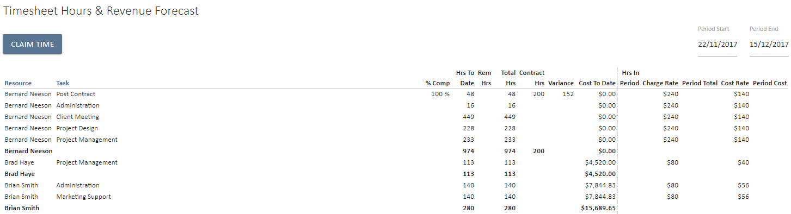

Importing contract deliverables

UniPhi allows for Contract Deliverables to be imported directly into the contract page via an Excel spreadsheet. As per the screenshots below, we are using the sample files to import deliverables.
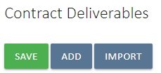
In the Contract Deliverables module, click on Import Deliverables and click on Sample File and save the Excel file.
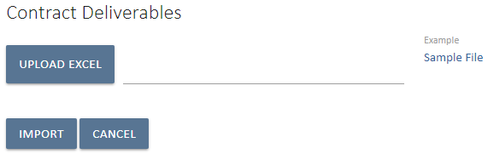
Opening the Excel file will reveal a sample data structure which must be followed for a successful import. It is a useful starting point that the end user refers to the sample file.
The following should be noted before proceeding further with importing deliverables:
- Row 1 in the sample file should not be deleted. This Row is required for successful importation of deliverables.
- Each row in the spreadsheet should be treated as an individual row in the contract deliverables page in the UniPhi contracts page.
Creating contract deliverables are shown below, starting with a basic heading type called Design.
Two deliverables are then added for this heading type. Architectural Services being a time and material deliverable and On Site survey being a lump sum type.
The corresponding Chart of Account code is planning which has a specified code, PL2. Once completed, the range name “Deliverables” is specified. Once all deliverables have been entered, the range name “Deliverables” must be specified. Range names can be specified via the Name Manger in Microsoft Excel.
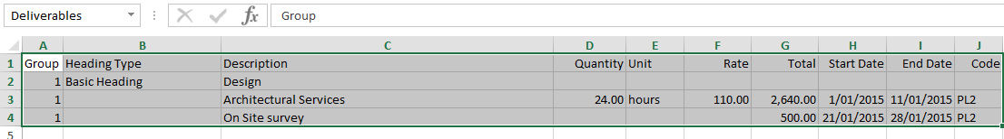
After the range name has been specified, save the working file, browse to select the file and click the import button.
The contract deliverables should now be successfully imported into UniPhi.
Column A: Group – This column corresponds to the Group field in the contract deliverables page. Enter the Group number of deliverables as you would if manually entering deliverables in UniPhi.
Column B: Heading Type – This column allows the user to specify if a particular heading type is to be used for deliverables. Enter the heading type for the corresponding row. Enter the Heading Type for the heading row only – not for all the deliverable rows that are associated.
Column C: Description - Enter the deliverable description in this column. For heading rows, enter the name of the heading.
Column D, E, F, and G: Time & Material – The Quantity, Unit, Rate and Total columns should be filled in if the deliverable is a Time and Material type. If it is a Lump Sum then leave these columns blank and enter the total in Column G. Summation formulas are accepted for calculation purposes.
Column H and I: Schedule Dates – These columns represent the Start and End dates. Enter the dates in dd/mm/yyyy format.
Column J: Code – This column requires the Chart of Account code to be entered. Only the code itself should be entered, not the full name of the account. Refer to the Chart of Account for the applicable codes.
Creating a Quote Document or Proposal
Once the estimate is completed, the quote document or proposal is ready to be created. UniPhi displays documents related to contracts as related templates. It knows templates are related to contracts when they contain document controls that pull data from the contracts module. Related templates are displayed in the top right hand corner of the edit contracts screen as per below:
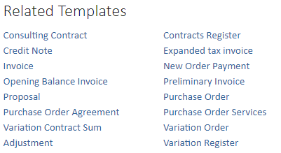
Click on the proposal template begins the process of creating the document to send to the client. A new document window will be displayed as per below:
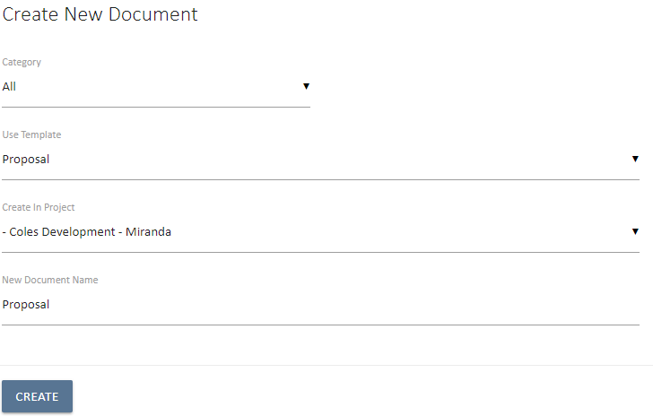
Click create and the template wizard will be displayed as per below:
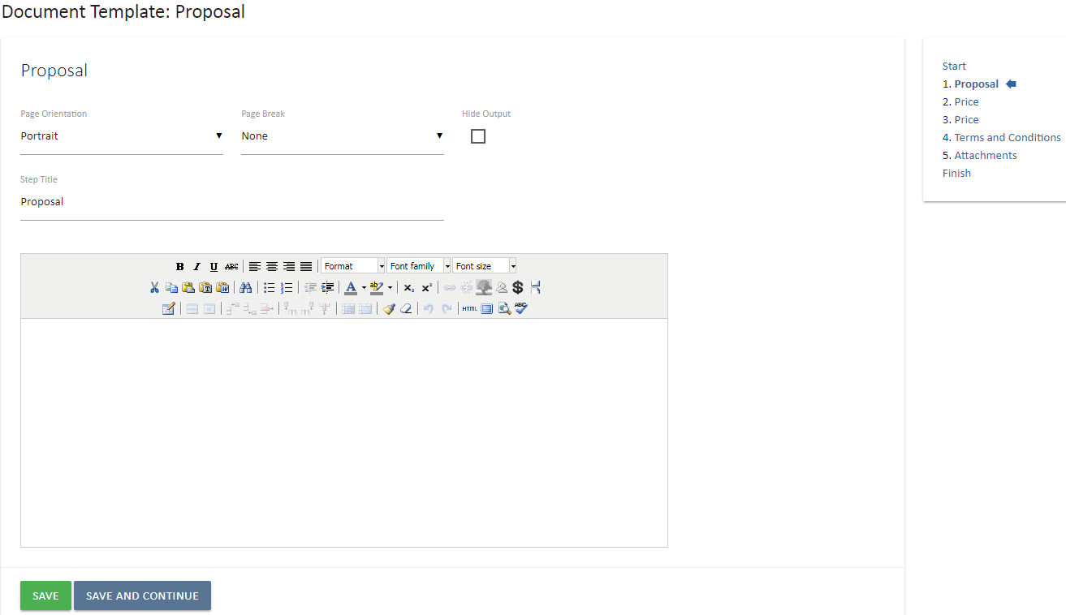
The key piece of integration is the Price and Schedule step displayed below:
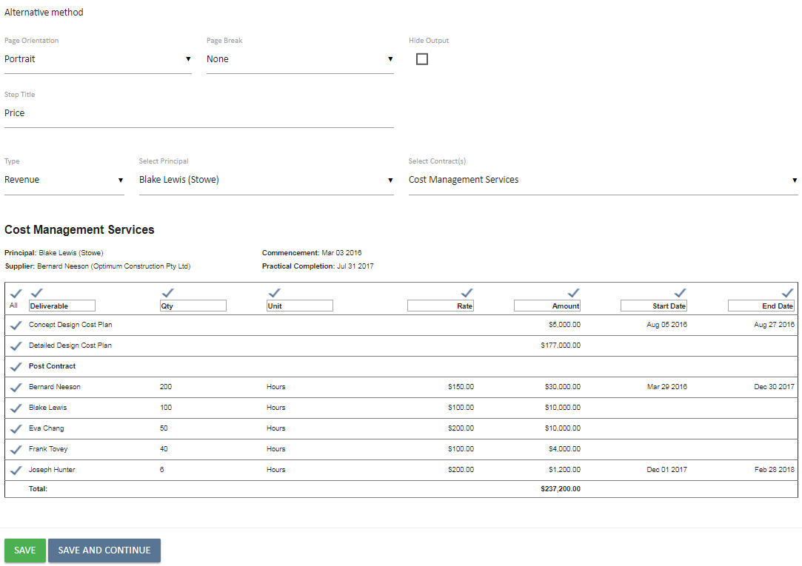
This information drawn from the contracts module will display in the proposal document as your price for the job. If you don’t need this much detail then your template can be designed to pull the value of the contract into the document using template variables. Your system administrator will assist in getting the proposal template right for your organisation.
The finish step (displayed below) will display some final options for you to consider:
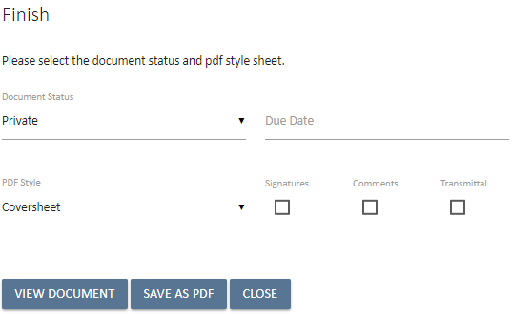
Viewing in HTML
Click View Document will view the document as an HTML version of the document you have created. The toolbar in private mode will omit certain icons, for example, you cannot copy or email a document.
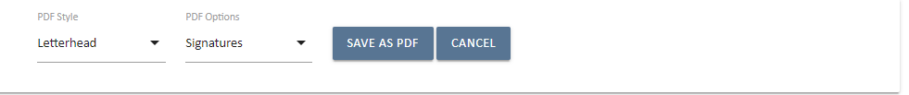
If the document is in Draft, Open for Review or Awaiting Sign off status a toolbar displayed similar to the view below will be available. This still enables you to edit , copy and email the document as well as having access to previous versions, which you can also revert back to if needed. Note, if there is a chance the client will amend the actual contract, leave the UniPhi document in “open for review”, then you can update the contract deliverables and edit the document to reflect the change. The document version will increase so you will have a full audit history of the changes.
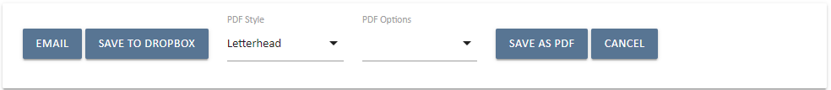
Documents cannot be edited once signed off. They can only be copied, emailed and saved as PDF as per the example below:
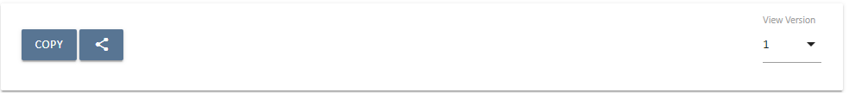
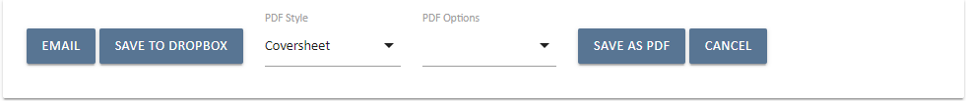
The toolbar view also above appears if a document is in the process of being edited by another person when you have accessed it and they have the document in private mode. You will not be able to edit.

What document status should I use?
There are five document status types that are used to provide version control, review, edit and finally sign off documents electronically. These are listed below:
Private - This document status is for documents that are currently being actively edited by their creator. While a document is private it can only be viewed by those who have edit rights to that document.You can select to view the document in HTML and then edit the document to continue its creation.
Draft - This document status opens a document up to be read by any other staff member in the business. A draft status means that the document is still under development, but is available for comment.
Open For Review - Like the draft status, this document status allows all other staff members to view and comment on the document. The difference is that in the eyes of the creator, the document is completed and “open for review”. Leave UniPhi contract documents at open for review while the real contract is being finalised
Awaiting Sign Off – This document status allows people who need to sign off a document to sign it off. If there is no sign off role for that template, then the document creator can sign it off.
Signed Off - This document status completes a document’s life cycle. A signed off document cannot be edited. It can be copied or deleted. Only sign off the UniPhi contract document when the actual contract document is signed off and uploaded into UniPhi.
The Save as PDF option will render the document to PDF and this is how the client will receive the document. When the document is ready to submit, use the email function to email the PDF version to the client.

Contract Maintenance
Once the contract is won and moved to the Active phase contract maintenance is required. UniPhi needs to be updated to provide the management of contracts. This data Revenueds into reporting and enables the project manager to track claims that are required, those in progress and those completed with a date range. Tracking and monitoring contracts can highlight issues to be addressed such as too many time sheeted hours listed and no variation to claim them. Leading to issues to be addressed and being proactive with clients earlier rather than later.
The contract summary view provides a snap shot of the health of the project, the data is utilised in reports
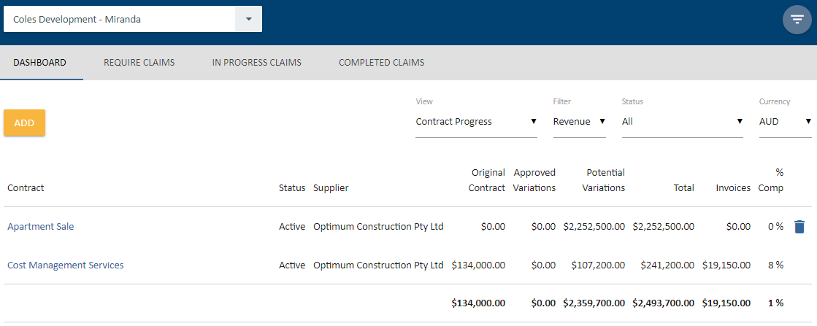

Contract maintenance involves;
- Moving the contract from pending to active
- uploading the contract agreement against the contract
- tracking % complete of individual and all contracts for a project or program of works
- scheduling or rescheduling deliverables dates
- phasing or re-phasing of contract Revenue and costs for cash flow purposes
- adding variations and extensions of time
- certifying claims for payment
- raising invoices or progress claims
- viewing and generating variation and extension of time registers
- communicating to clients

Creating an Invoice
You need to update the progress of the % complete or add in claim quantity of the deliverables and variations in the Contracts Deliverable & Claims form similar to the view below:
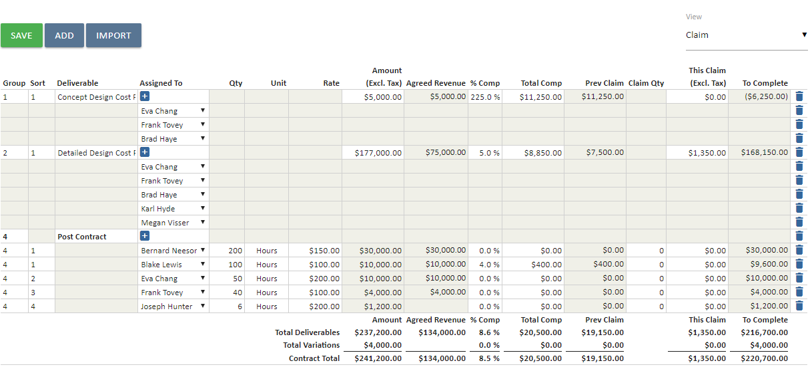
On updating the deliverables and variations select and the claim amount will be displayed, as will the previous claim amount and % complete of the contract.
Once updated invoices and progress claims can be raised, and this is completed by selecting the relevant document in Related Templates
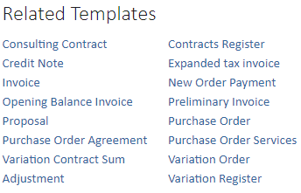
Selection of the Invoice will; populate the document wizard and follow the steps that are listed in the checklist. You can select any of the steps and go back and forward using the checklist.
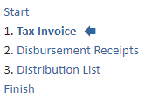
The invoice is populated for you to complete:
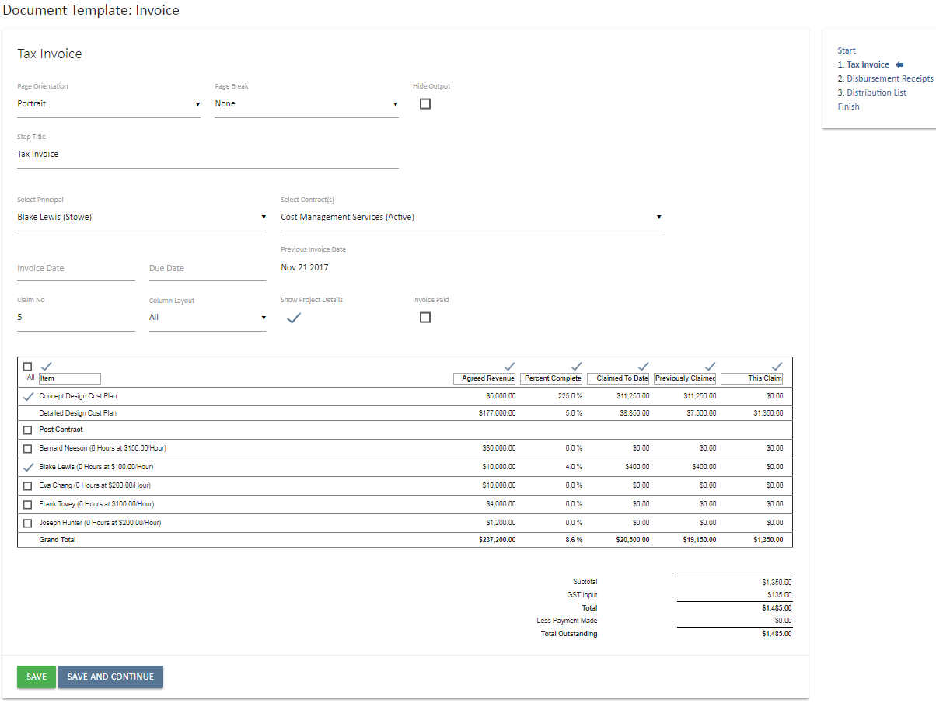
- select the contract you want to claim for or the principle
- enter the invoice date (the last invoice date is recorded for you )
- the claim number is populated – you can edit this field
- if this is an invoice that has already been paid – then select the check box
- you can select the check box next to the deliverables and variations that have been billed previously if you want them to be displayed in the body of the invoice as well, or leave unchecked and only new items will be included.

Note there are three layouts you can select to display the invoice in the finished document to suit your client requirements. These will each display a different heading for the columns in the table for both deliverables and variations.
Select the drop down to choose your preferred option
You can change these whilst working in the invoice to review how they look
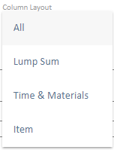

Lump Sum
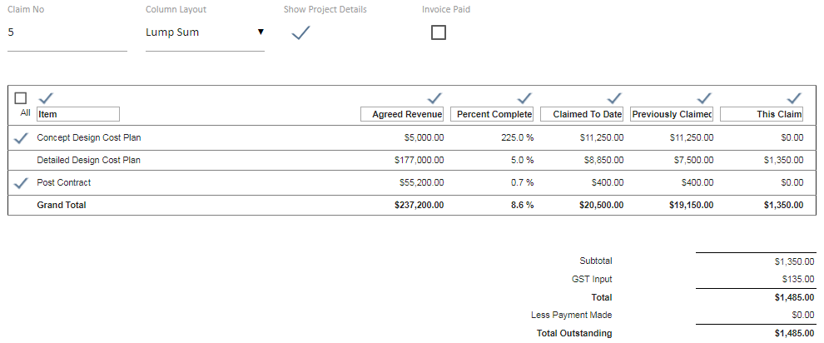Time and Materials 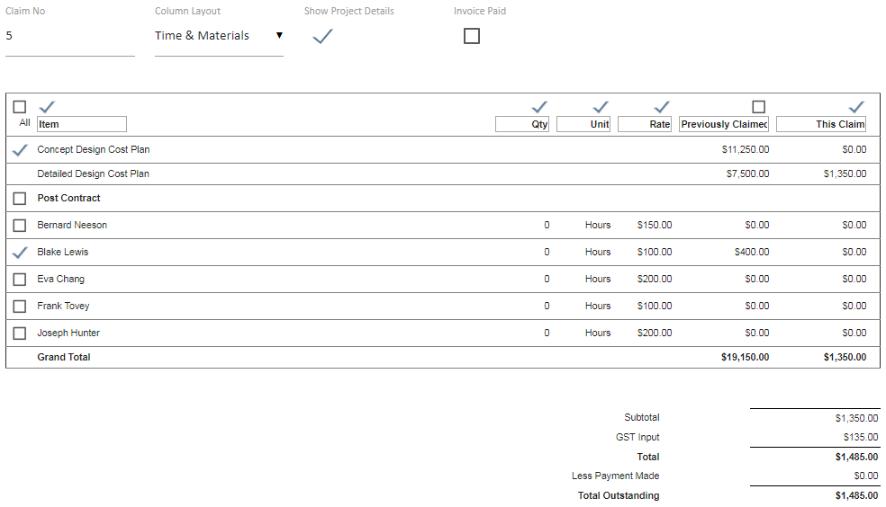
Item
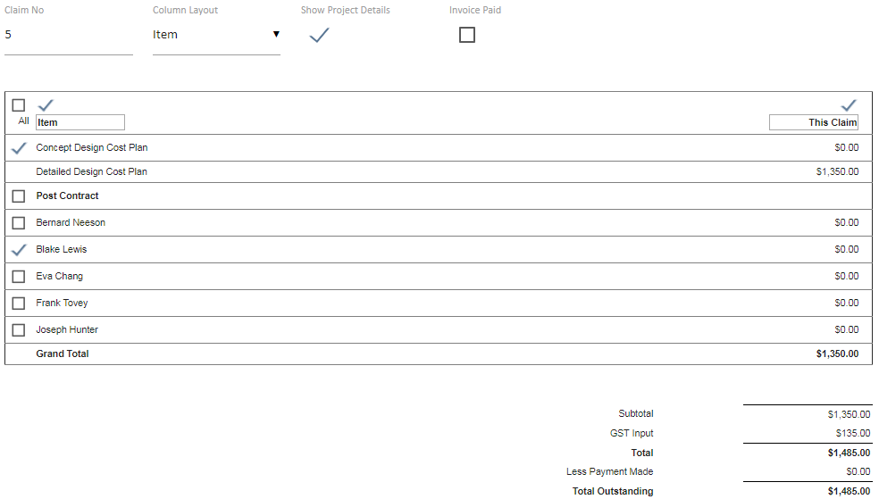
Once you have completed the document then it will need to be signed off so the information is then captured in to the accounting system you will use.
Once an invoice is signed off it will also update the Contract Summary with the progress complete and amount claimed to date.
The invoice can be emailed to the client and a transmittal captured for your records.
The revenue contract provides a register for deliverables, variations, extensions and invoices.
The cost contract provides a register for deliverables, progress claims, variations and extensions of time
These can be located once you have drilled into the contract by selecting the Details option.
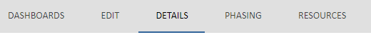
To return to edit the contract select the edit.

Opening Balance Invoice
Invoiced values can be updated to contracts in UniPhi using a balancing progress claim. A Balancing Invoice is a document template that can be used to update the progress of a contract (i.e claim deliverables) without committing that value as actuals. In other words, it will not double count the claim that has already been processed outside of UniPhi.
The Opening Balance Invoice is able to be selected from Related Template (on Revenue contracts).
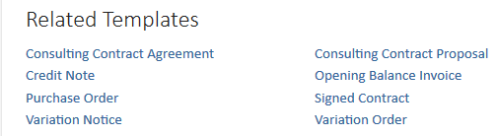
The functionality of this document is exactly the same as a normal invoice as detailed on page 69.

Contracts details and registers
The Contract Details will also be available and we can see if a signed off contract document has been attached by the document icon and name present in this box. This will mean you have an original contract Revenue displayed in the Contract Summary view
The contact details provides a snapshot of the contract and details of principles and suppliers, if no addresses or contact information appears you can update this in Portfolio> Resources >All projects by selecting the resource name and updating their details.
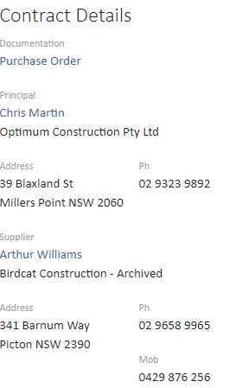

Contract registers
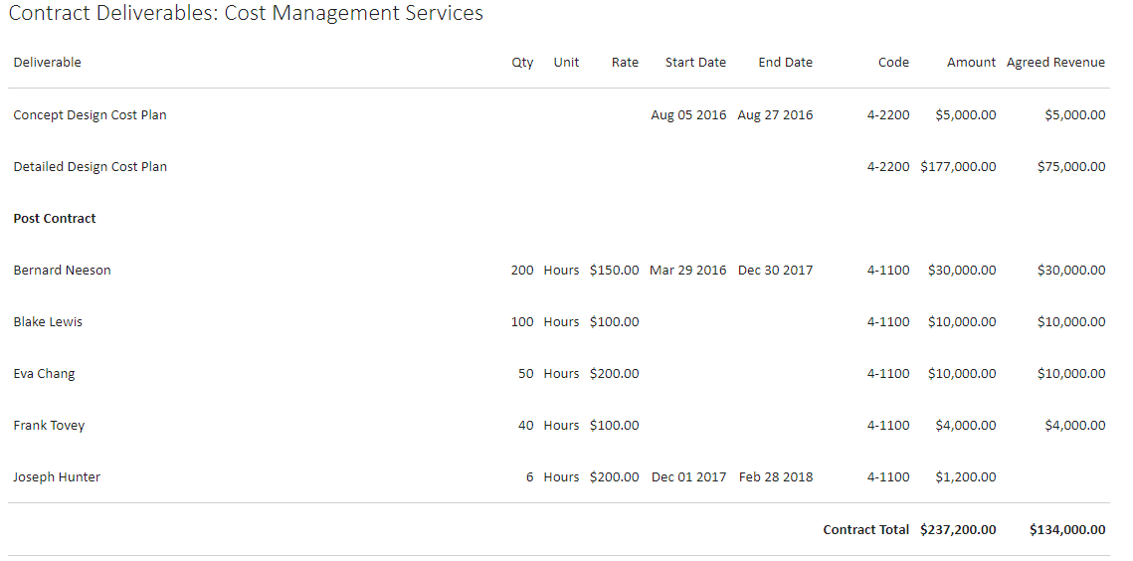
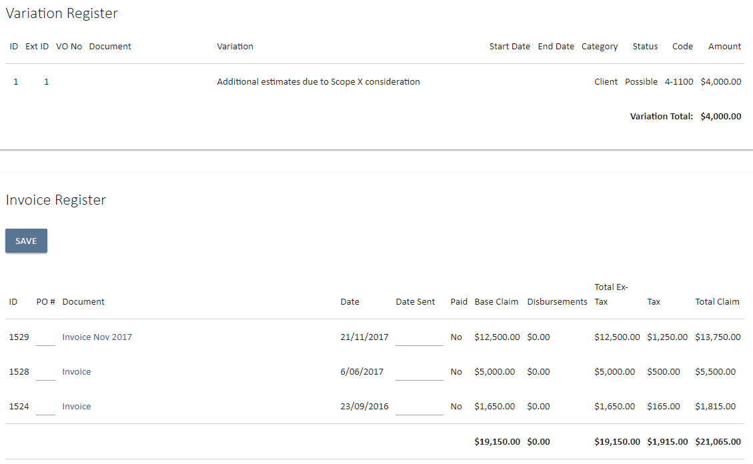

Cost Contract registers
The cost contract will display the deliverables and variations registers and instead of invoice it will have the progress claim and extension of time available.
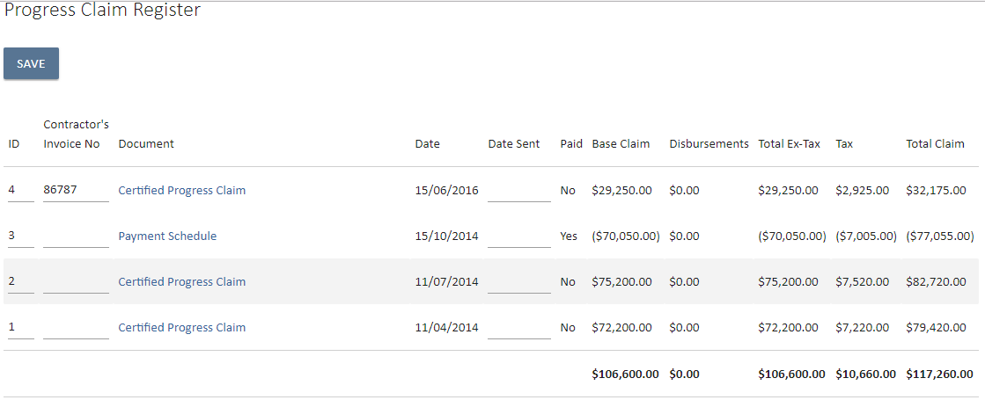
Contract Auto Phasing
In the Contracts module for your project select a contract. Select the schedule view and you will see the start and end dates fields. The phasing of the deliverables will be based on these dates if they are entered.
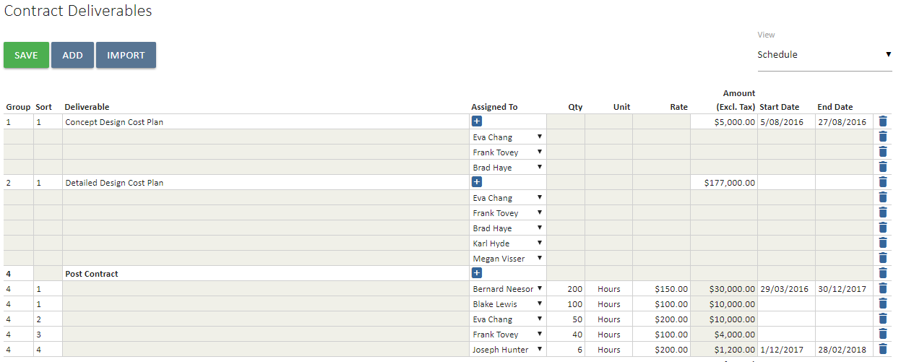
Now navigate to the Phasing view.
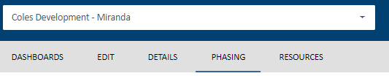
Here you will see the deliverables and their amounts in the respective months based on your selection above in the Schedule view of the contract.
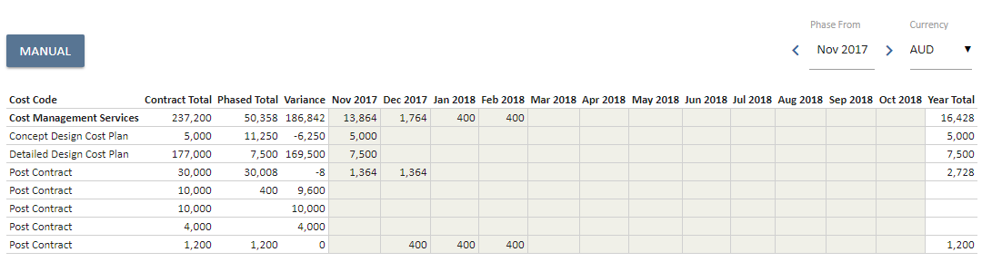
Click Manual in order to phase.
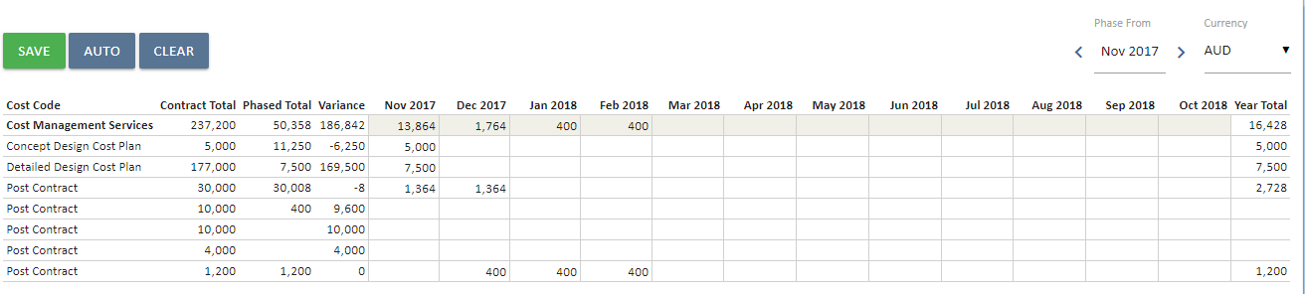
The contract deliverables are listed down and their contracted value is displayed next to them. You can Auto Phase a contract or manually edit the phasing fields and distribute costs over time if you choose.
To Contract Auto Phase select the tick box.
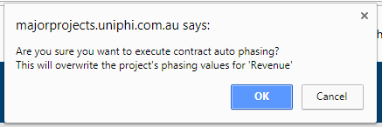
You will be prompted asking you are you sure you want to contract phase as this will override Revenue phasing that occurs in the Revenue Module. If you have entered a Revenue Budget and phased using Revenue phasing prior to the contract phasing being activated a budget will appear.
If you have not then no budget will be entered on the budget line, or appear in the summary against phased budget. Select OK and phasing will be completed.
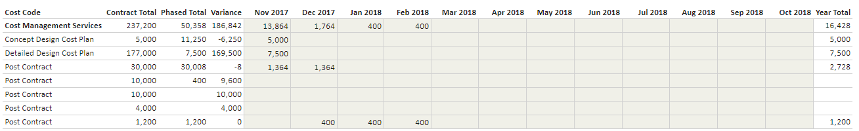
Notice that the cost of the contract has been distributed evenly across the term of the contract. If the contract carries over to the next financial year, you will need to select the next financial year from the Phase From: date selector to view the cost amounts for the next 12 months.
You can only Auto Phase a contract after you have added a deliverable (or deliverables) to it.
You can see below that the Revenue > Revenue Phasing table displays the contracted values in the Act/Fcst row
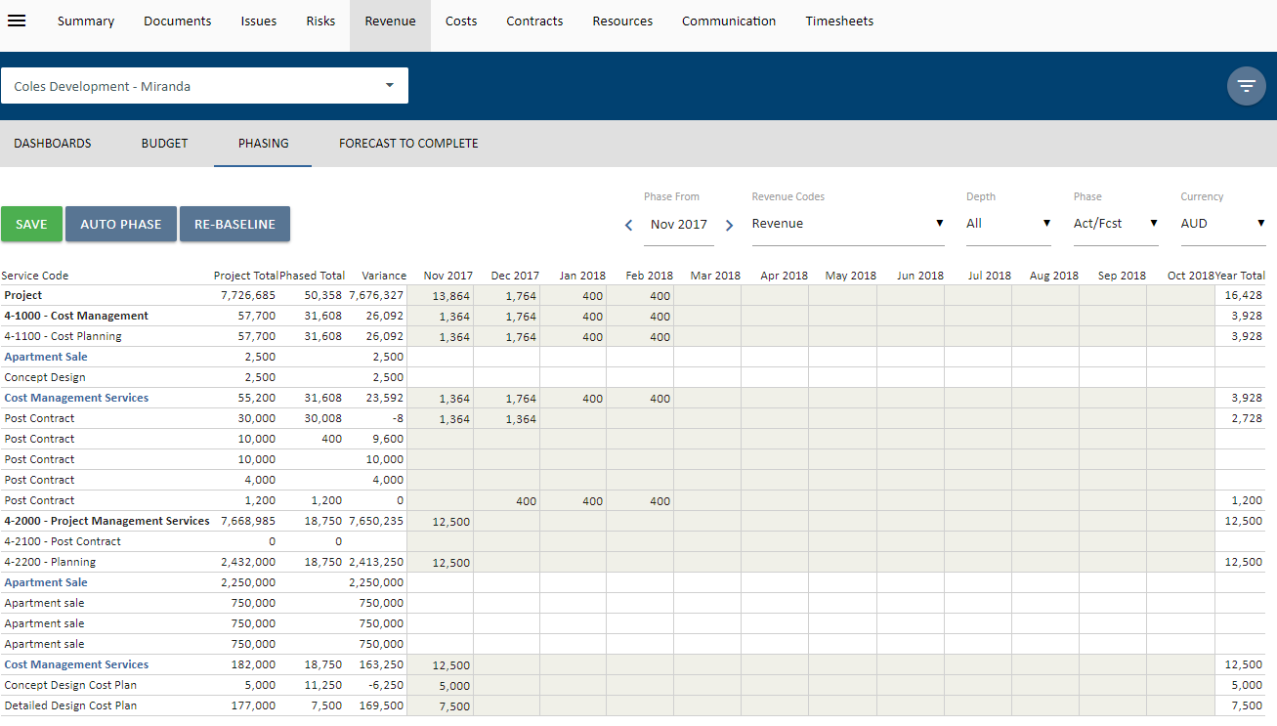
Selecting Contract from the Depth dropdown or selecting Act/Fcst from the Phase dropdown will show the contract phasing. Therefore selecting a budget level from Depth or Budget from phase dropdown will show the budget phasing. By selecting All from both menus, the comparison between the two is visible.

Manual Contract Phasing
To manually phase select a contract and navigate to the Phasing view.
The fields are editable as they are not greyed out. You can see the Contract total in the left hand side.
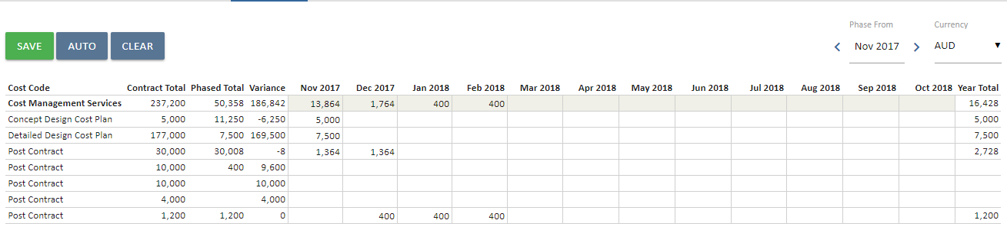
If the fields are greyed out, select 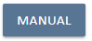

Enter in the values over the time period you need. Selectand the phased total will be displayed. If you need to select another financial year you select the year ending drop down and continue to phase.
Select once you have finished. The overall Revenue are displayed in the Revenue module and by selecting the Revenue module you will see a view similar to below providing a breakdown of the cost codes and amounts. You can select for financial year of ALL years to see whole of project.

